**Name: Mayank Arora**

**Batch: Data Track (Batch - 2)**

1. **Create new Azure VM Instance (instance name: globetechvm231) & install docker into it, explain all steps with screenshots**

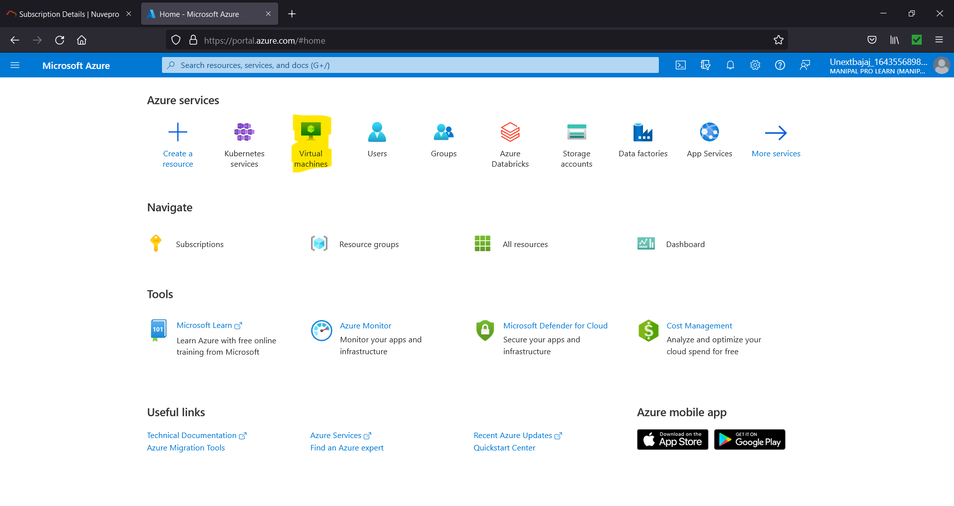

Figure 1.1. Select Virtual Machine.

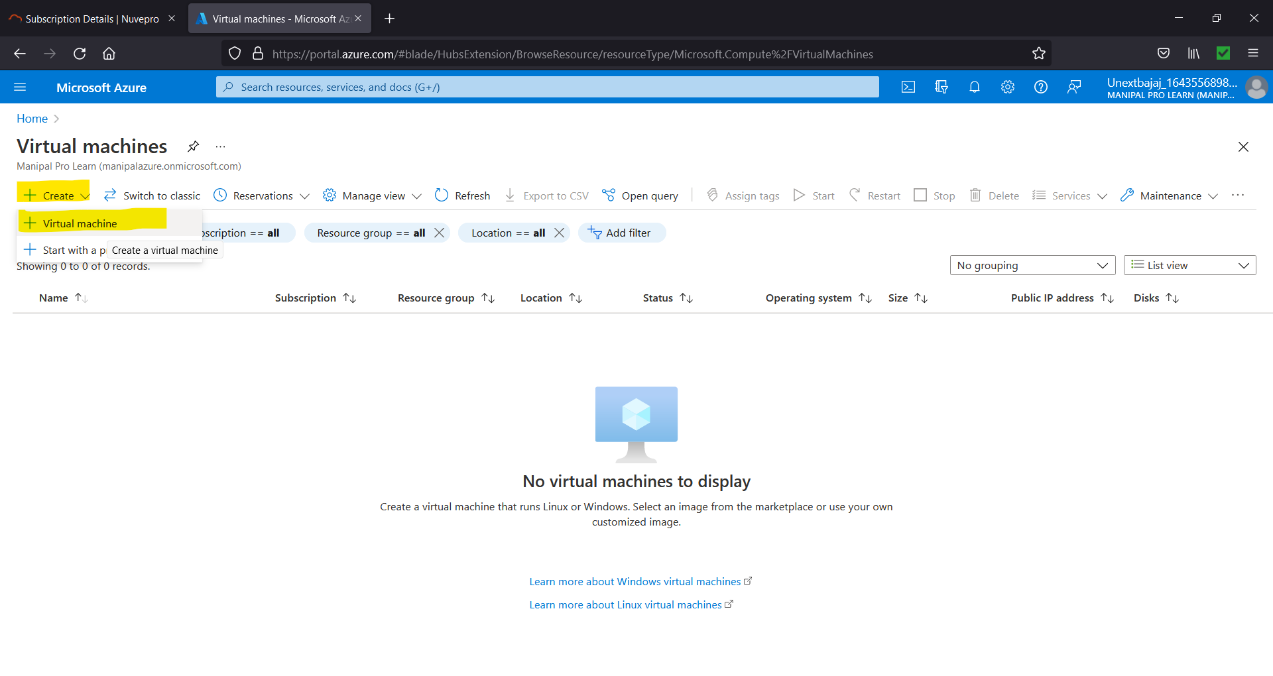

Figure 1.2. Select “Create” and then “Virtual Machine”.

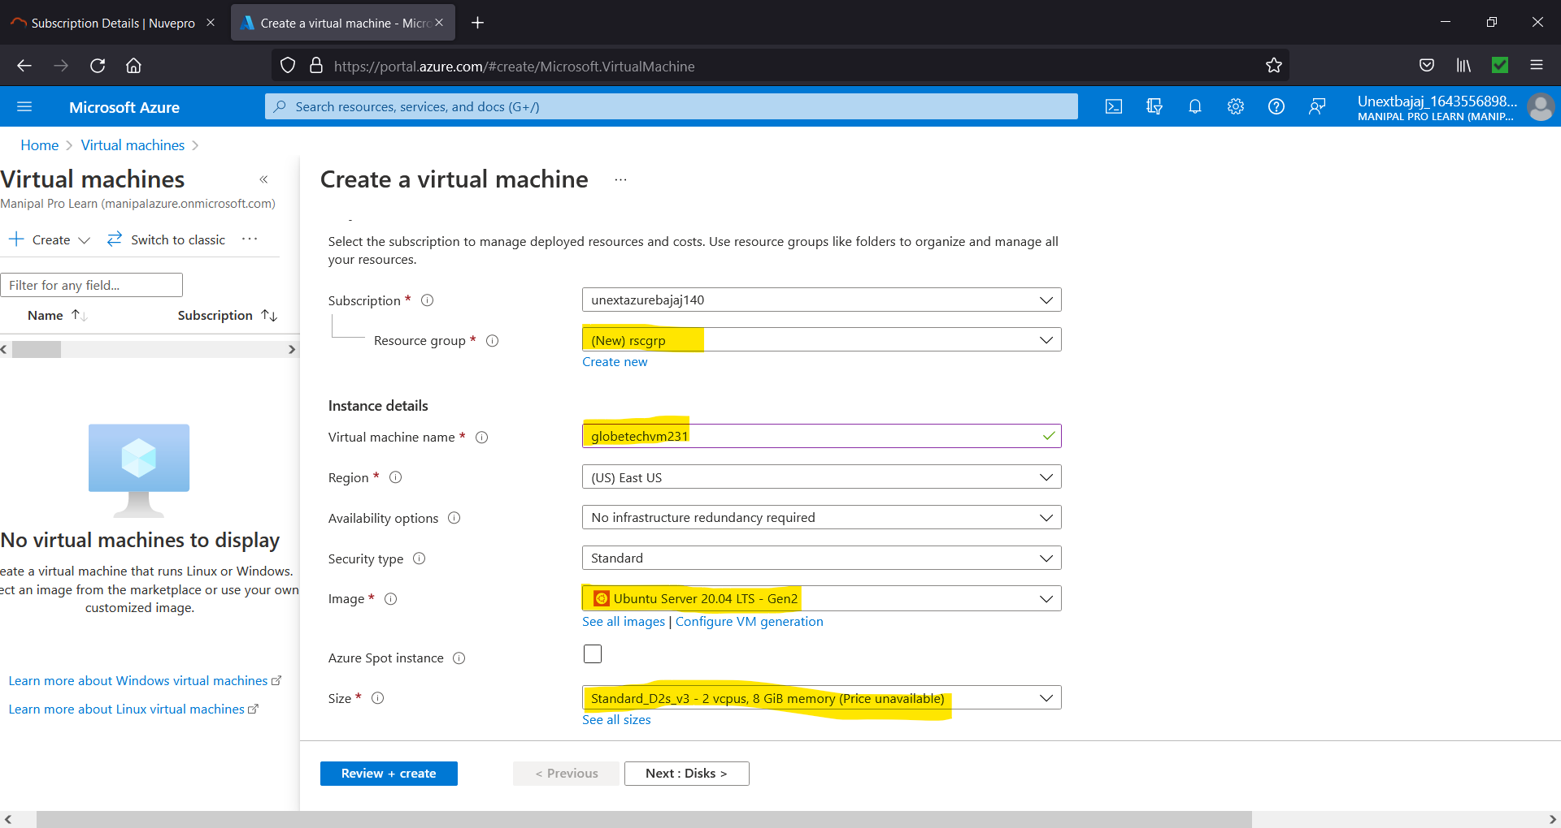

Figure 1.3. Give resource group name, VM name, select the image and size.

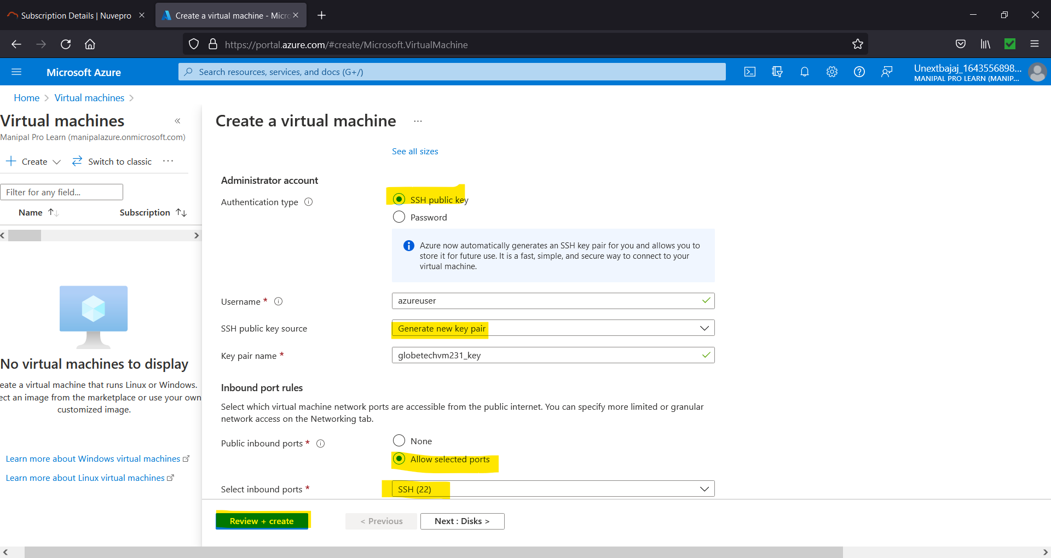

Figure 1.4. Choose Authentication Type and Inbound Port Rules and click on “Review + create”.

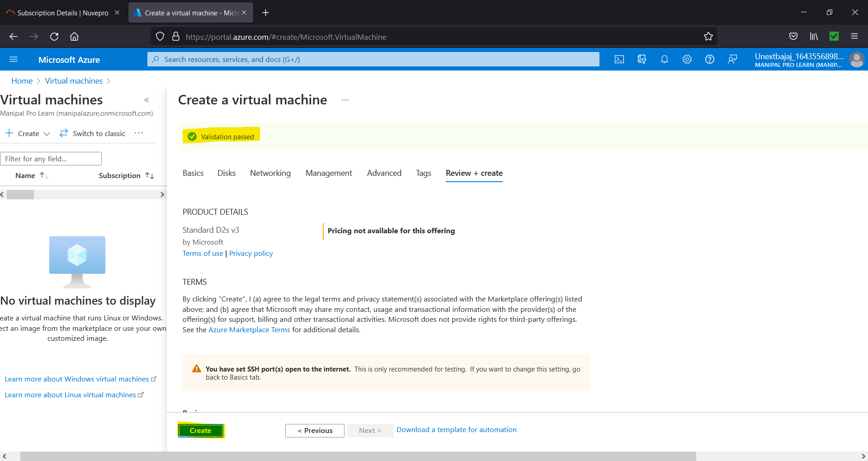

Figure 1.5. Review the settings and change anything if required else if validation has passed click on “Create”.

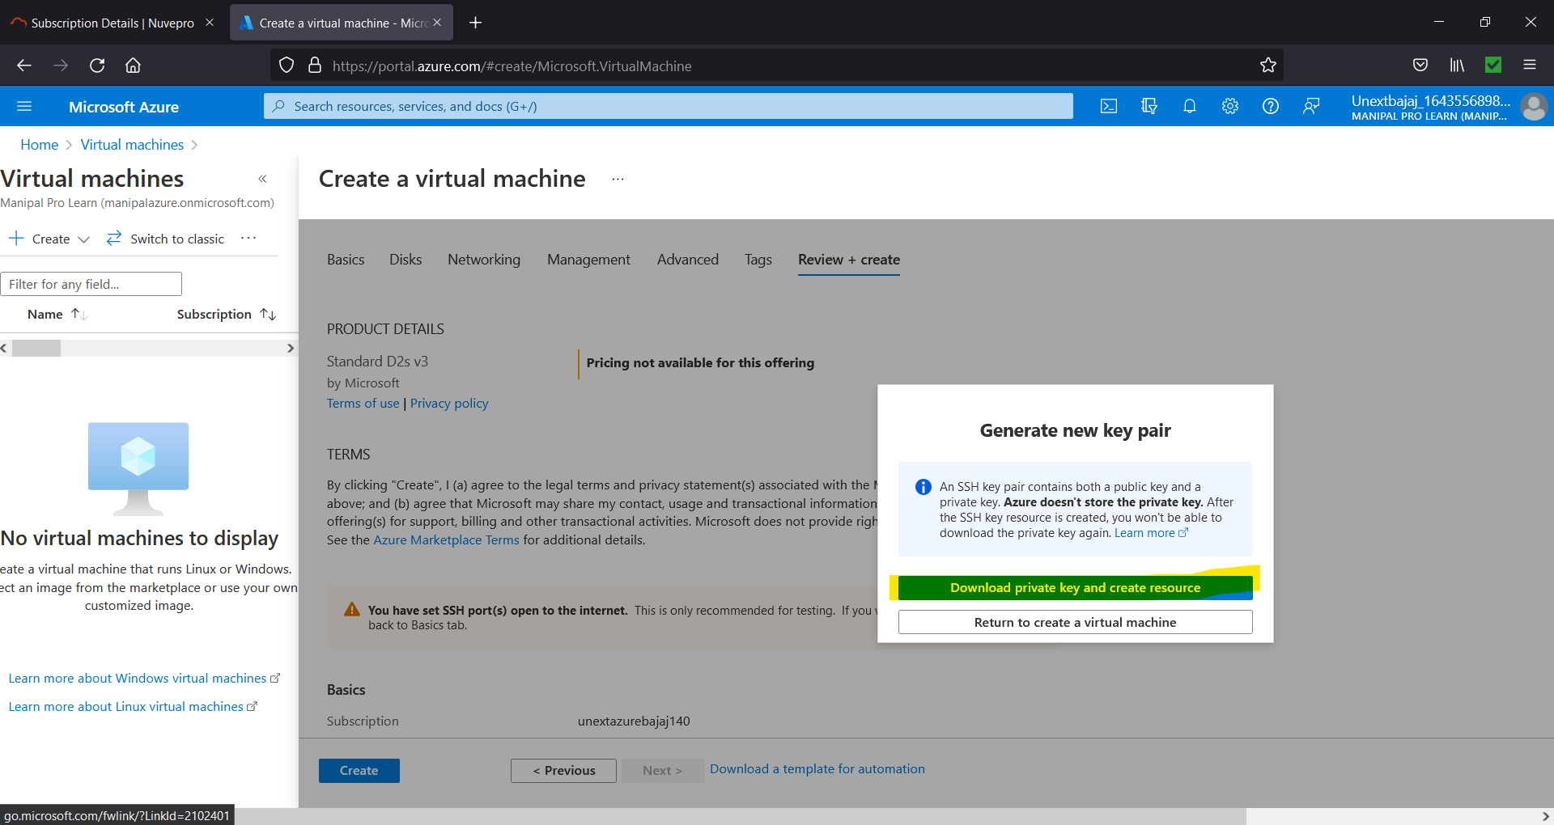

Figure 1.6. Select “Download private key and create resource”.

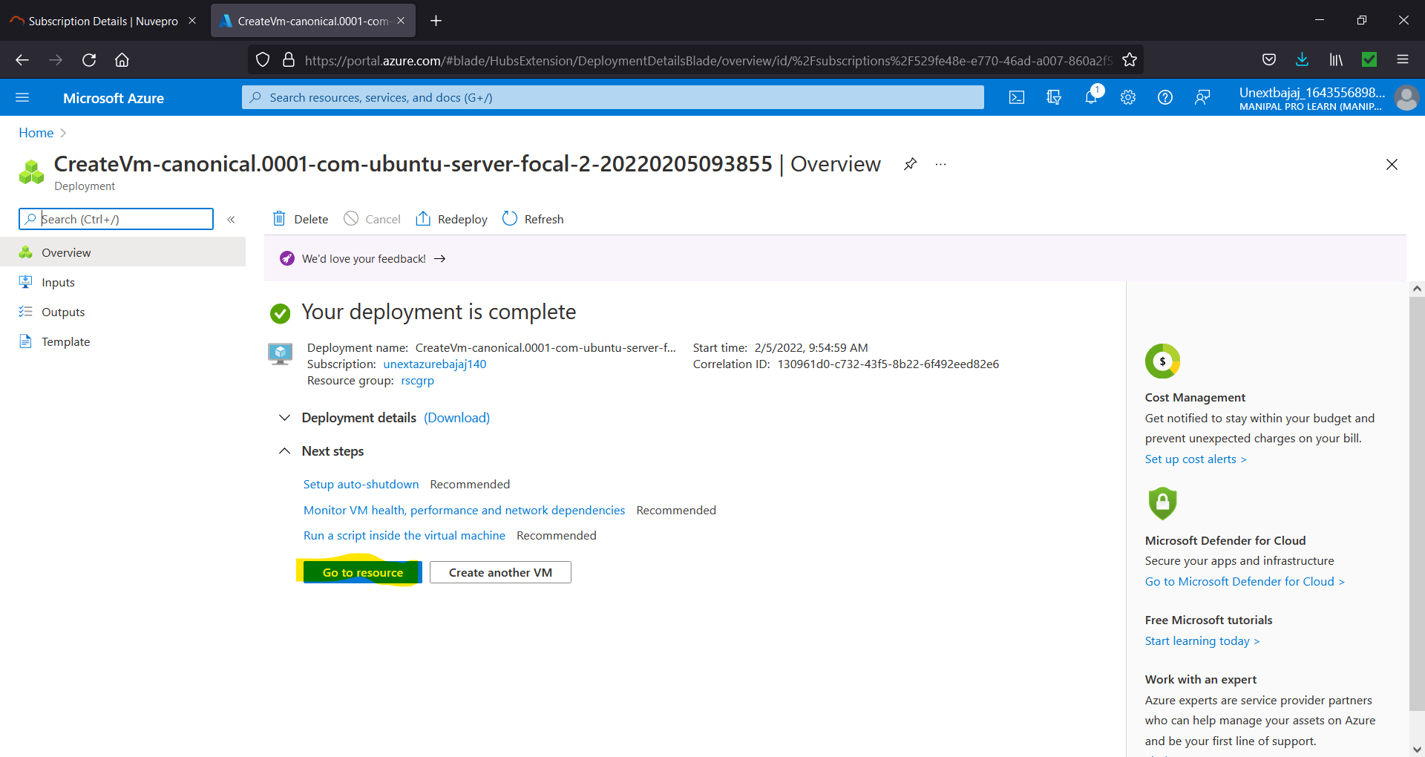

Figure 1.7. Click on “Go to resource”.

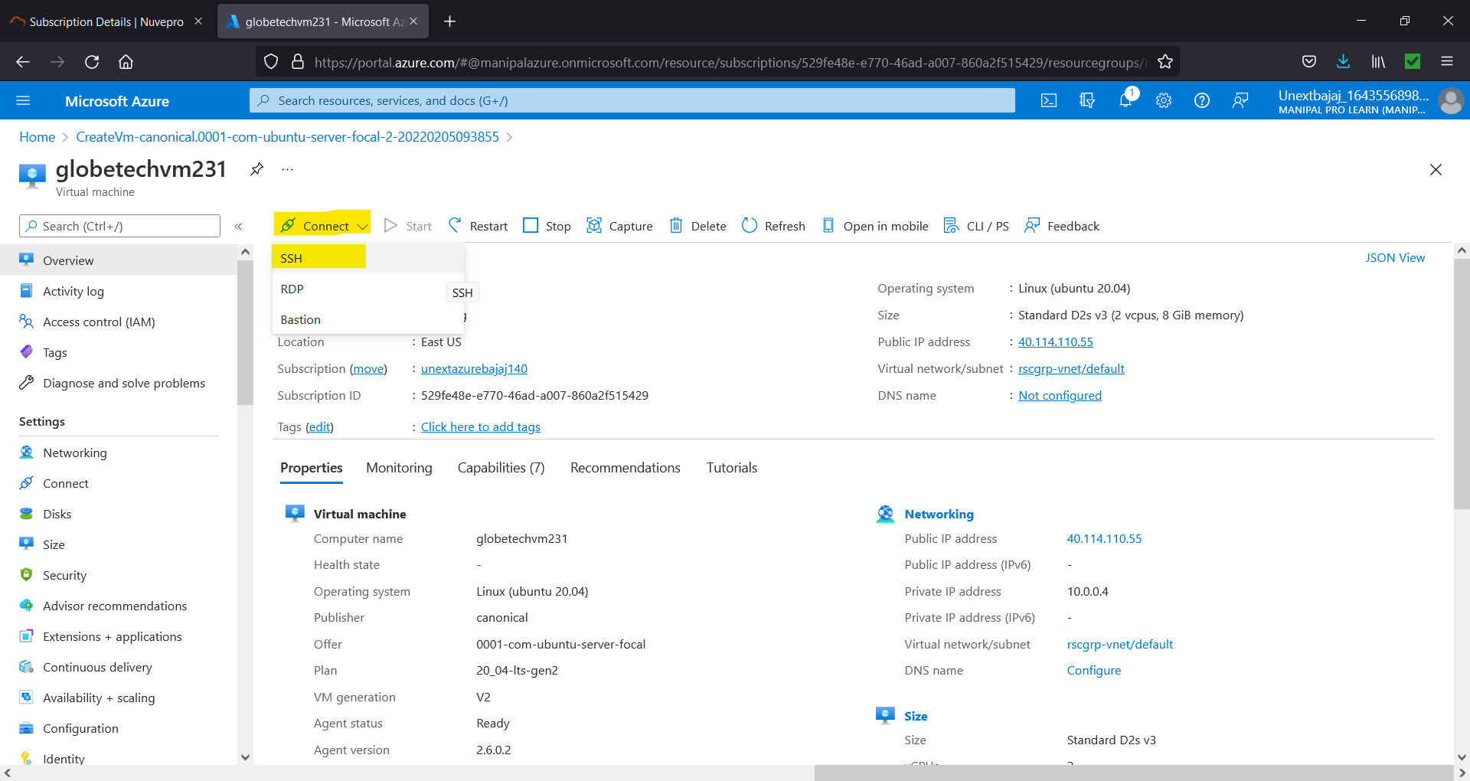

Figure 1.8. Select Connect 🡪 SSH.

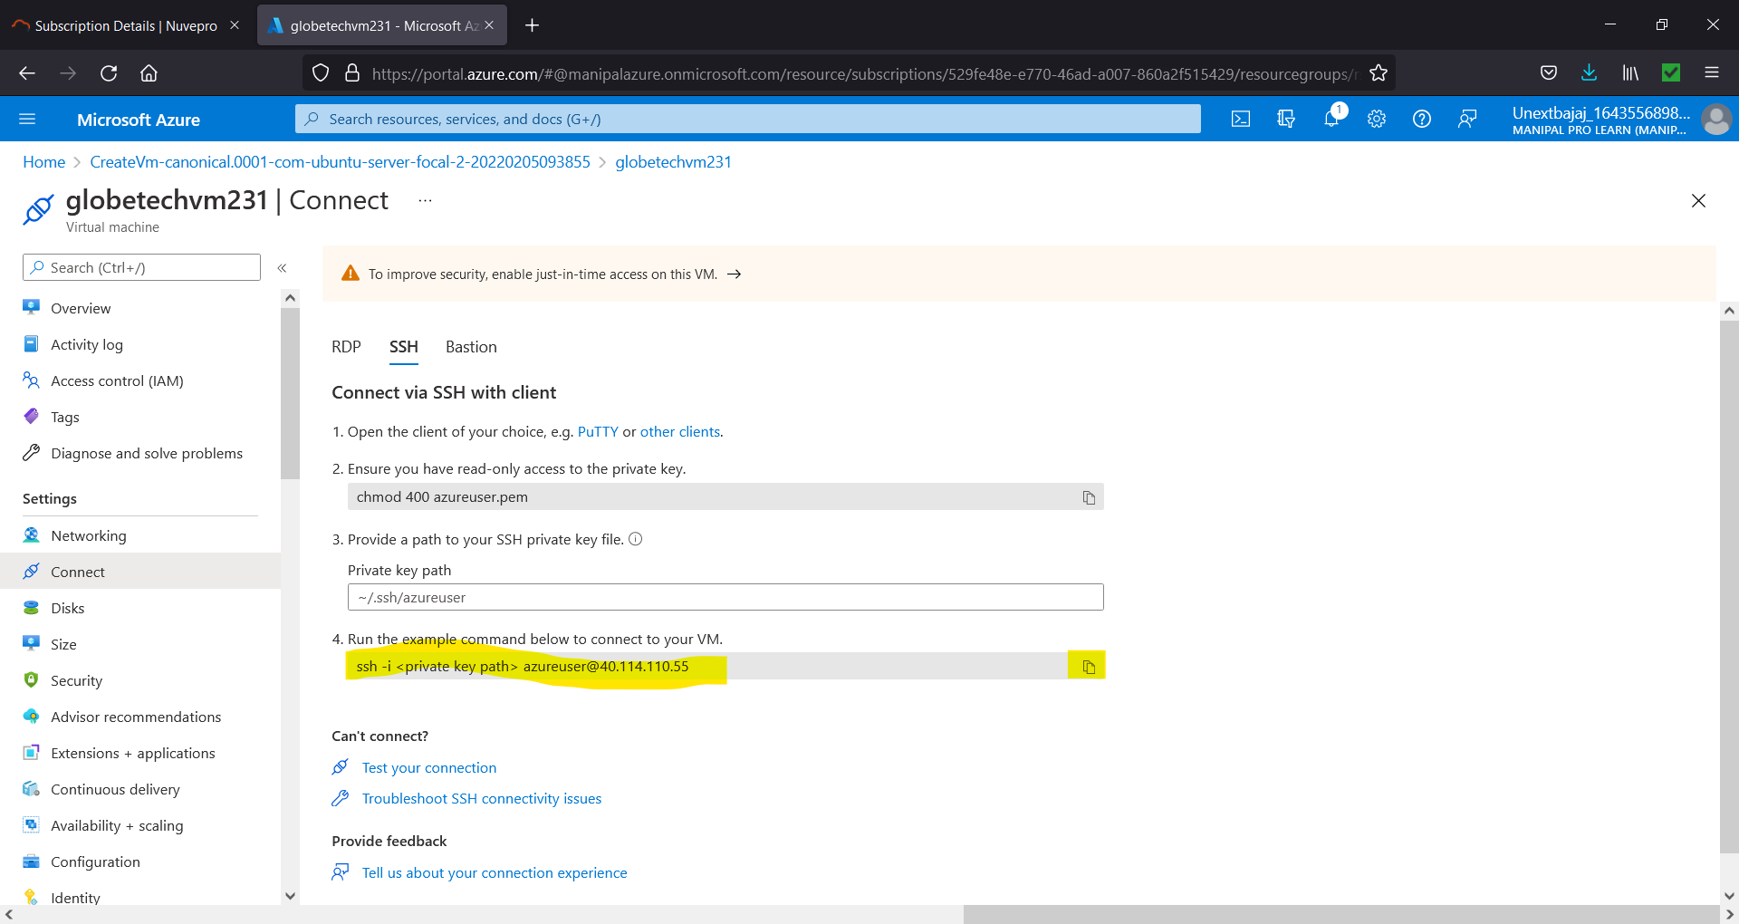

Figure 1.9. Copy the command in point 4 and replace <private key path> with the path of your file that was downloaded in Figure 6.

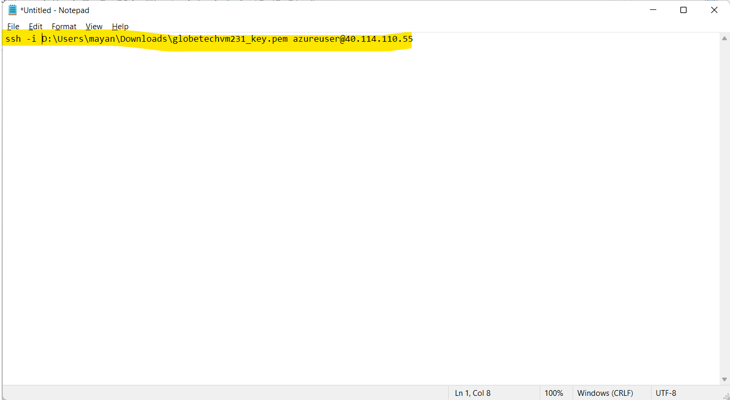

Figure 1.10. Create the Command.

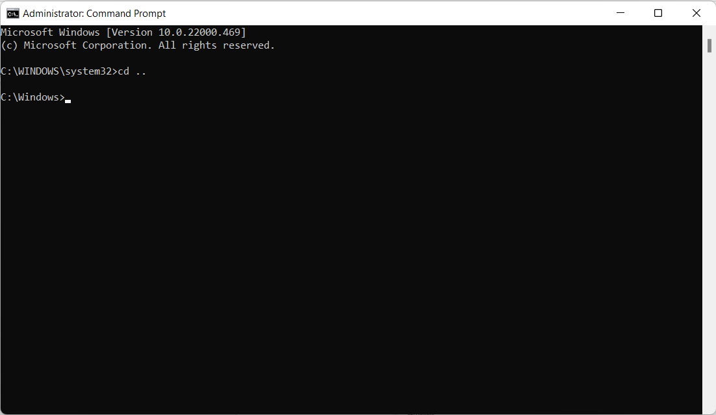

Figure 1.11. Open command prompt as administrator and go back one directory.

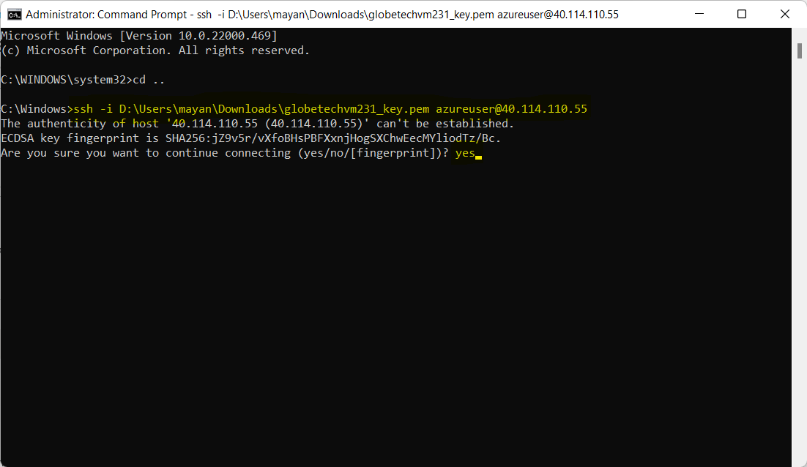

Figure 1.12. Paste the command that was created in Figure 1.10 after providing the path and give “yes” if prompted.

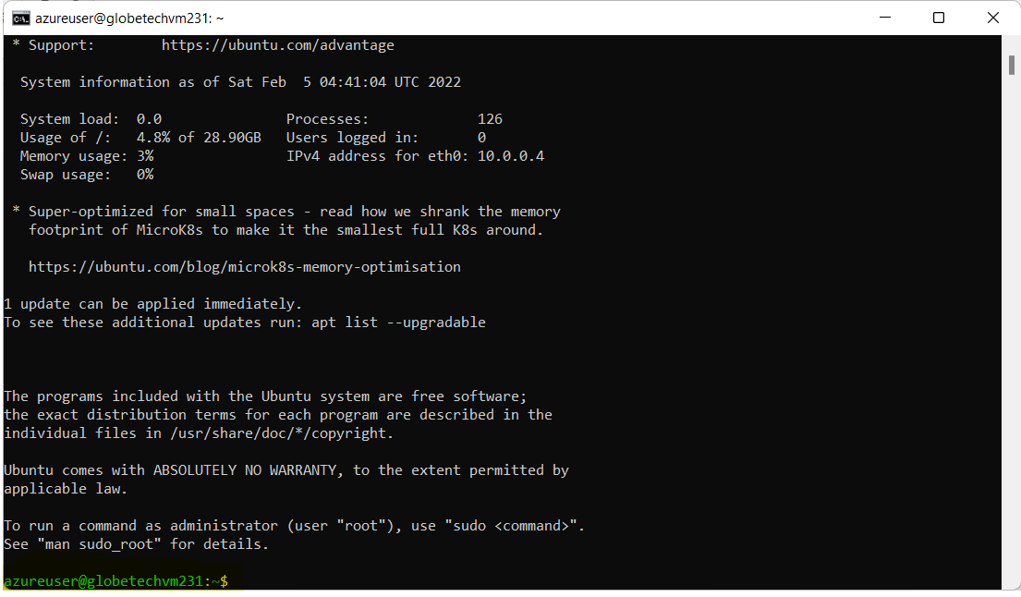

Figure 1.13. We are now in the Azure VM.

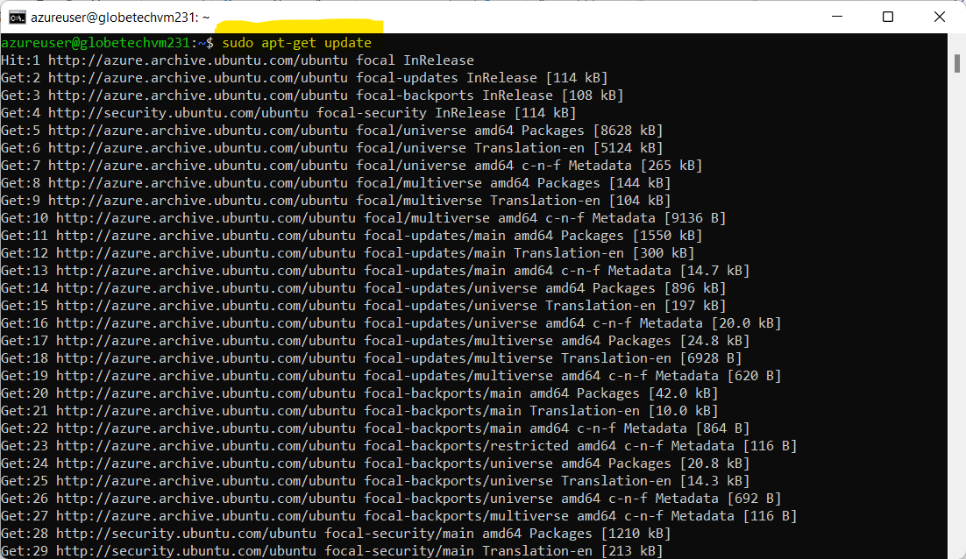

Figure 1.14. To install Docker, first update the Virtual Machines’ OS to the latest version.

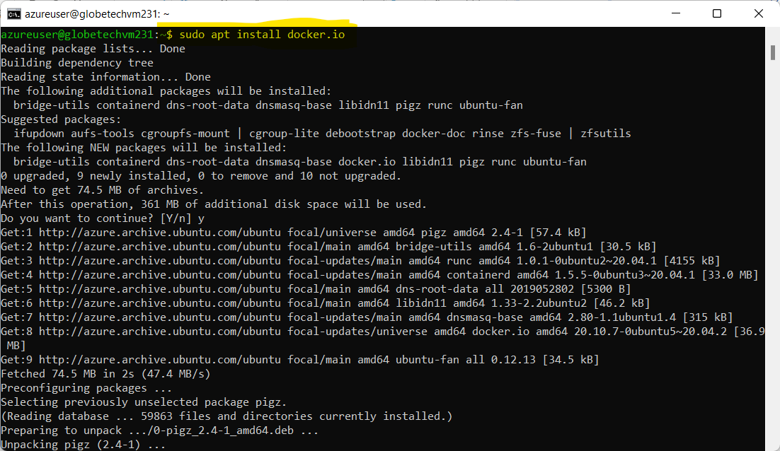

Figure 1.15. Install Docker.

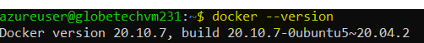

Figure 1.16. Check version to confirm installation.

1. **Explain with screenshots - how Docker images will be installed in a VM & explain various features of Docker?**

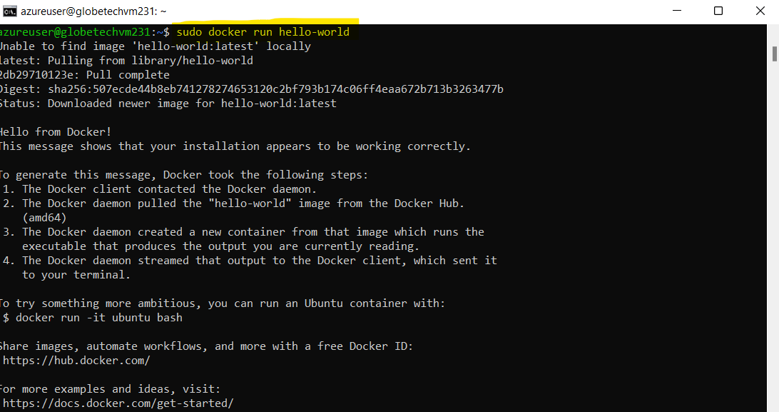

Figure 2.1. Installing a Docker Image named “hello-world”.

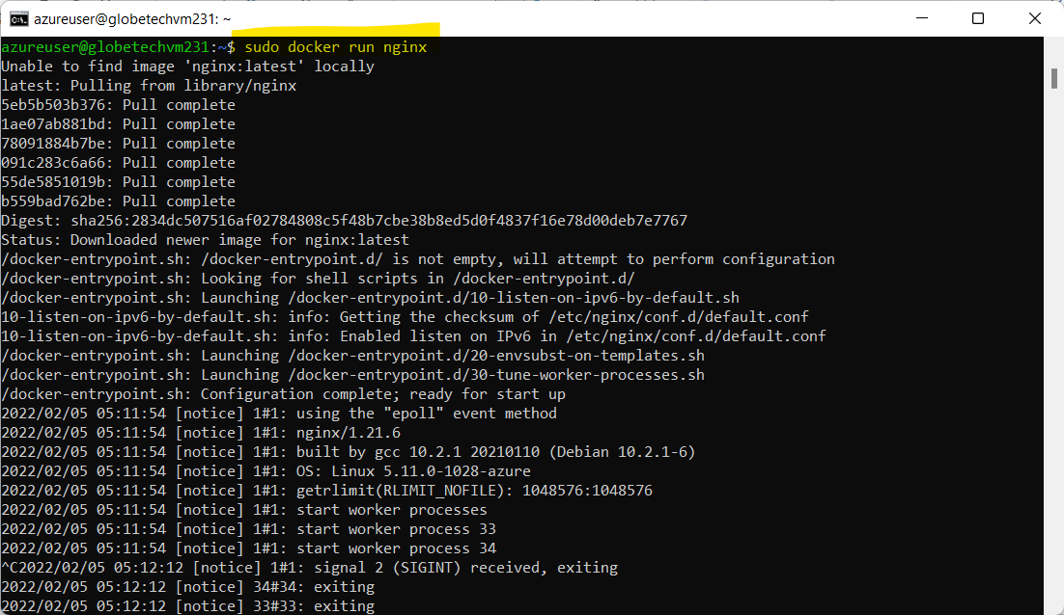

Figure 2.2. Installing a Docker Image named “nginx”.

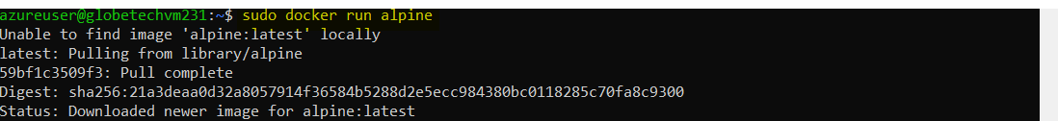

Figure 2.3. Installing a Docker Image named “alpine”.

Features of Docker: -

1. Docker is a DevOps tool used in the deployment stage. Docker is used to automate the deployment of applications in lightweight containers so that applications can work efficiently in different environments.
2. Docker containers occupy less space.
3. Short boot up time.
4. Containers have better performance since they are hosted in a single docker engine.
5. Easy to scale up.
6. High efficiency.
7. **In Azure - please create Kubernetes cluster called: Bajajkubecluster678 & Create a sample Voting App & explain all steps with screenshots.**

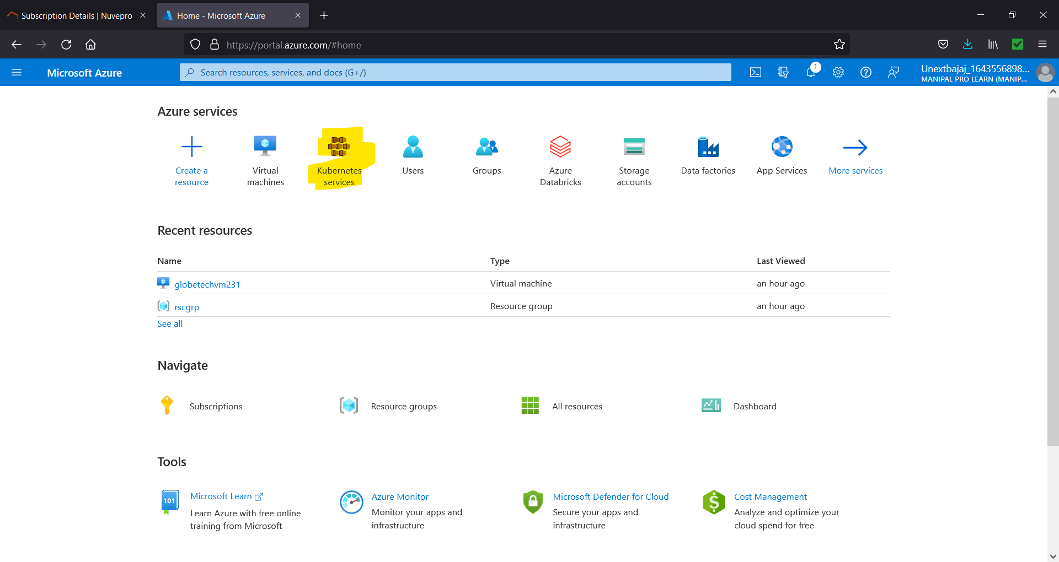

Figure 3.1. Select “Kubernetes services”.

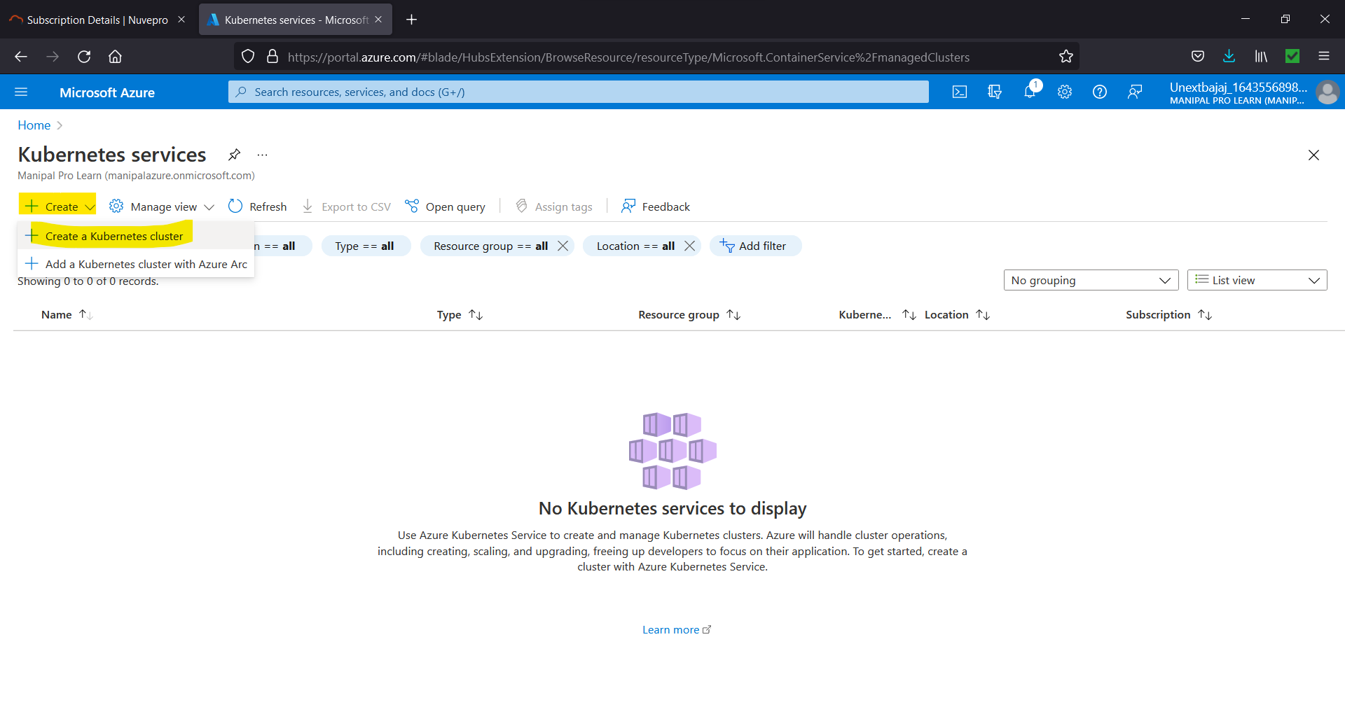

Figure 3.2. Select “Create” 🡪 “Create a Kubernetes cluster”.

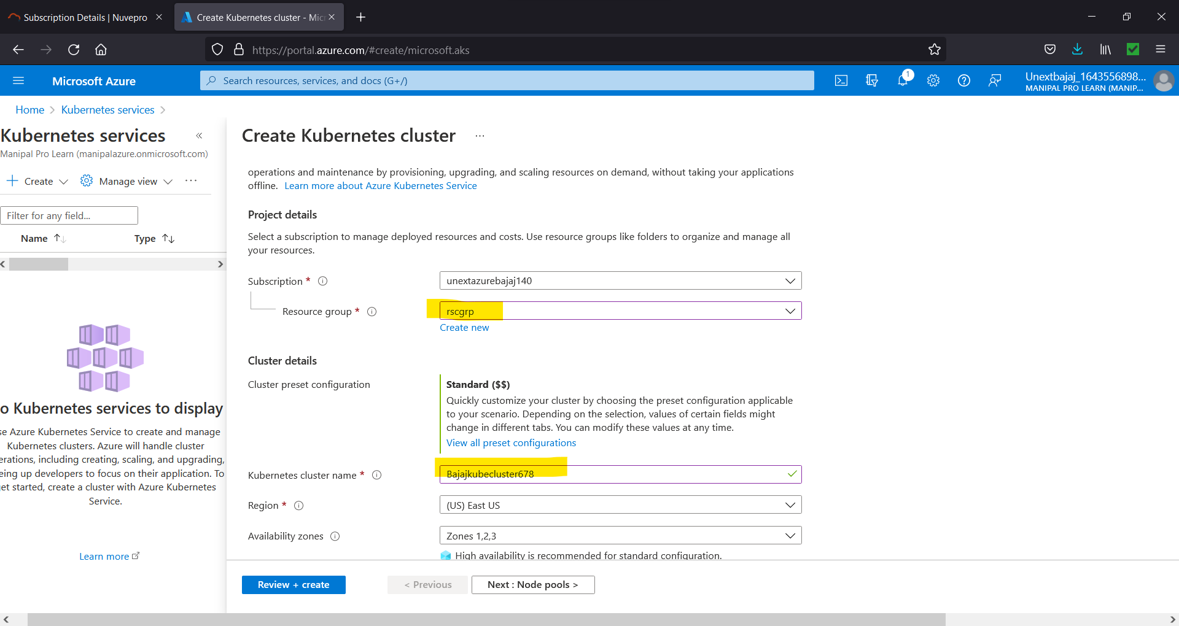

Figure 3.3. Give resource group, cluster name.

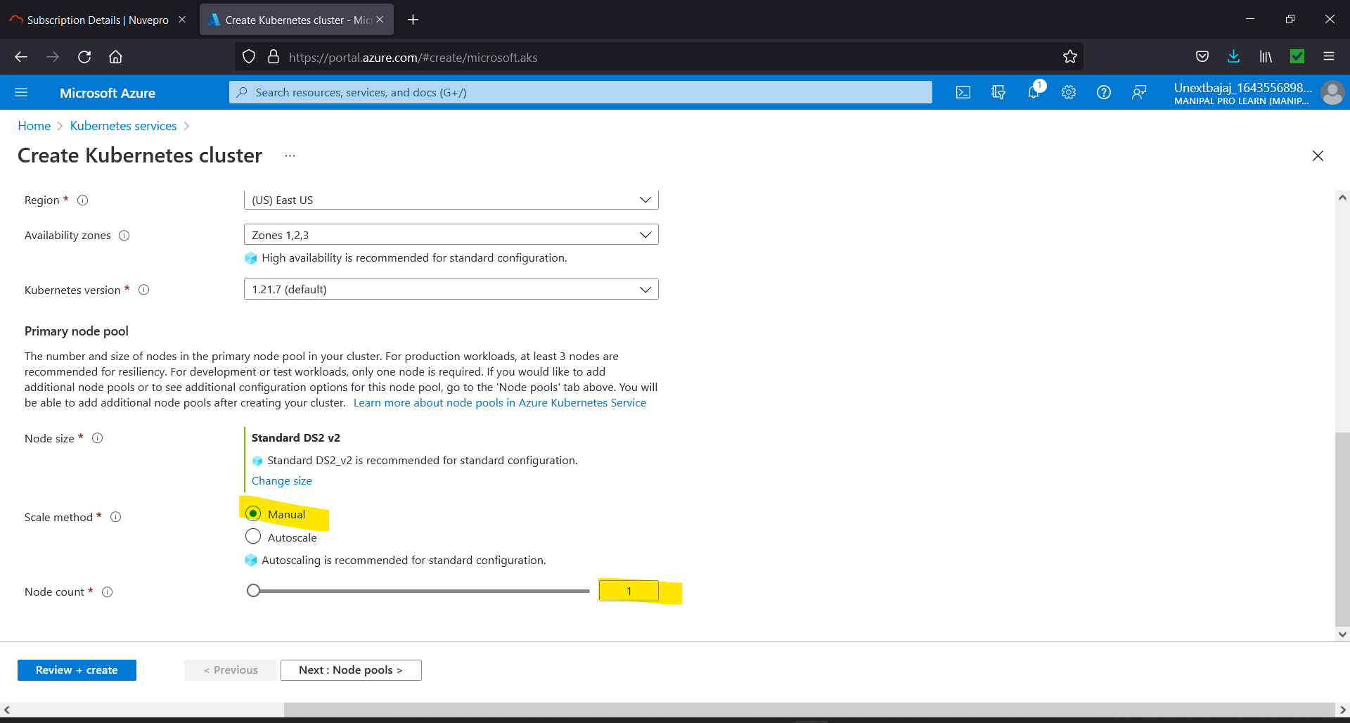

Figure 3.4. In scale method select Manual and node count = 1 to keep the application simple and then click “Review + create”.

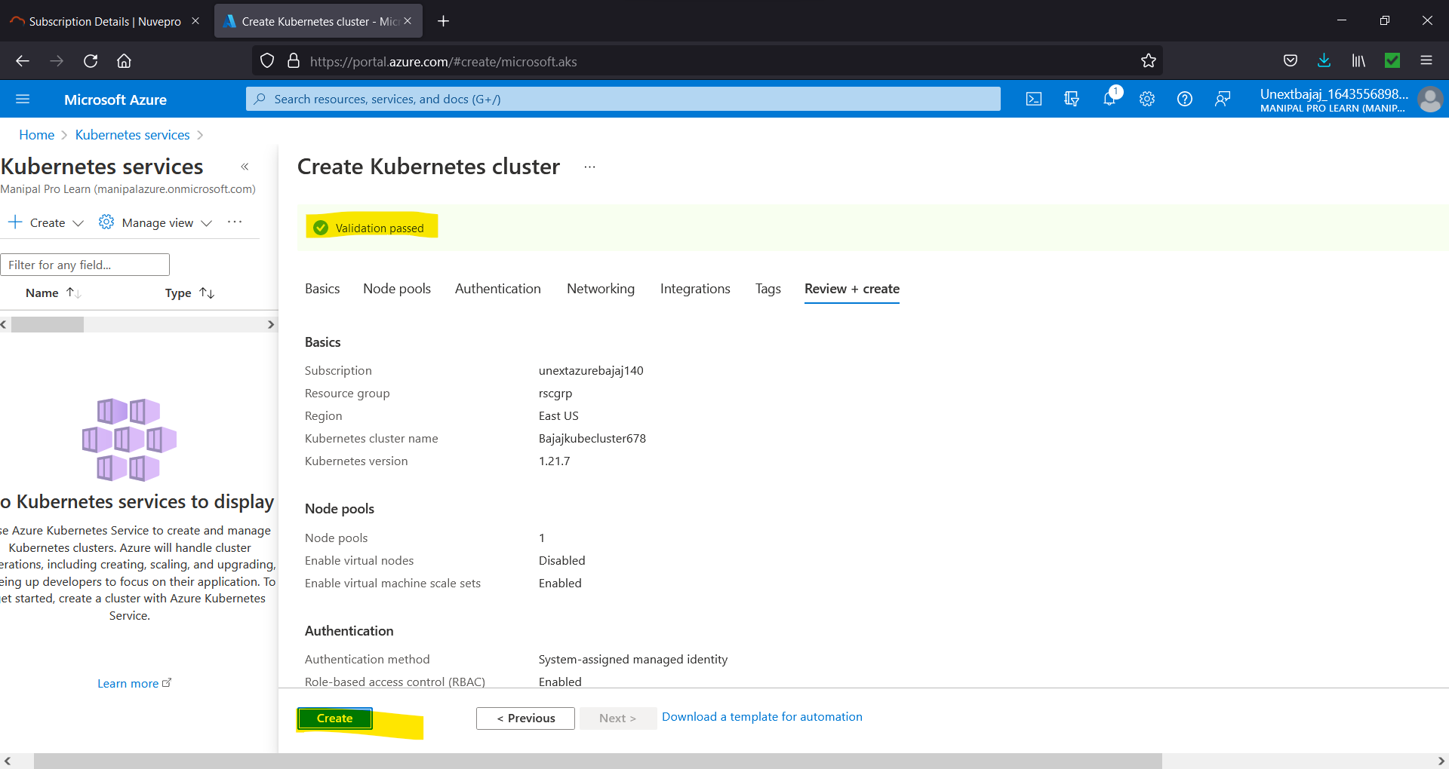

Figure 3.5. Review the settings and change anything if required else if validation has passed click on “Create”.

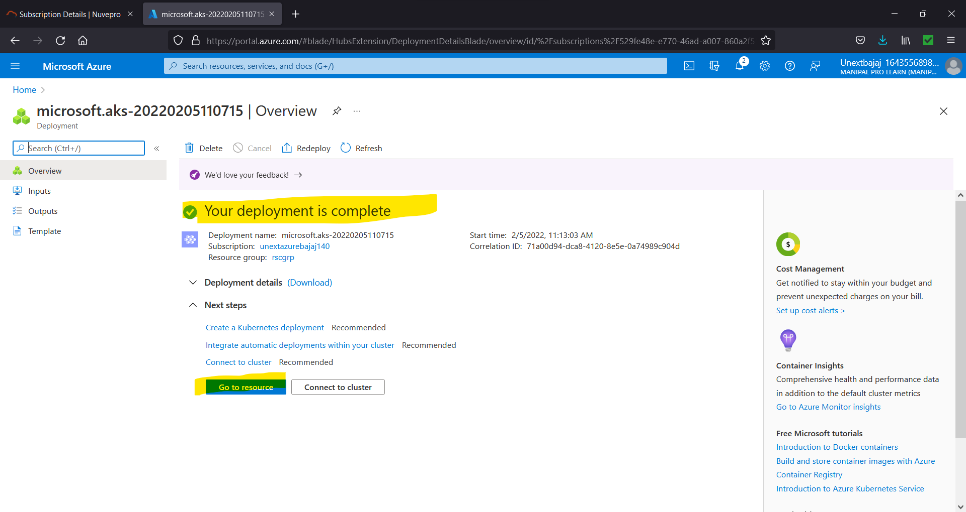

Figure 3.6. Click on “Go to resource”.

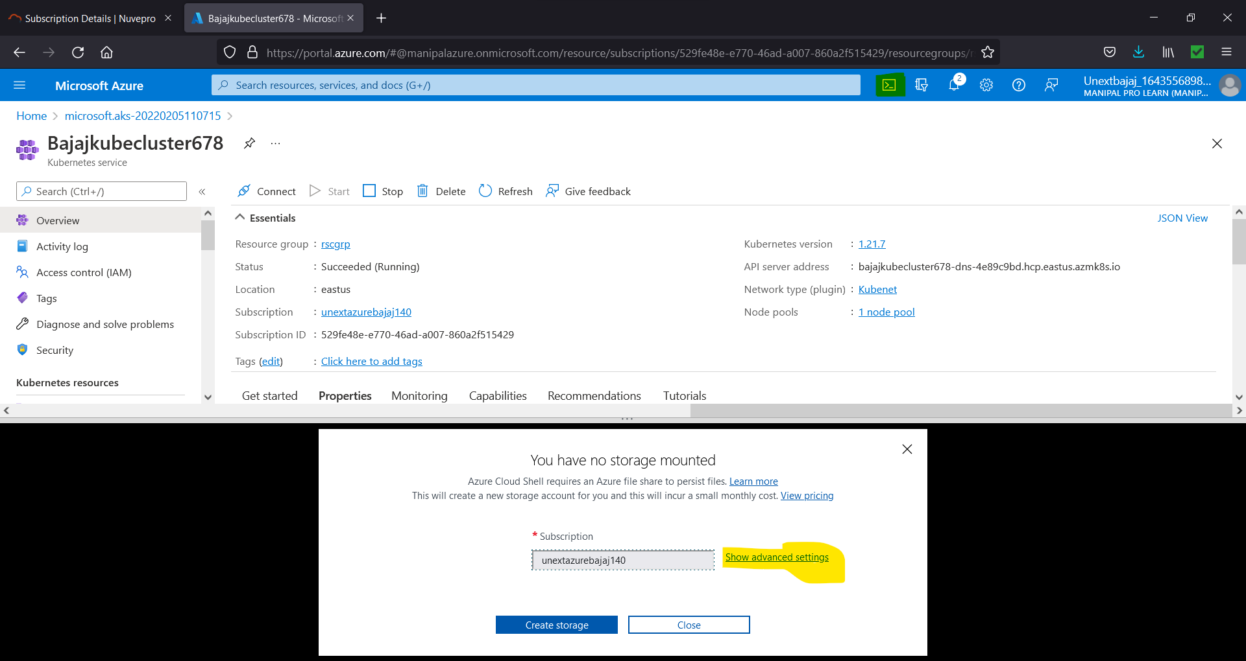

Figure 3.7. Open Azure Cloud Shell and select bash (change the region if it’s not East US by going in advanced settings).

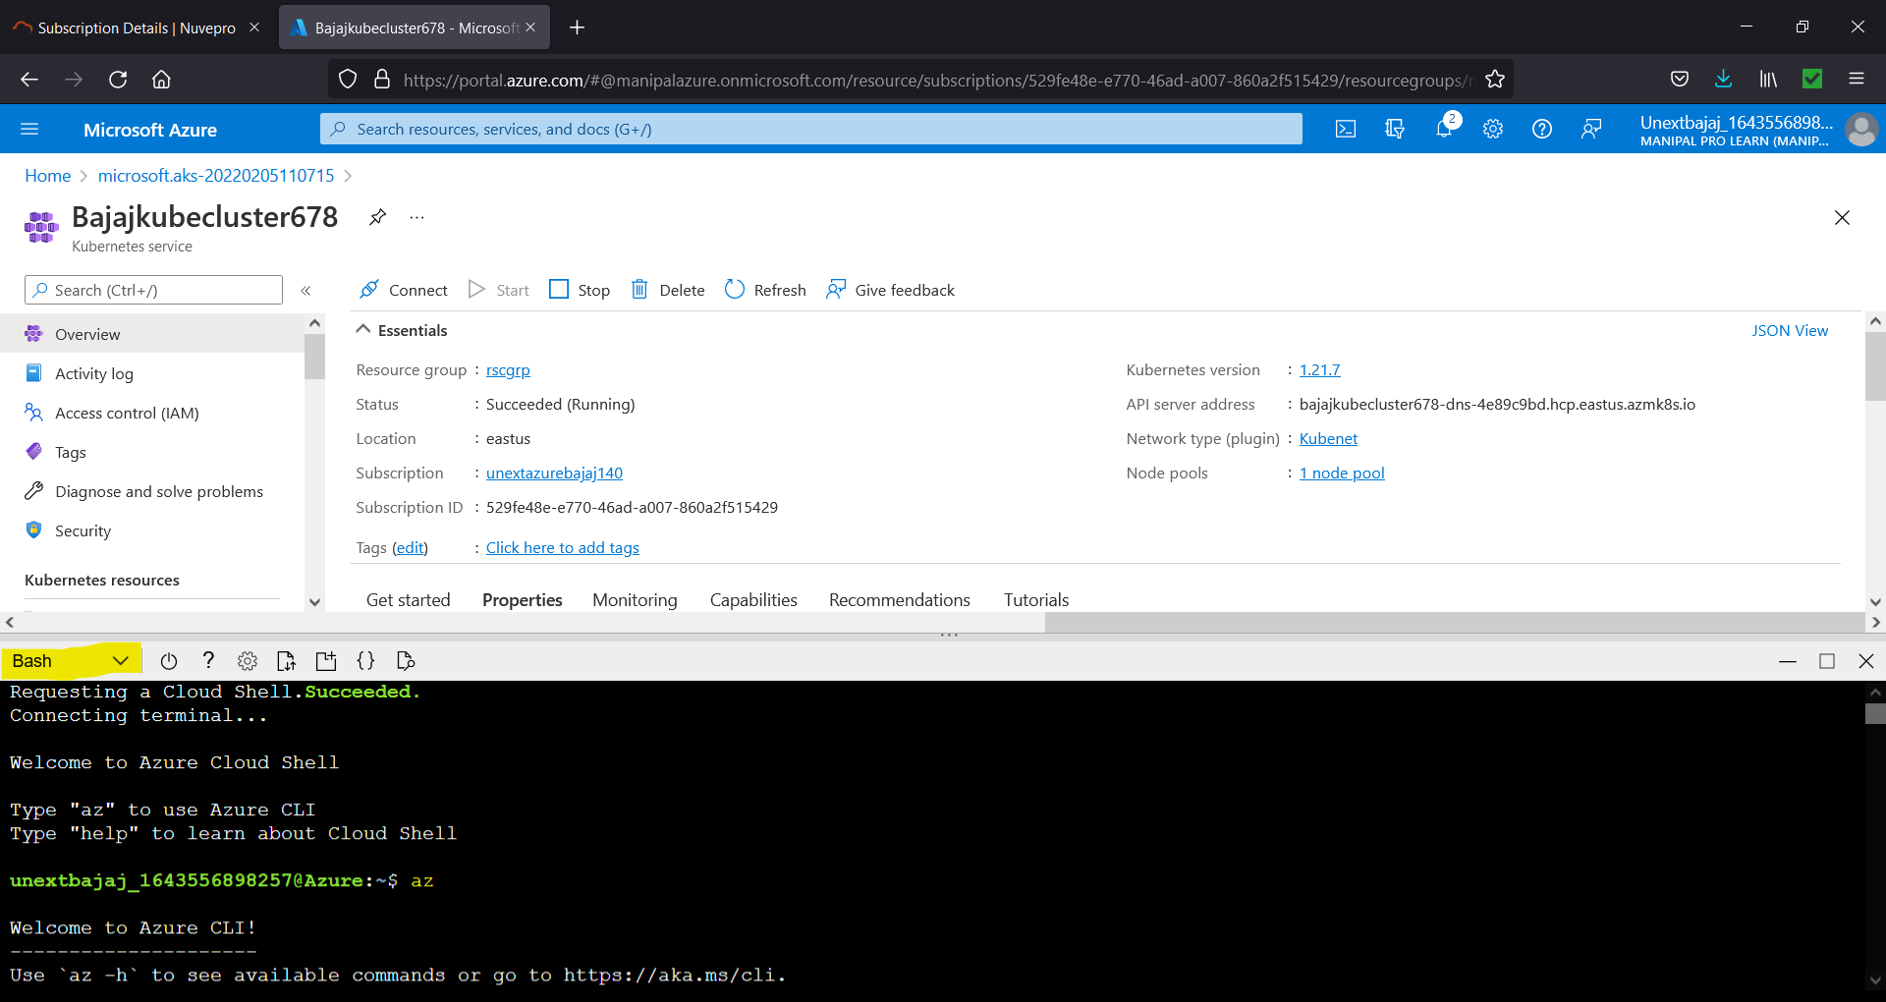

Figure 3.8. Type “az” to enter Azure CLI (without quotes).



Figure 3.9. Now we need to type a command to download the credentials and configure Kubernetes (az aks get-credentials --resource-group <name of resource group> --name <name of Kubernetes service>).



Figure 3.10. Now, we need a command to get the list of nodes and check the connection (Here the STATUS must be ready, then only we can run the application).



Figure 3.11. Next, we open a file named “azure-vote” in VI editor and put the code for the application in this file.

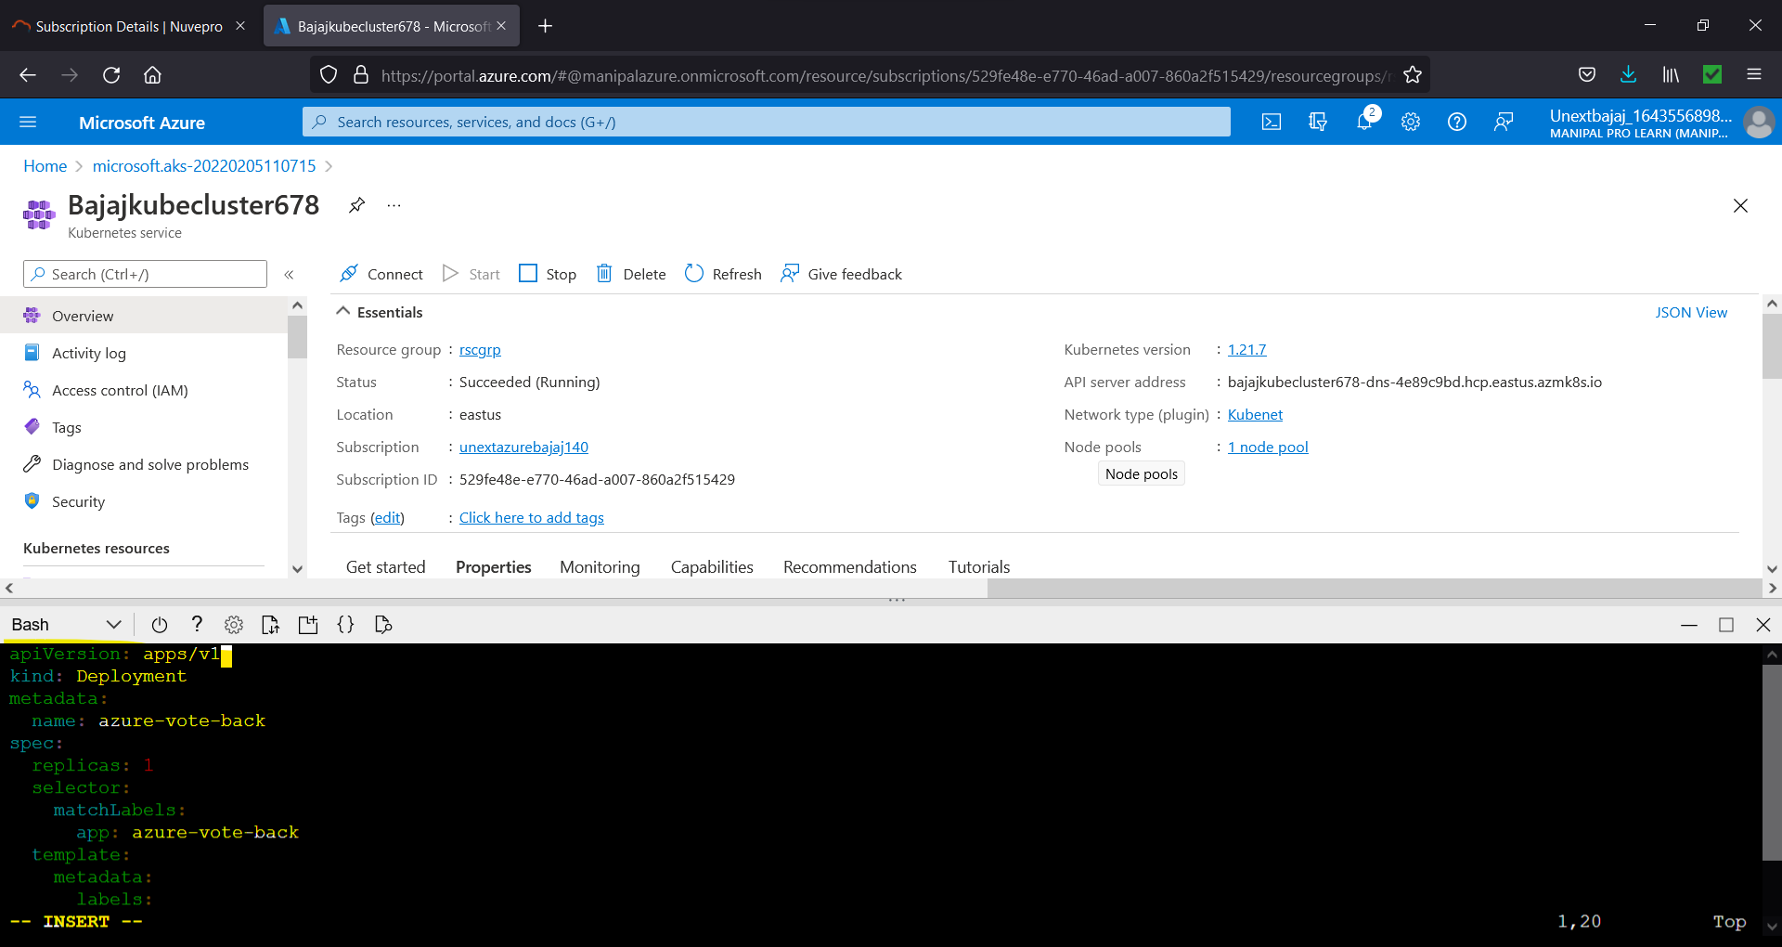

Figure 3.12. Put the code in the file (Press “i” to enter into insert mode and “esc + : + wq” to save and exit).

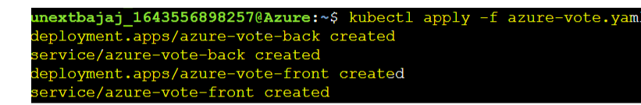

Figure 3.13. Next, we need to deploy the application (kubectl apply -f <filename>). Different containers will be created. Out of these we need to expose “azure-vote-front” to the frontend i.e., the Internet.



Figure 3.14. Exposing the application to the internet (--watch is used so that we can see what is happening in the frontend). The service would be available on the mentioned External IP address.

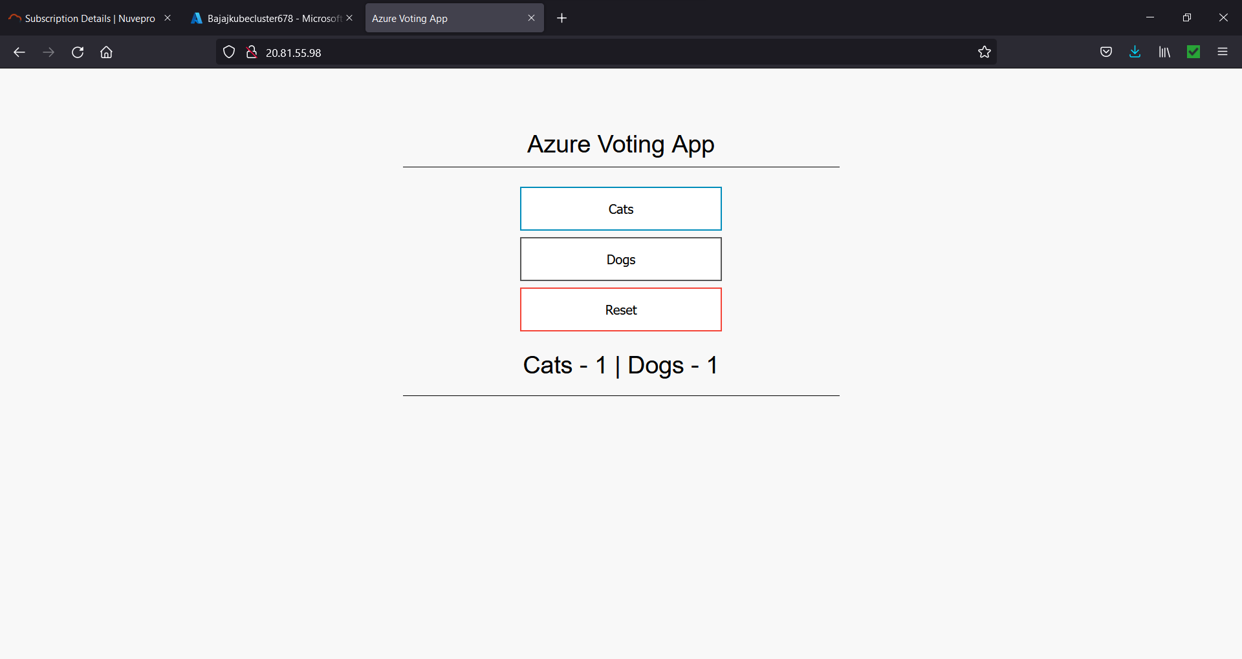

Figure 3.15. Application Preview

1. **In Azure, please create Windows Server 2019 Datacenter VM & connect the VM with RDP & explain all steps with screenshots.**



Figure 4.1. Select Virtual Machine.



Figure 4.2. Select “Create” and then “Virtual Machine”.

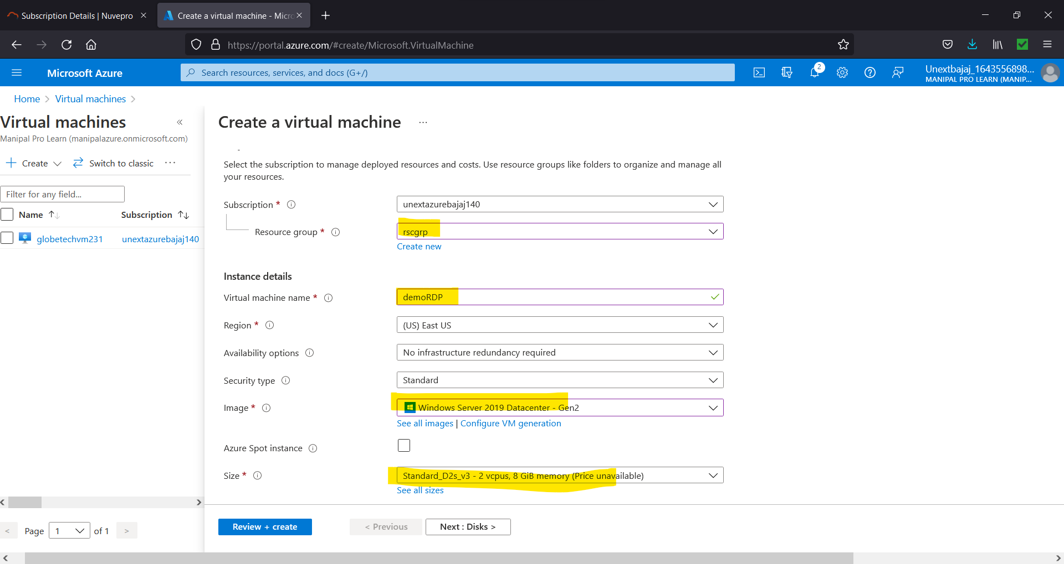

Figure 4.3. Give resource group name, VM name, select the image and size.

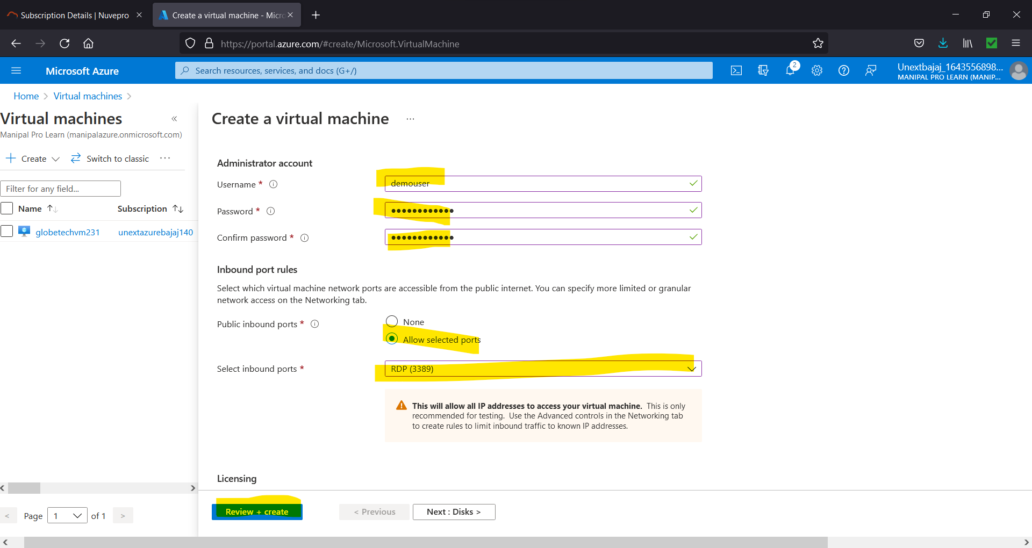

Figure 4.4. Choose Settings and click “Review + create”

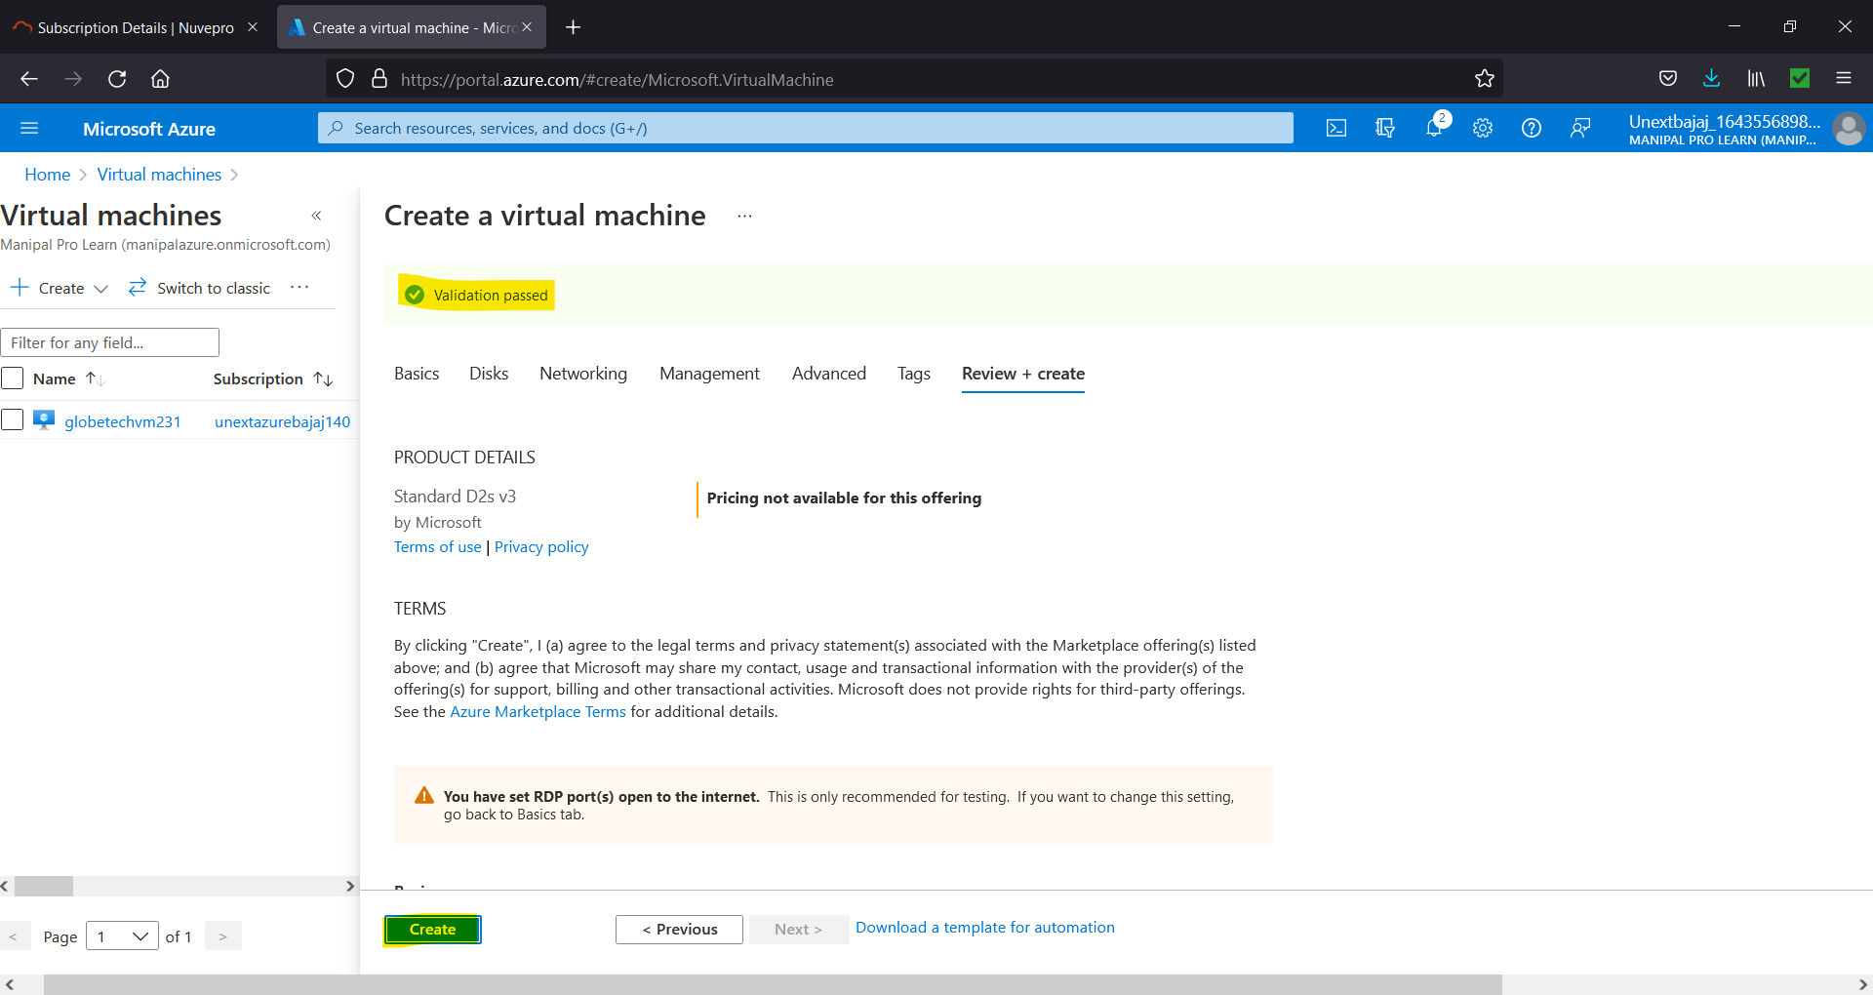

Figure 4.5. Review the settings and change anything if required else if validation has passed click on “Create”.

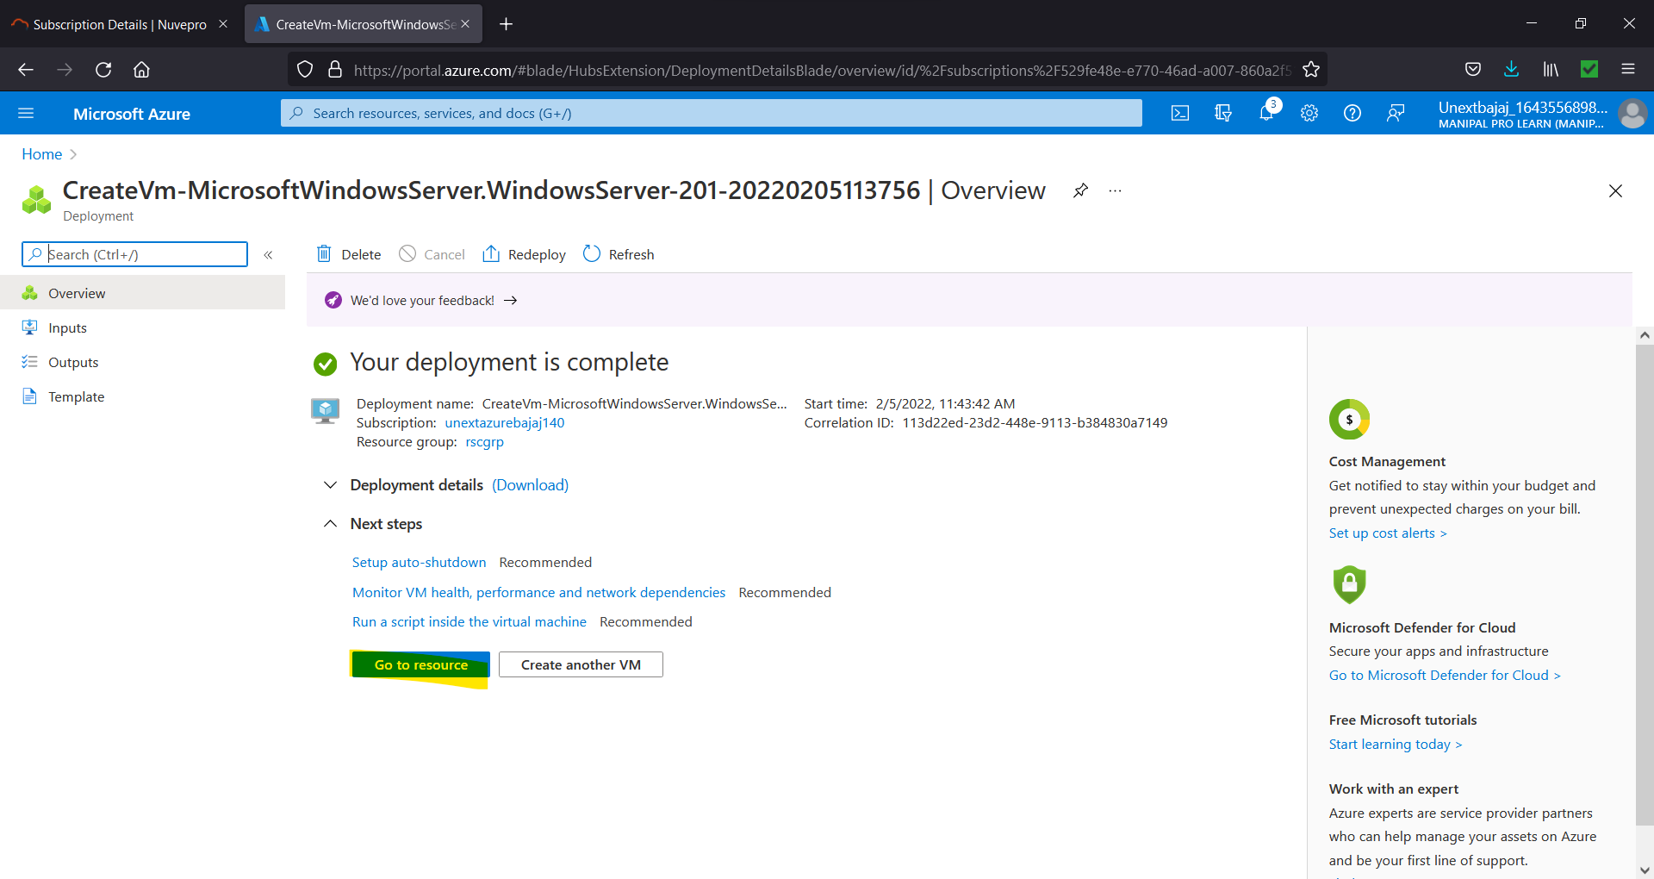

Figure 4.6. Click on “Go to resource”.

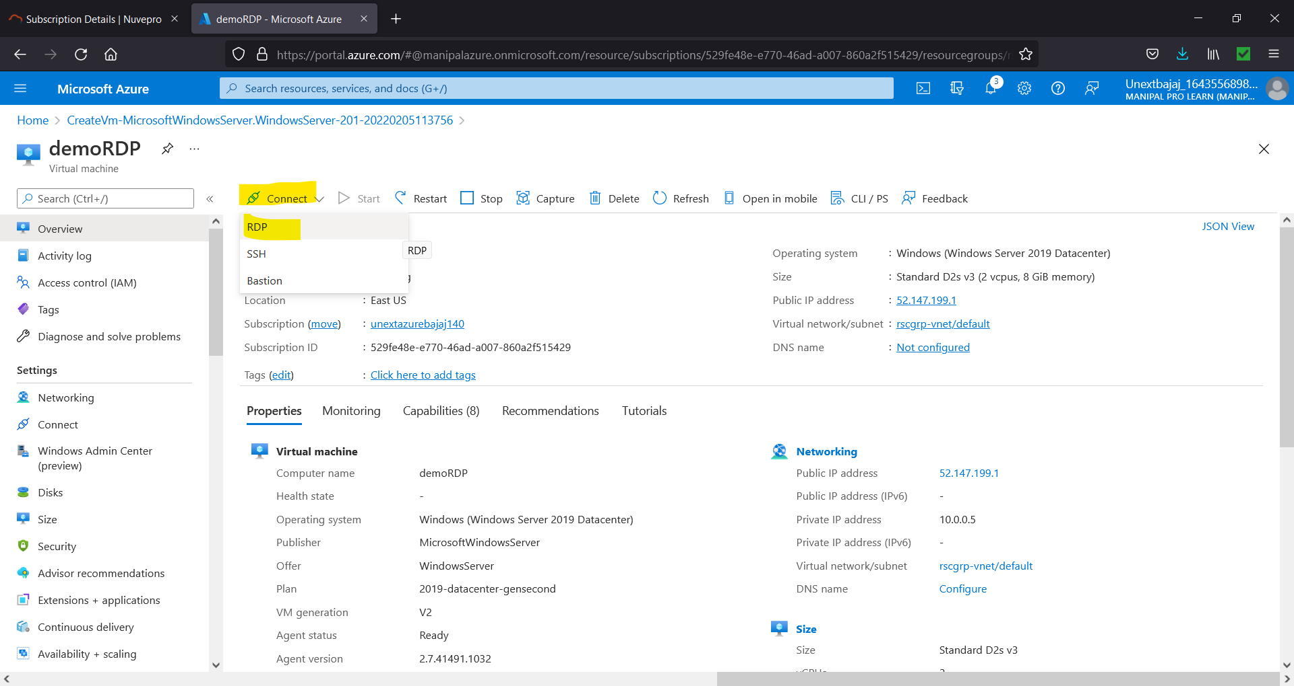

Figure 4.7. Select 🡪 RDP

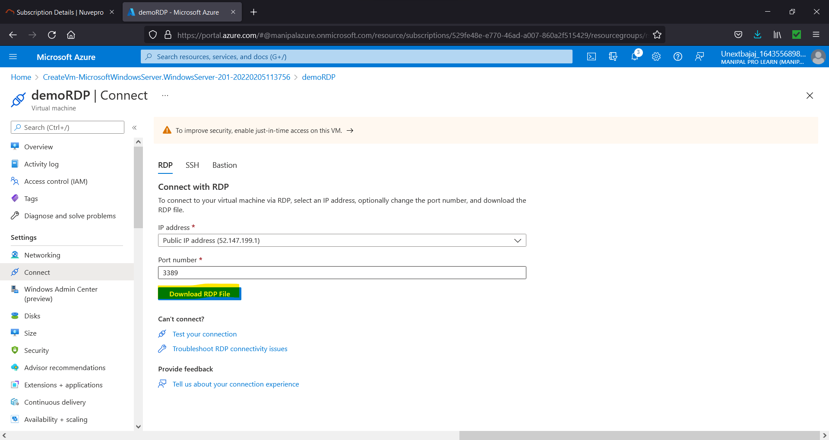

Figure 4.8. Download RDP File

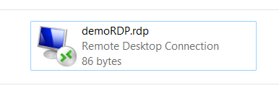

Figure 4.9. Double Click the downloaded file.

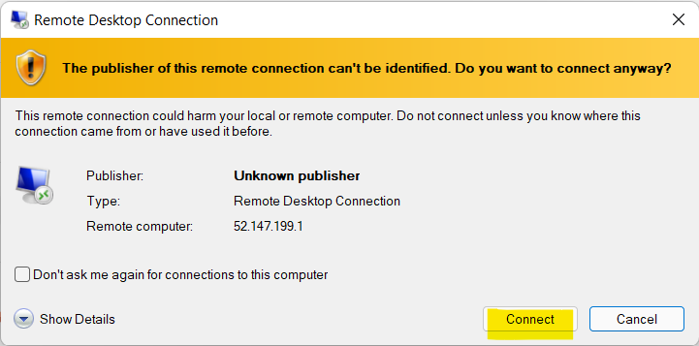

Figure 4.10. Select “Connect”.

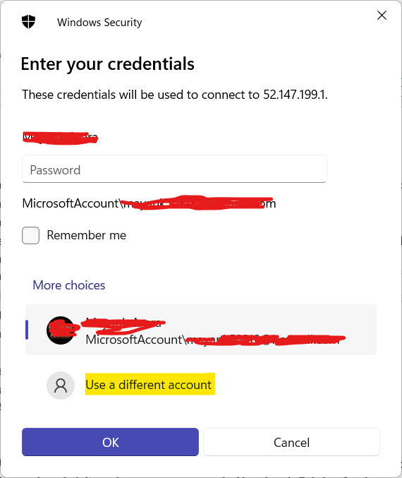

Figure 4.11. Select “Use a different account”.

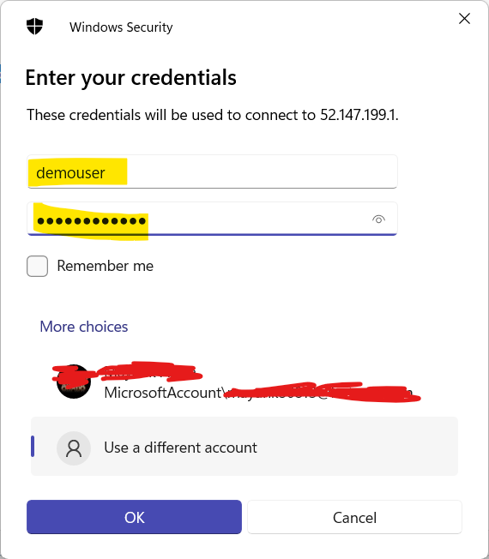

Figure 4.12. Give the username and password that you gave in Figure 4.4.

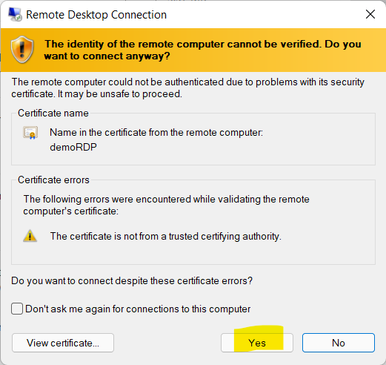

Figure 4.13. Select “Yes”.

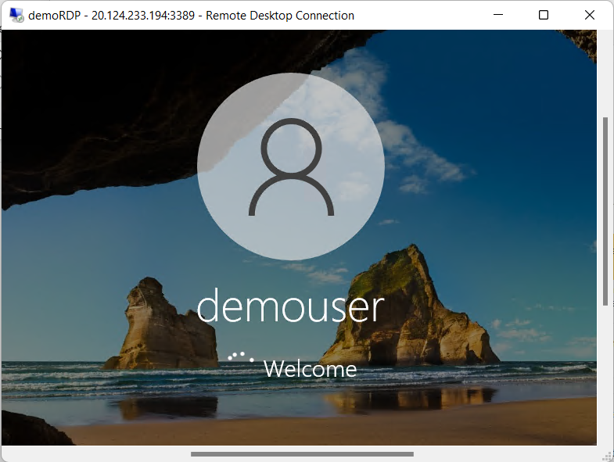

Figure 4.14. You are in you Virtual Machine.

1. **Explain various cloud Service & deployment models with block diagrams & examples?**
   1. Cloud Services Models: -
      1. Infrastructure as a Service: -
         1. It provides virtualized computing resources over the internet.
         2. No worries about the underlying physical machine.
         3. Abstract the user from physical machine.
      2. Platform as a Service: -
         1. No control over the underlying architecture including OS, storage, servers etc.
         2. The cloud provider gives the ability to the customer to deploy customer created apps using programming languages, tools etc. that are provided by the cloud provider.
      3. Software as a Service: -
         1. Cloud provider leases applications or software which are owned by them to its client.
         2. Example: salesforce.com provides the CRM (Customer Relation Manager) on a cloud infrastructure to its client and charges them for it, but the software is owned by the salesforce company only.

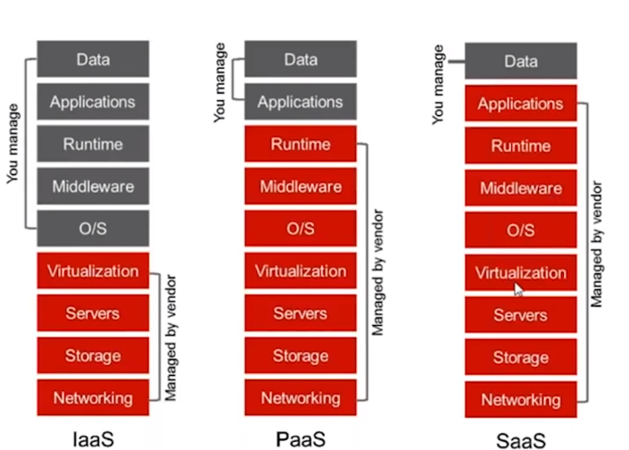

* 1. Deployment Models: -
     1. Public Cloud: -
        1. A service provider makes resources such as applications and storage available to the public over the internet.
        2. Easy and inexpensive setup because hardware, application and bandwidth costs are covered by the provider.
        3. No wasted resources because you pay for what you use.
        4. Example: Google Drive, Dropbox, Gmail etc.

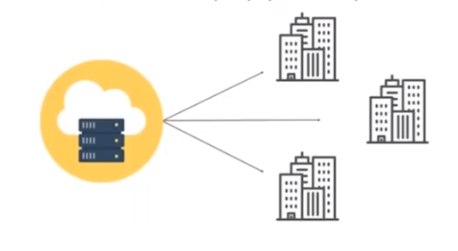

* + 1. Private Cloud: -
       1. Offers hosted services to a limited number of people behind firewall, so it minimizes the security concerns.
       2. Private cloud gives companies direct control over their data.
       3. Example: A company’s cloud protected by firewall like HP Data Centre.

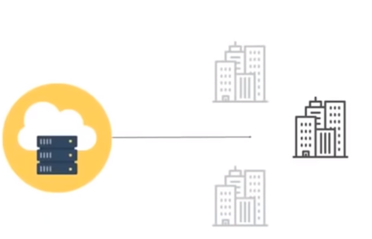

* + 1. Hybrid Cloud: -
       1. A cloud computing environment which uses a mix of on premises private cloud and third party, public cloud services.
       2. It helps you leverage the best of both worlds.
       3. Example: GitHub.

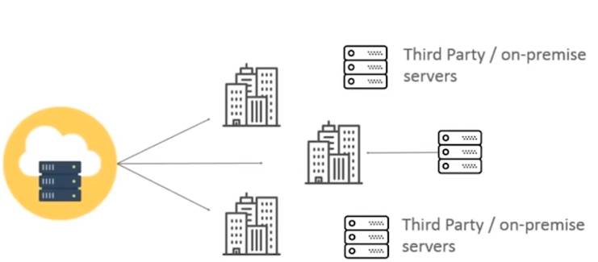

1. **Explain what is cloud security & how virtualization is achieved with block diagram?**

Cloud security is a discipline of cyber security dedicated to securing cloud computing systems. This includes keeping data private and safe across online-based infrastructure, applications, and platforms. Securing these systems involves the efforts of cloud providers and the clients that use them, whether an individual, small to medium business, or enterprise uses.

Cloud providers host services on their servers through always-on internet connections. Since their business relies on customer trust, cloud security methods are used to keep client data private and safely stored. However, cloud security also partially rests in the client’s hands as well. Understanding both facets is pivotal to a healthy cloud security solution.

Virtualization plays a very important role in the cloud computing technology, normally in the cloud computing, users share the data present in the clouds like application etc, but with the help of virtualization users shares the infrastructure.

The main usage of Virtualization Technology is to provide the applications with the standard versions to their cloud users, suppose if the next version of that application is released, then cloud provider must provide the latest version to their cloud users and practically it is possible because it is more expensive.

To overcome this problem, we use basically virtualization technology, By using virtualization, all severs and the software application which are required by other cloud providers are maintained by the third party people, and the cloud providers has to pay the money on monthly or annual basis.

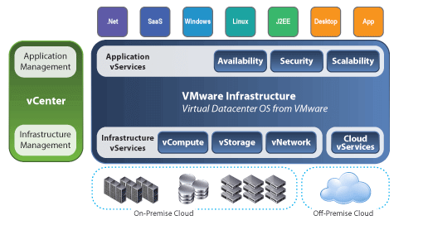

1. **In azure, please create Azure Blob & upload sample CSV, Excel, TXT files in it & explain all steps with screenshots?**

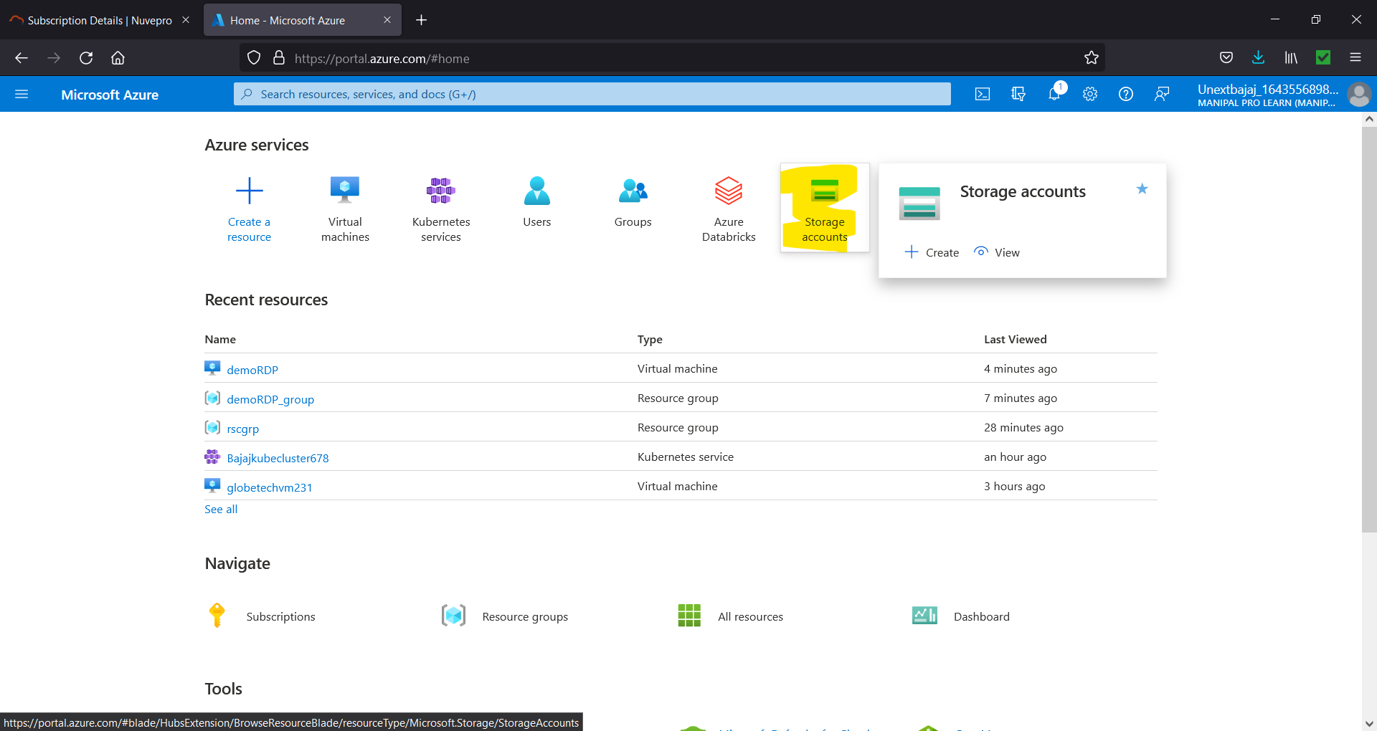

Figure 7.1. To create a Blob Storage, first we need a Storage Account

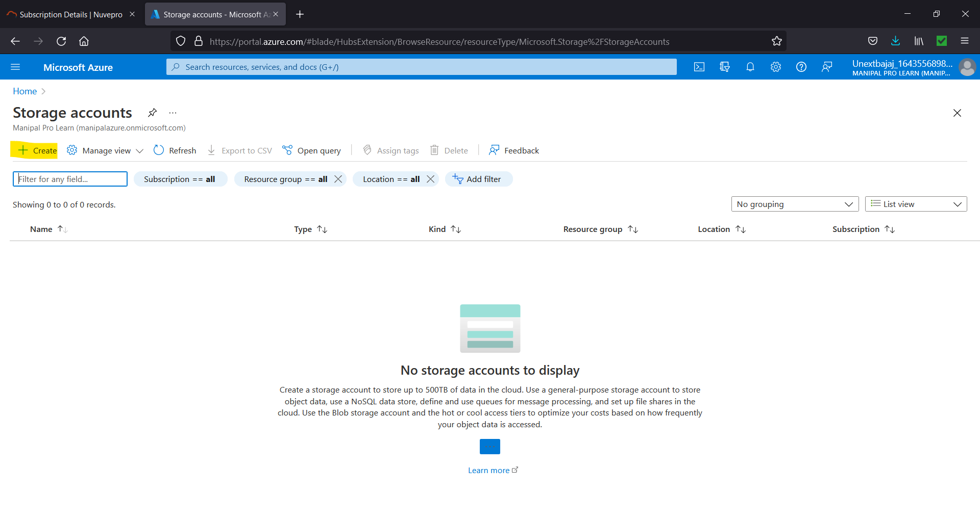

Figure 7.2 Select “Create”

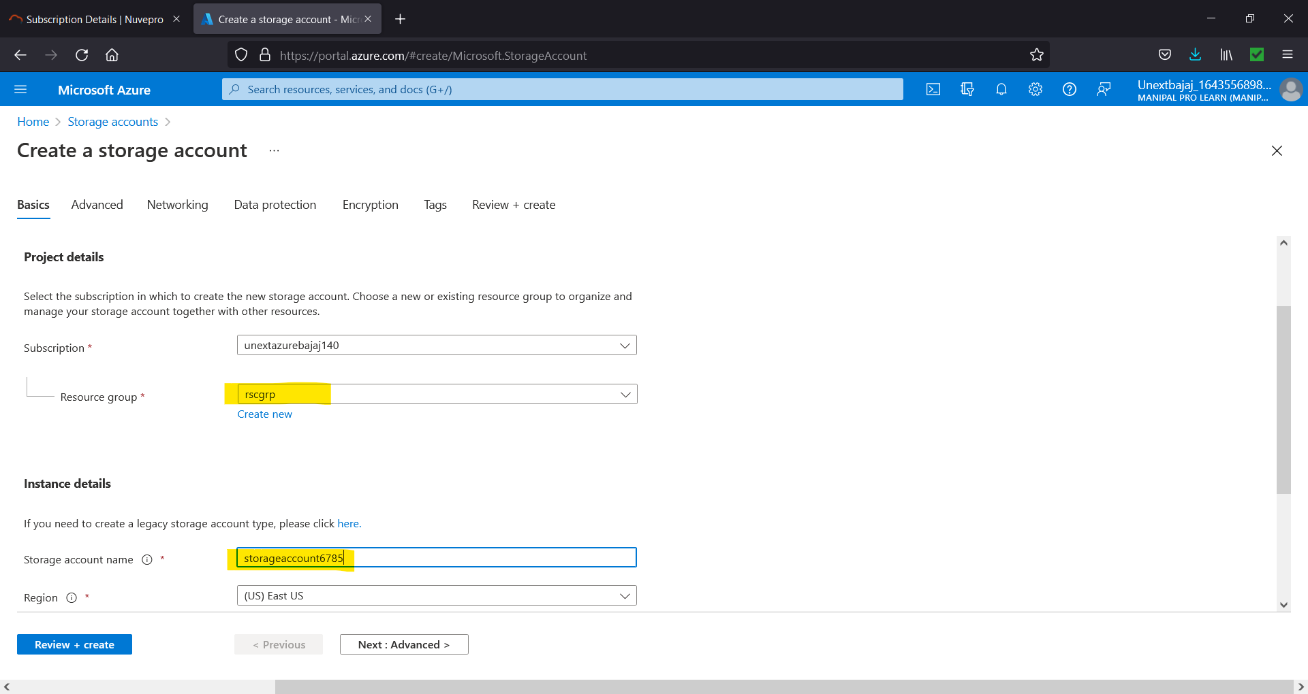

Figure 7.3. Give resource group and unique storage account name.

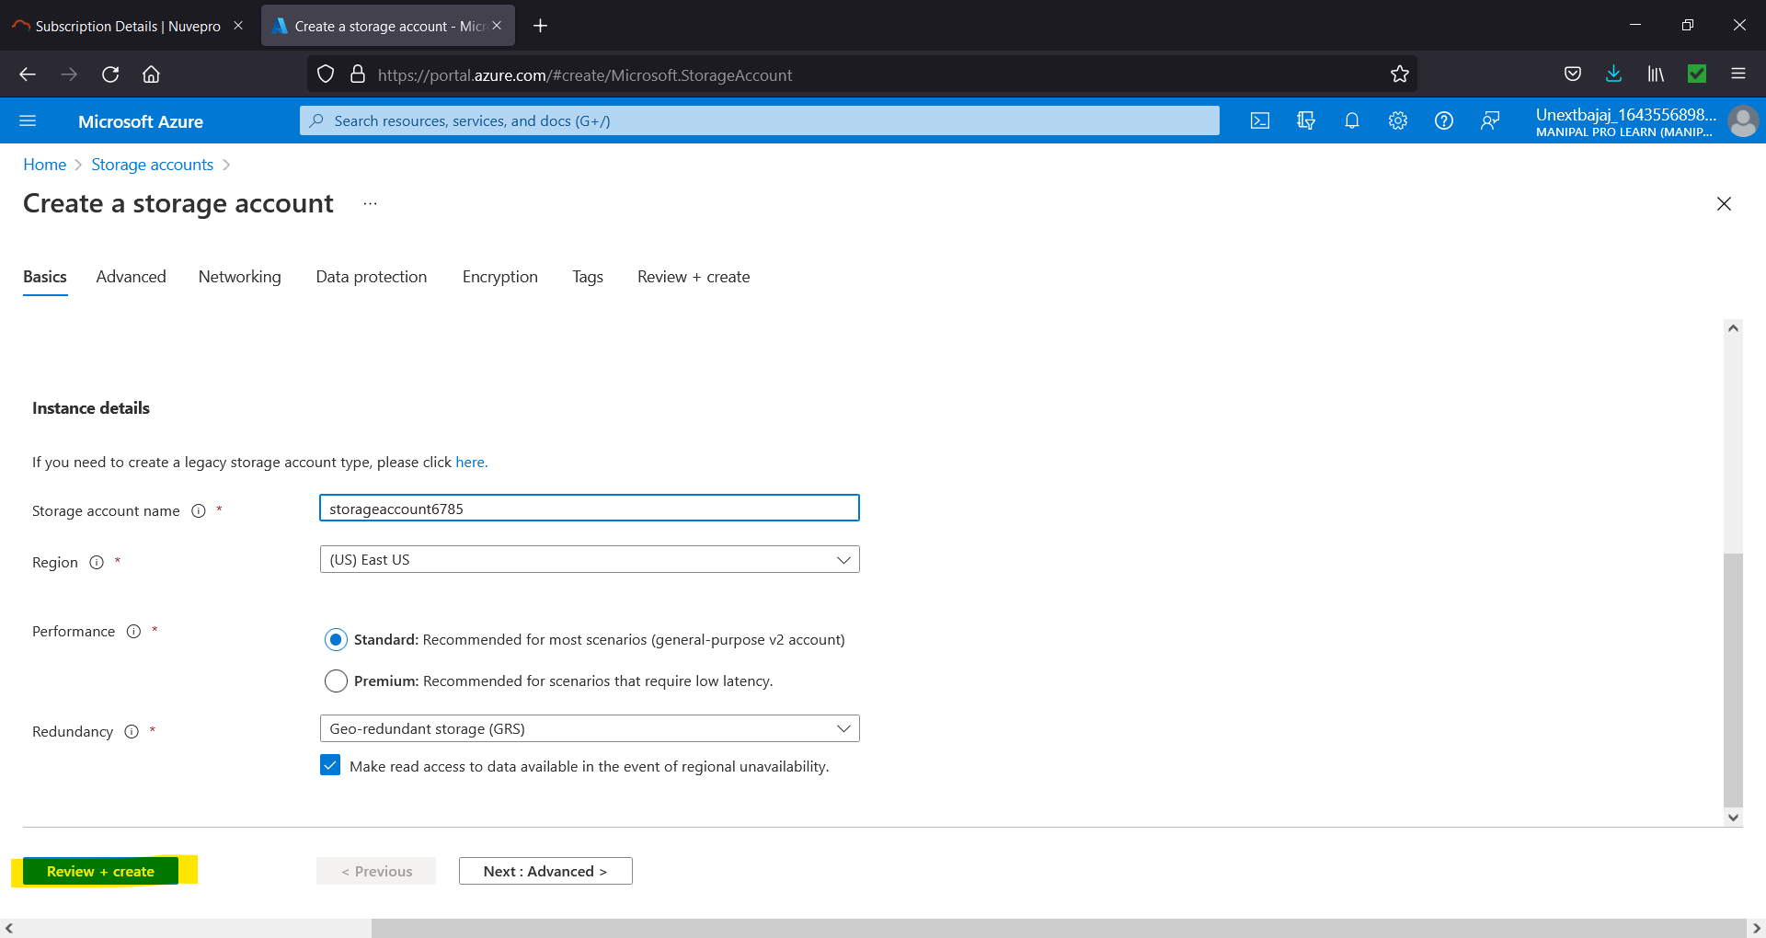

Figure 7.4. Choose other settings and click “Review + create”

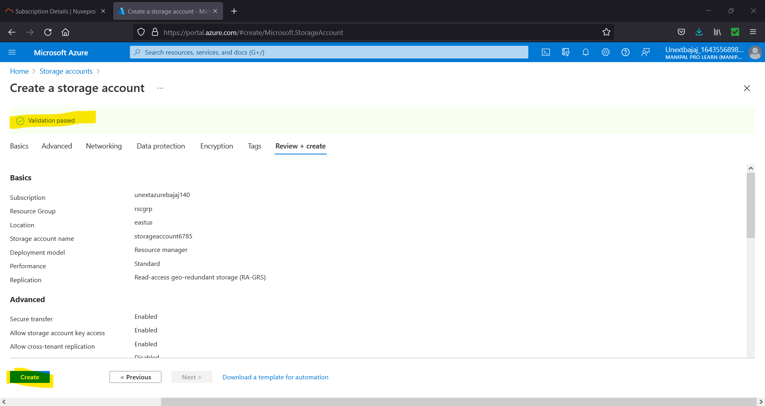

Figure 7.5. Review the settings and change anything if required else if validation has passed click on “Create”.

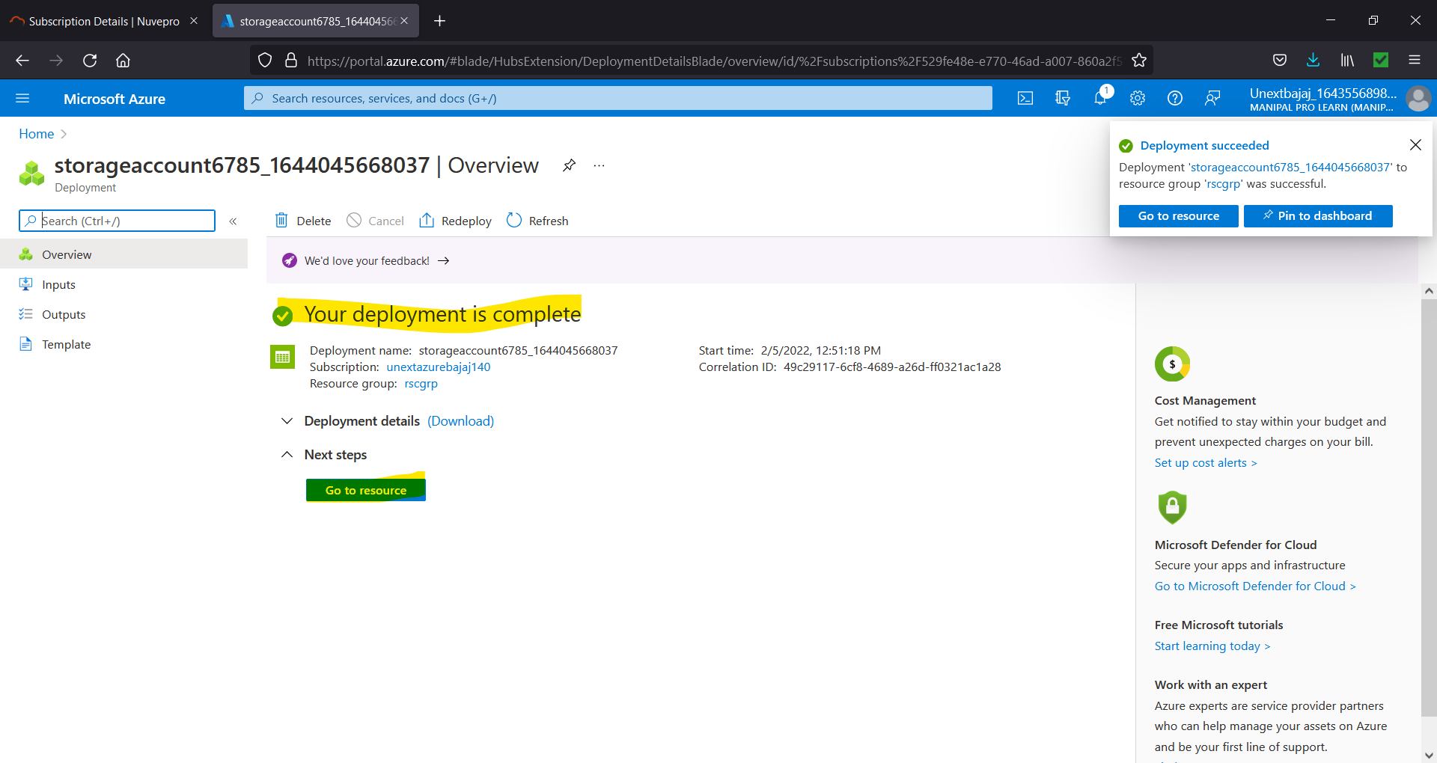

Figure 7.6. Click on “Go to resource”.

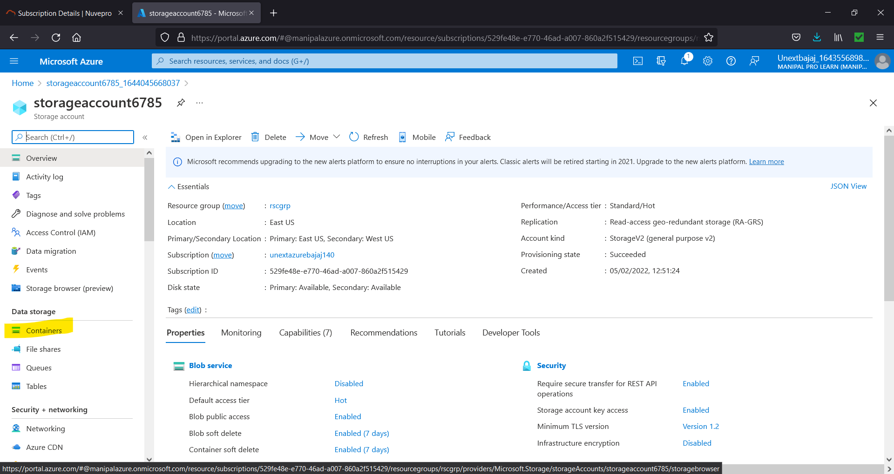

Figure 7.7. To create Blob Storage, click on “Containers”.

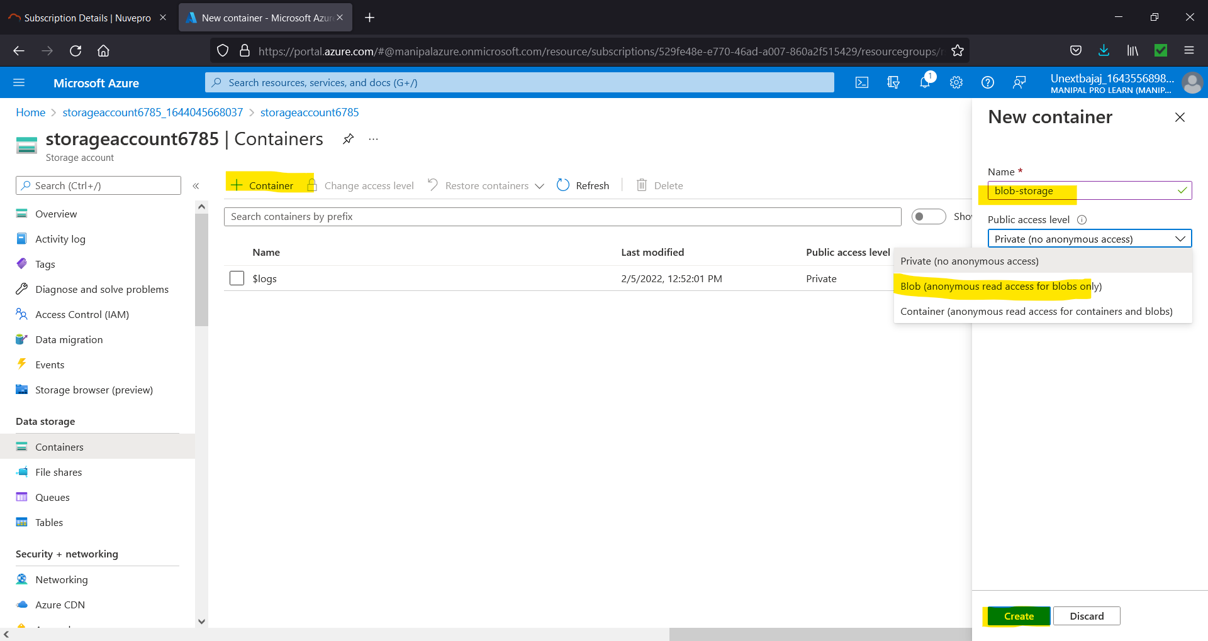

Figure 7.8. Click on “+ Container”, give the name and select “Blob” and click on “Create”.

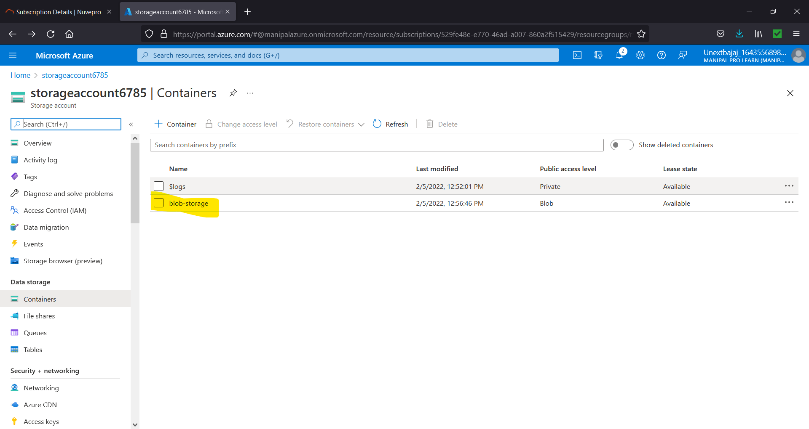

Figure 7.9. To upload anything first select the blob in which you want to upload

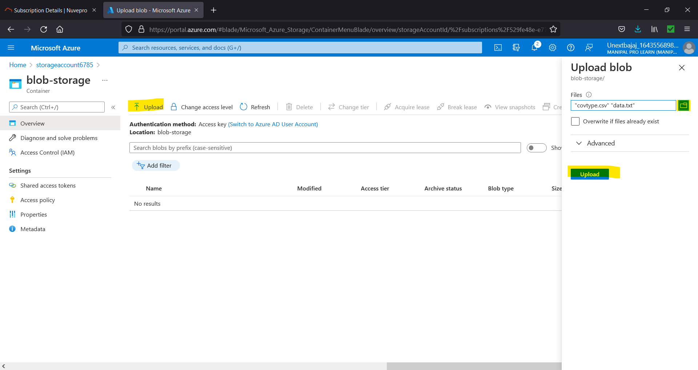

Figure 7.10. Select “Upload” and select the files by clicking on the folder icon and then click the “Upload” button.

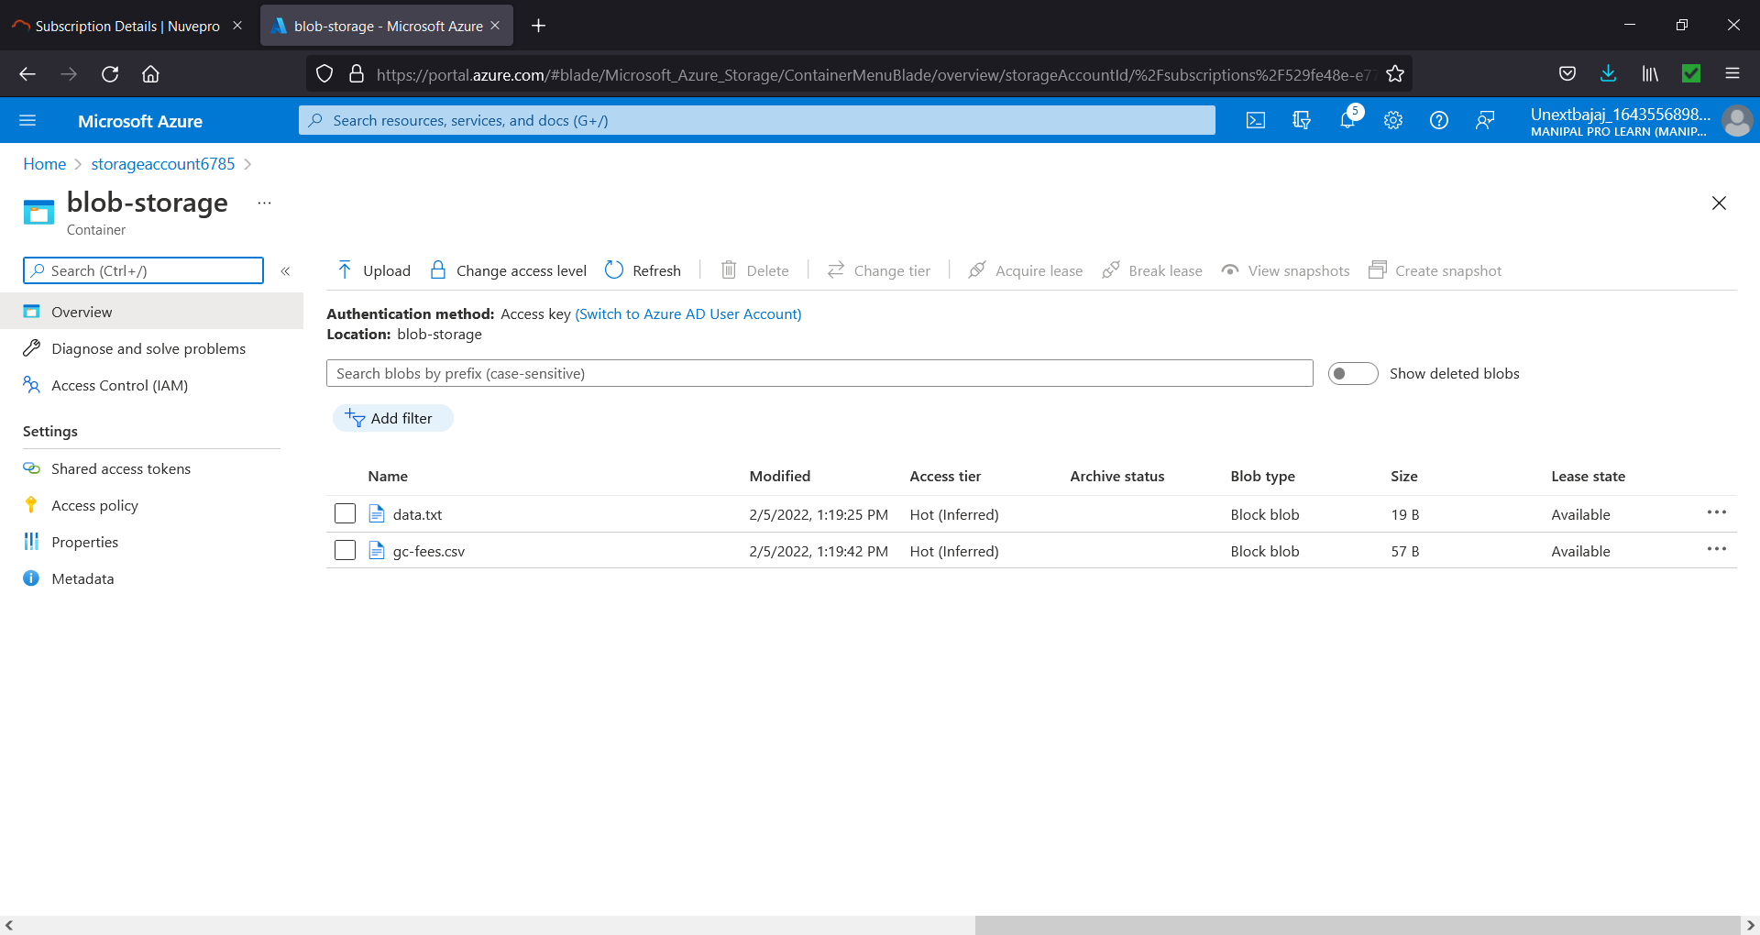

Figure 7.11. The files will be uploaded.

1. **In Azure, please create Azure Data factory, create source & destination storage blobs, - try to copy a few files from Source blob to destination blob using Azure Data factory.**

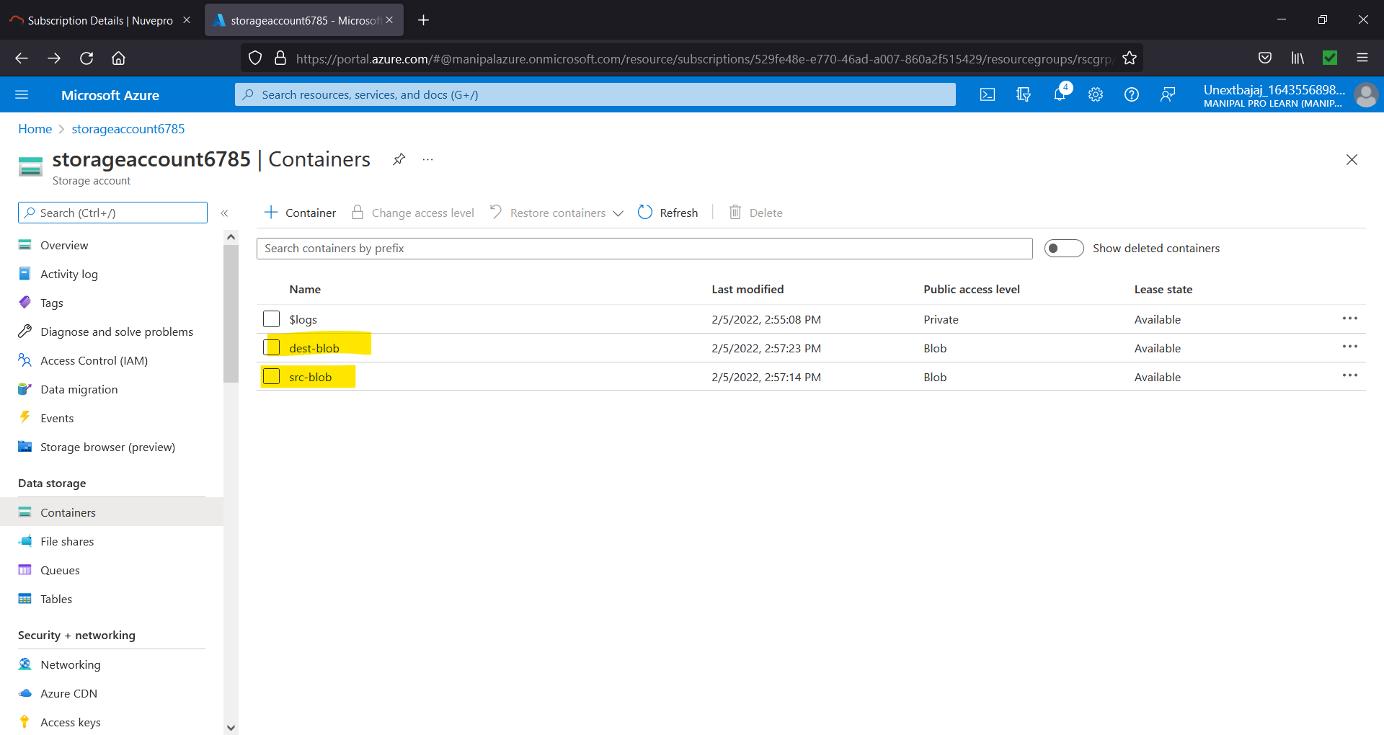

Figure 8.1. Create two blobs so we have a source and destination.

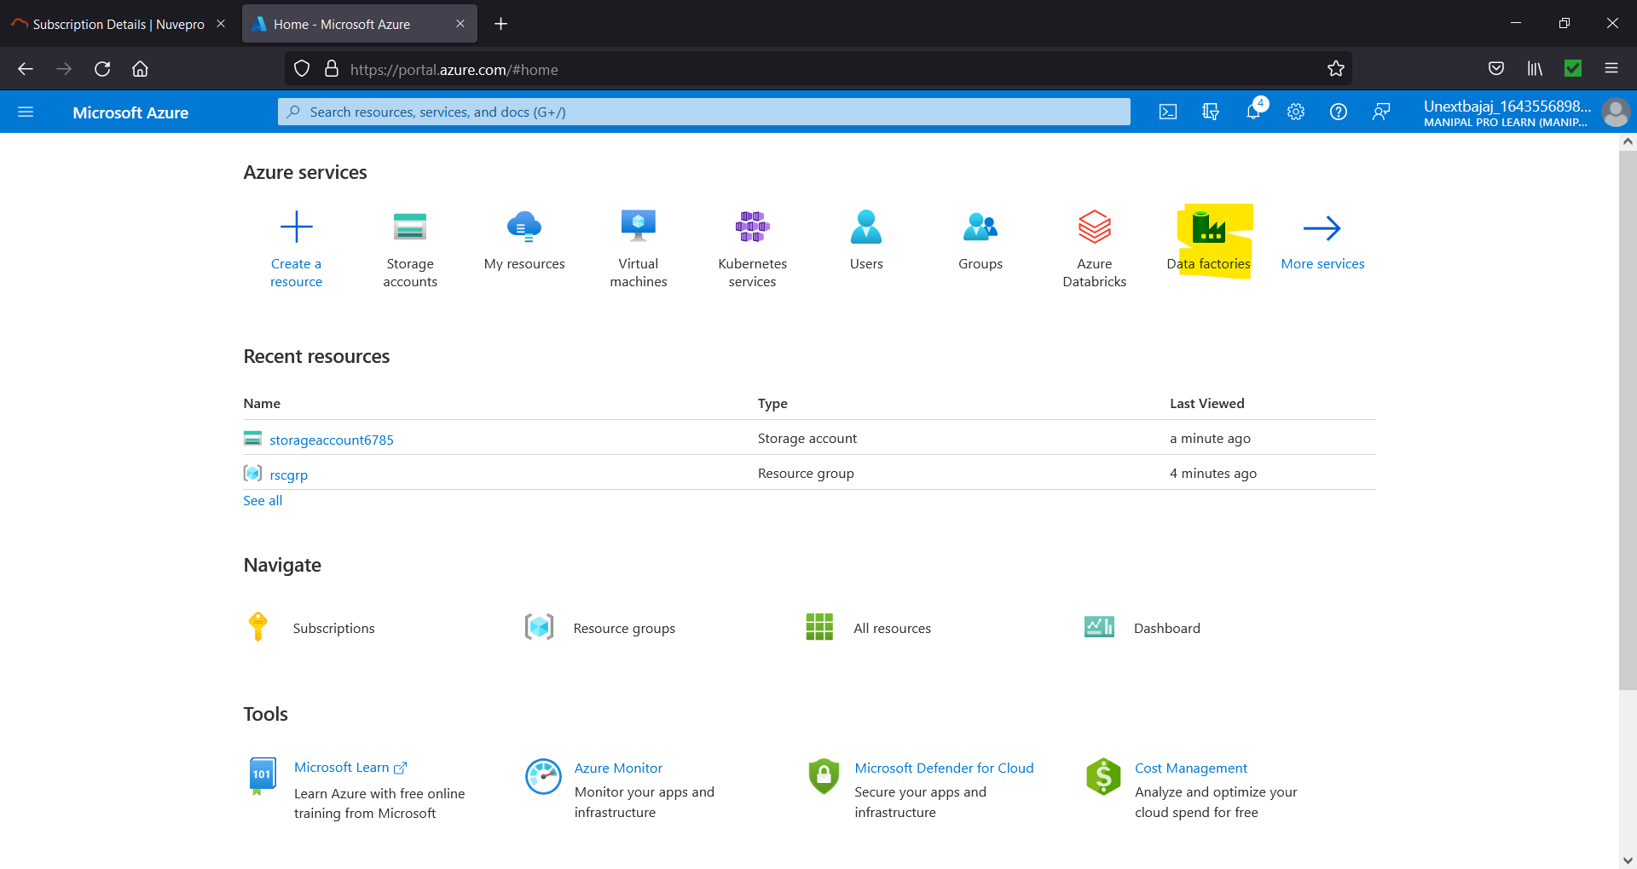

Figure 8.2. Click on Data Factories

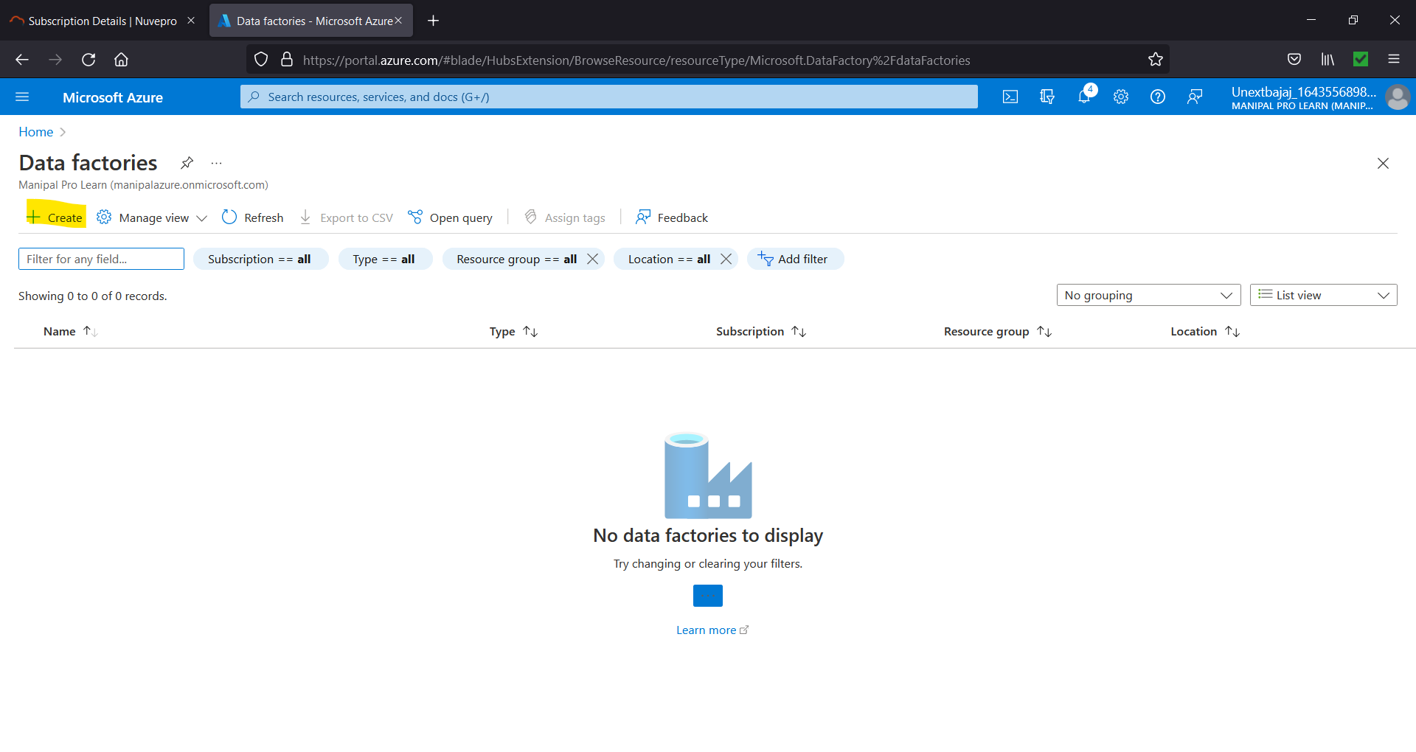

Figure 8.3. Click on Create

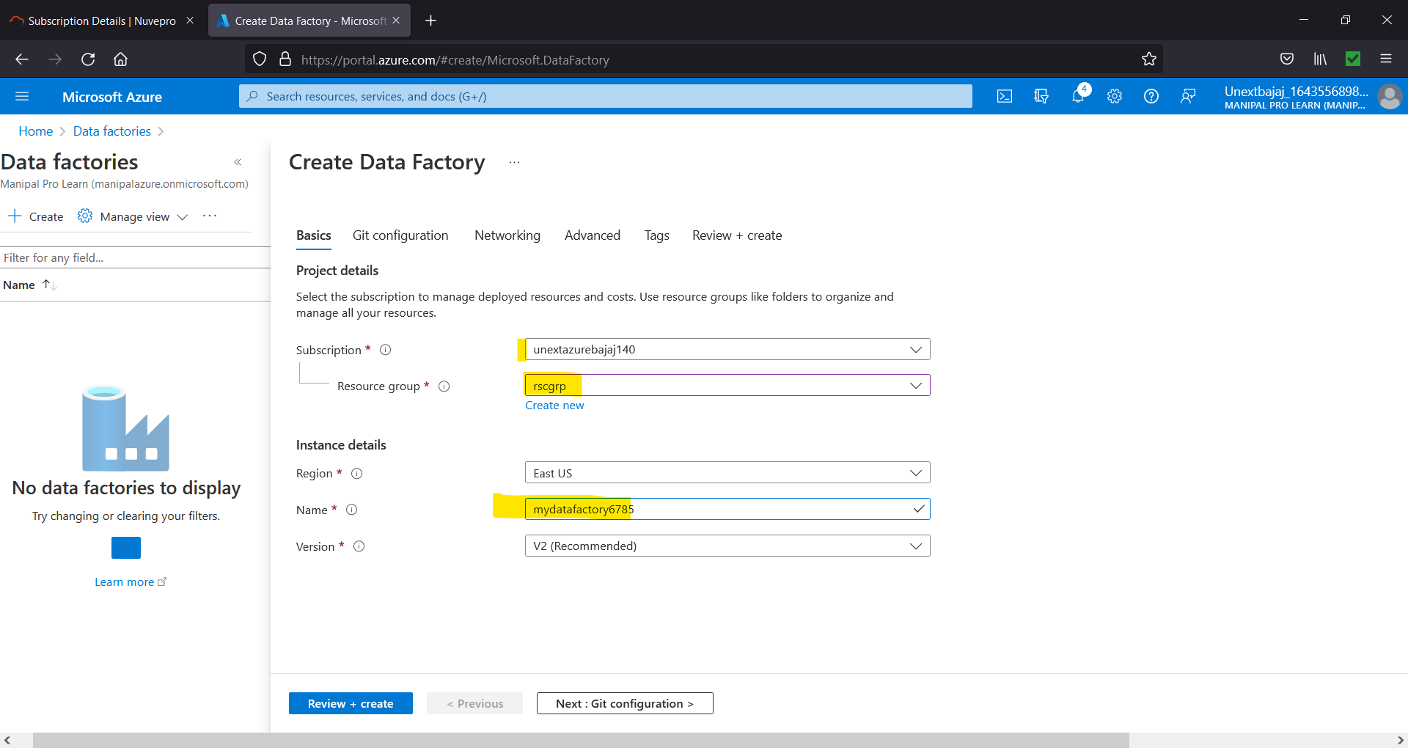

Figure 8.4. Give resource group and unique name

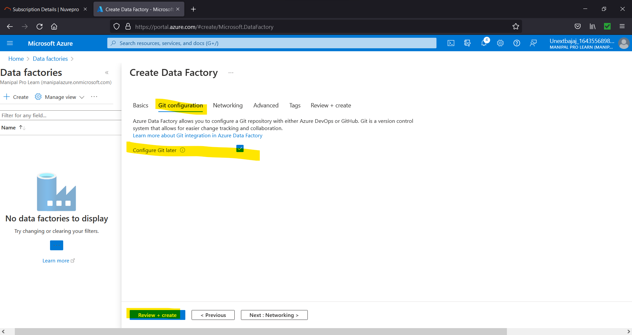

Figure 8.5. Select Configure Git Later

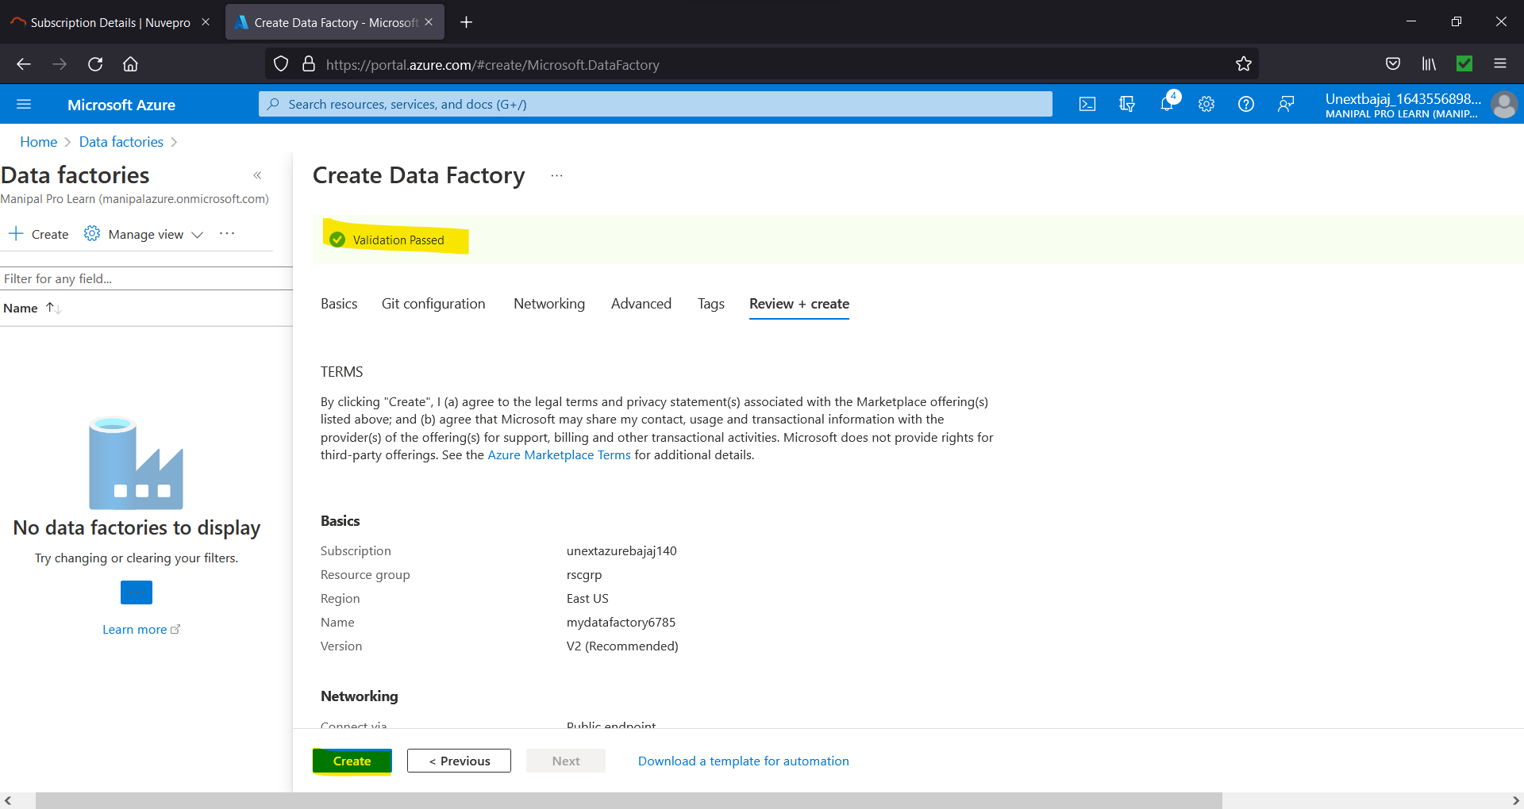

Figure 8.6. Select Create

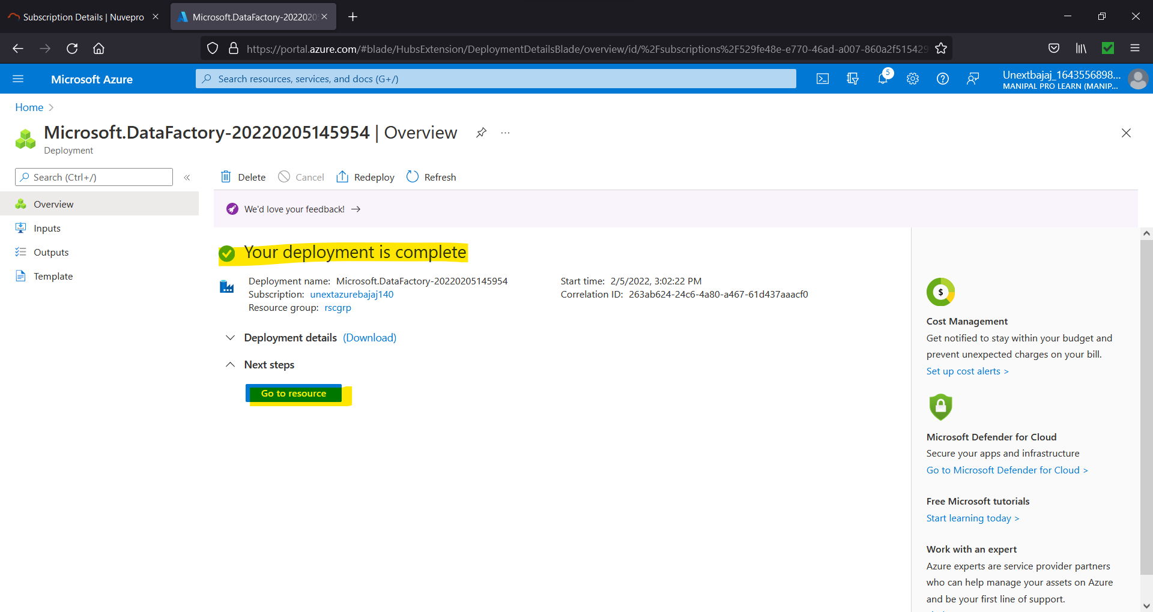

Figure 8.7. Go to Resource

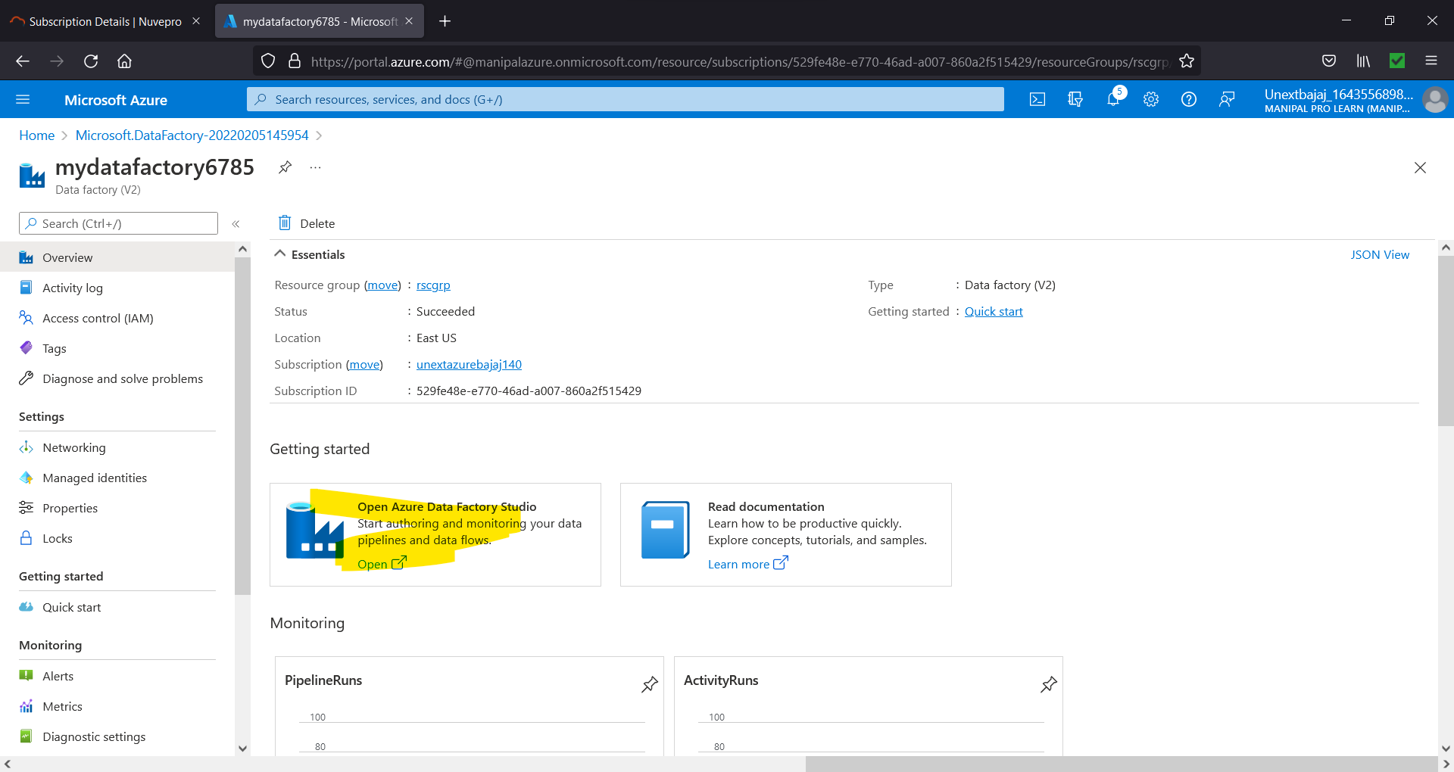

Figure 8.8. Click on this option

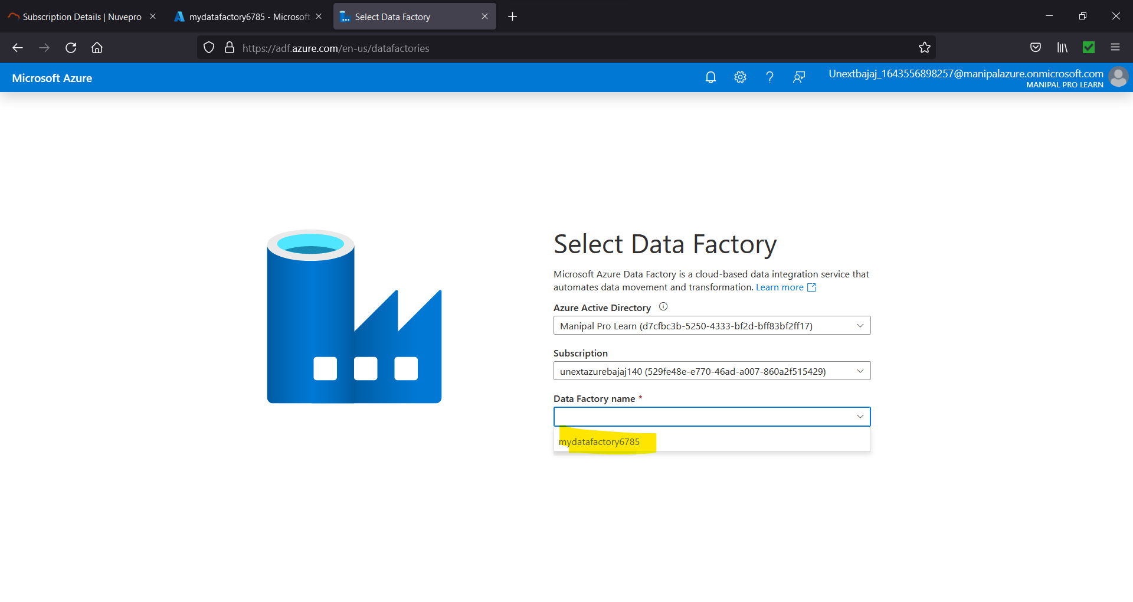

Figure 8.9. Select storage account

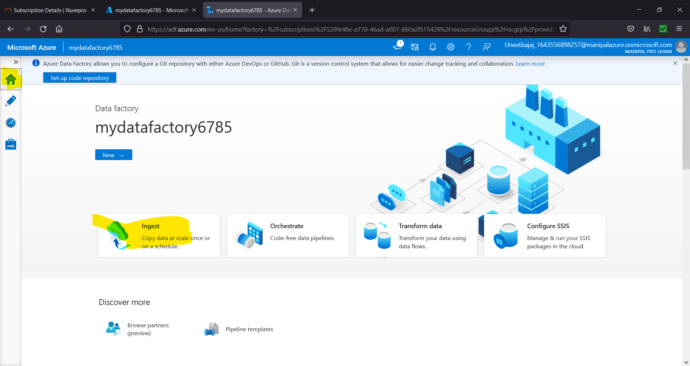

Figure 8.10. Select Ingest

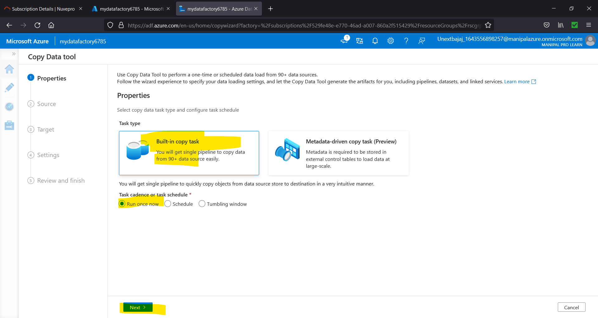

Figure 8.11. Select this option

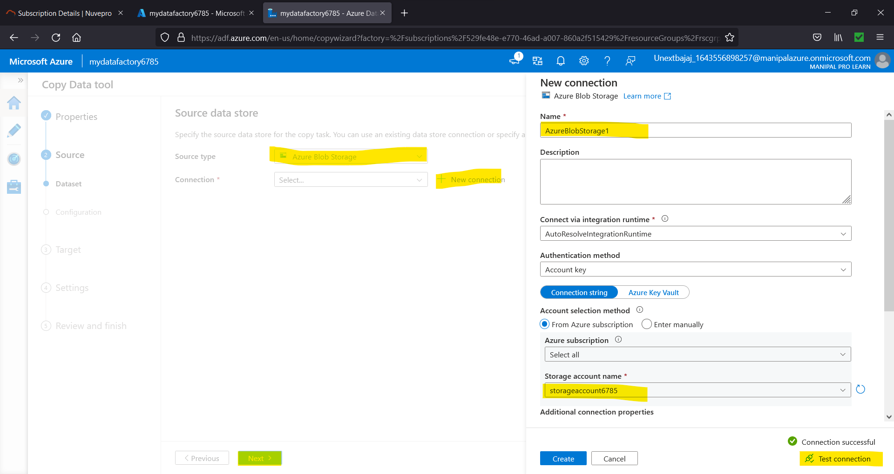

Figure 8.12. Creating connection with source blob

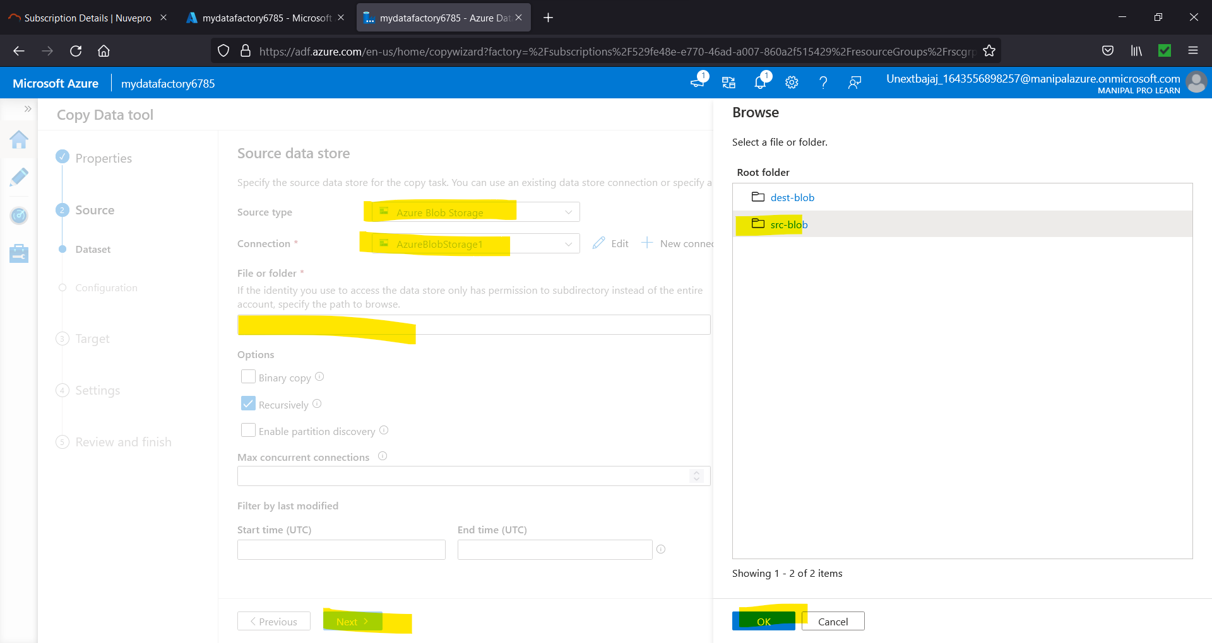

Figure 8.13. Selecting the source blob

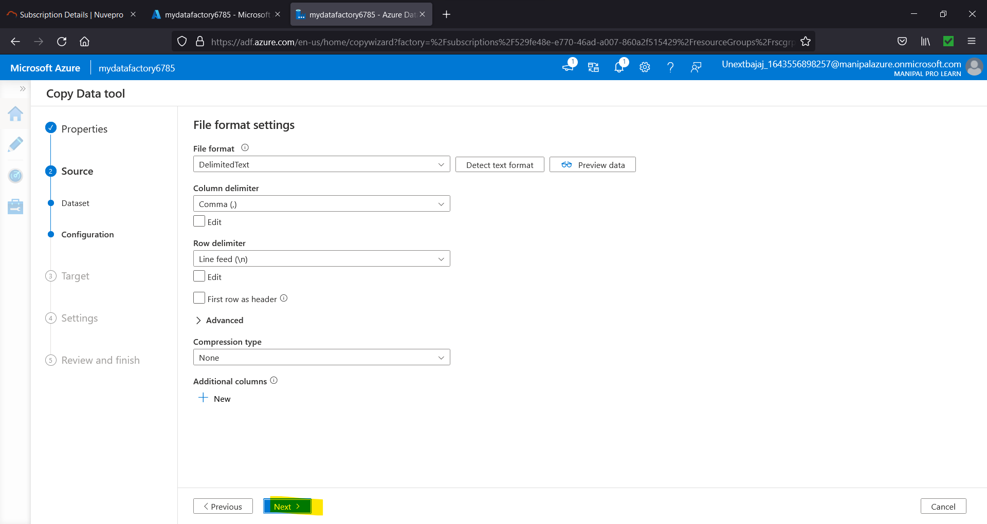

Figure 8.14. Click Next

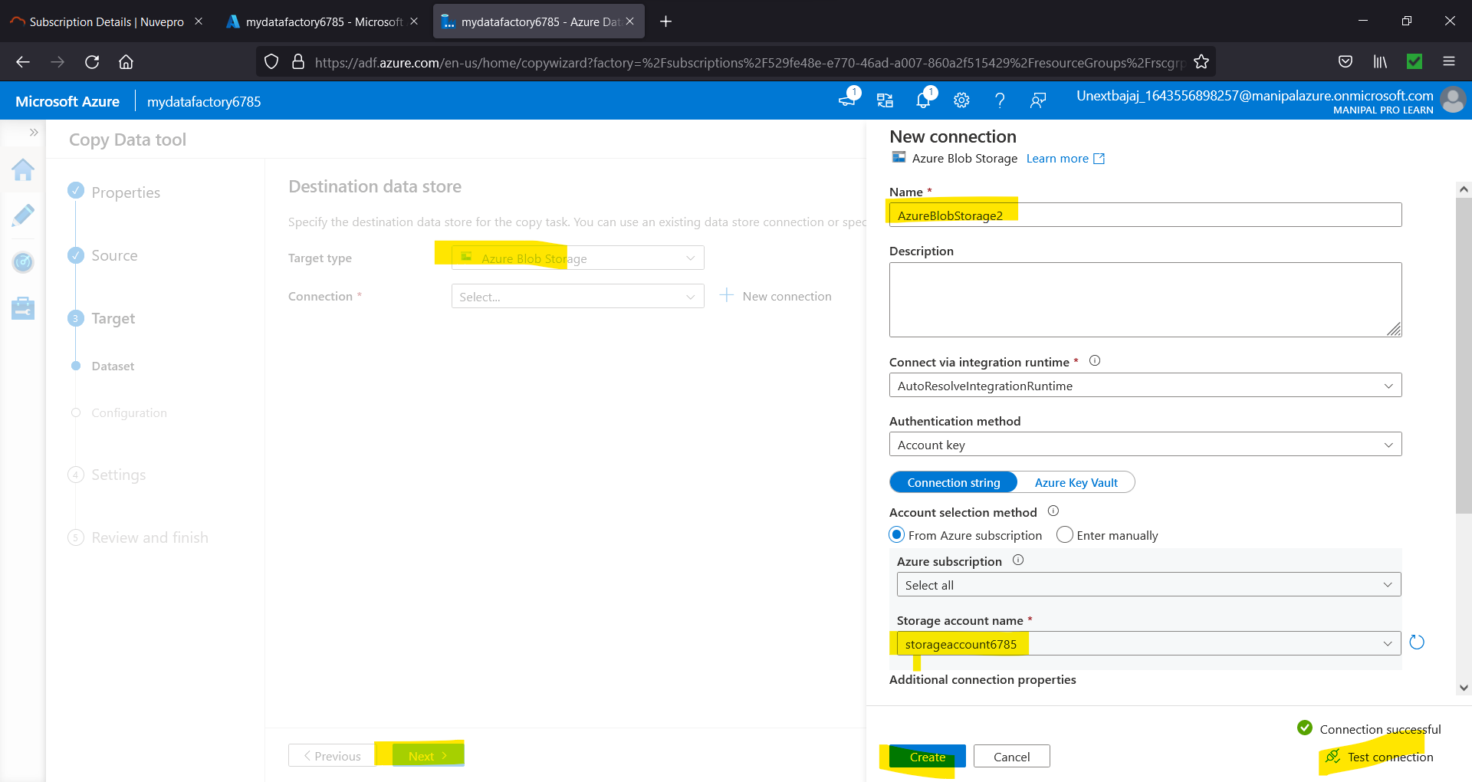

Figure 8.15. Creating connection with destination blob

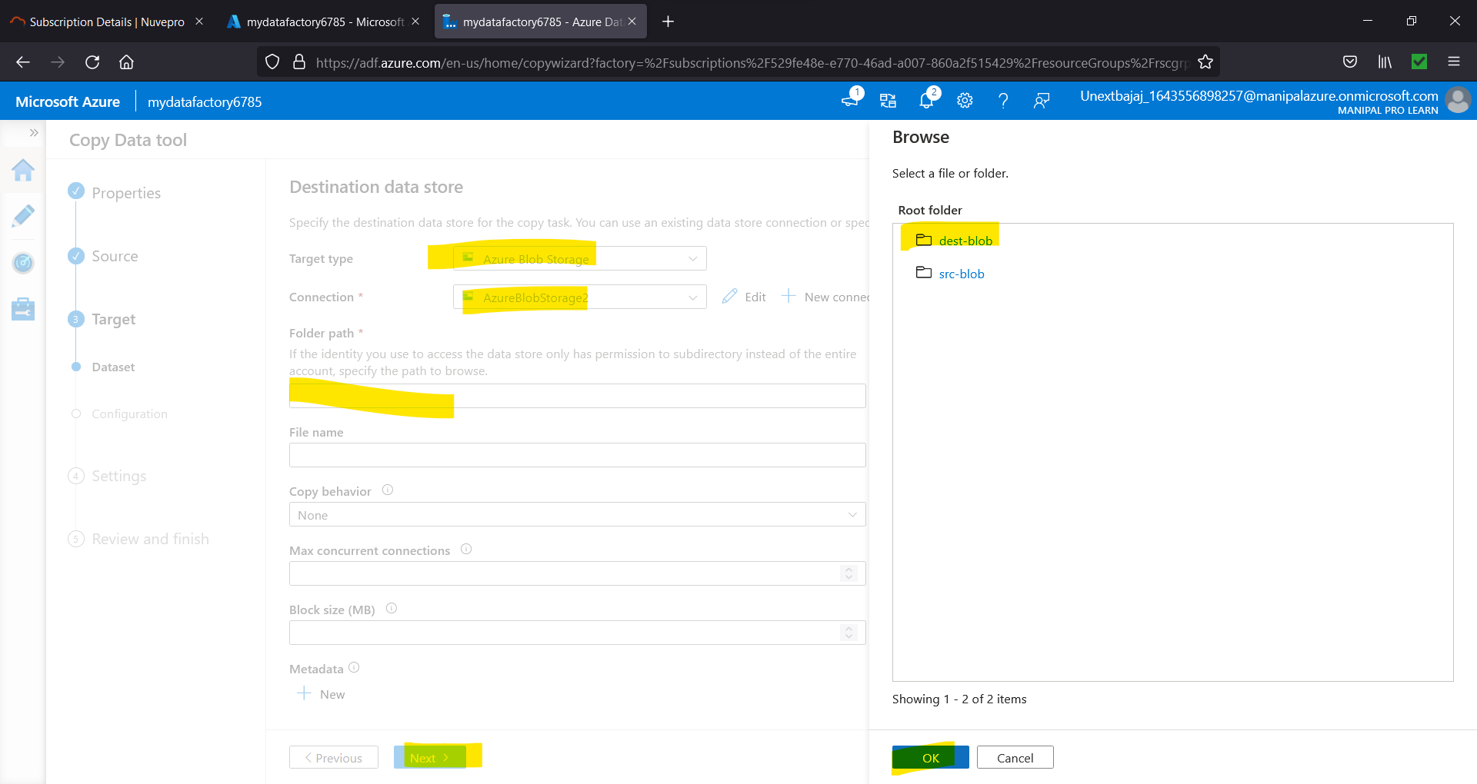

Figure 8.16. Selecting the destination blob

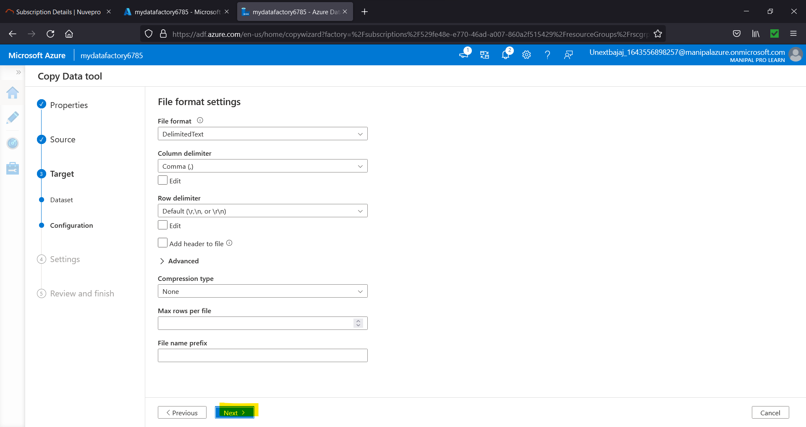

Figure 8.17. Click Next

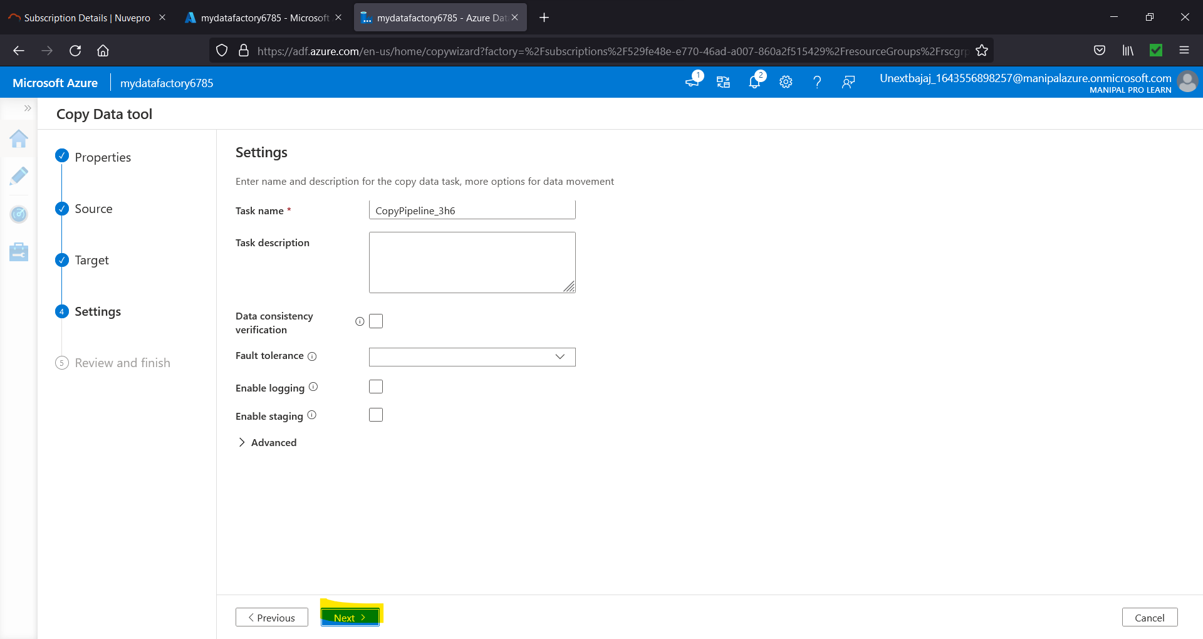

Figure 8.18. Click Next

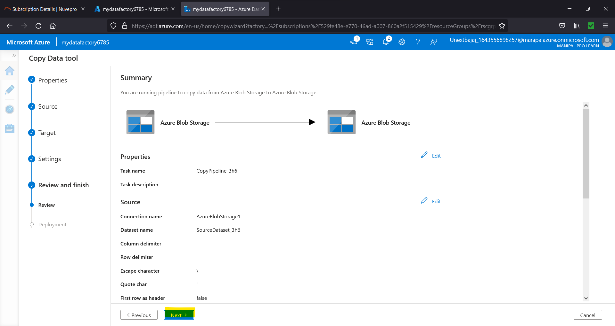

Figure 8.19. Click Next

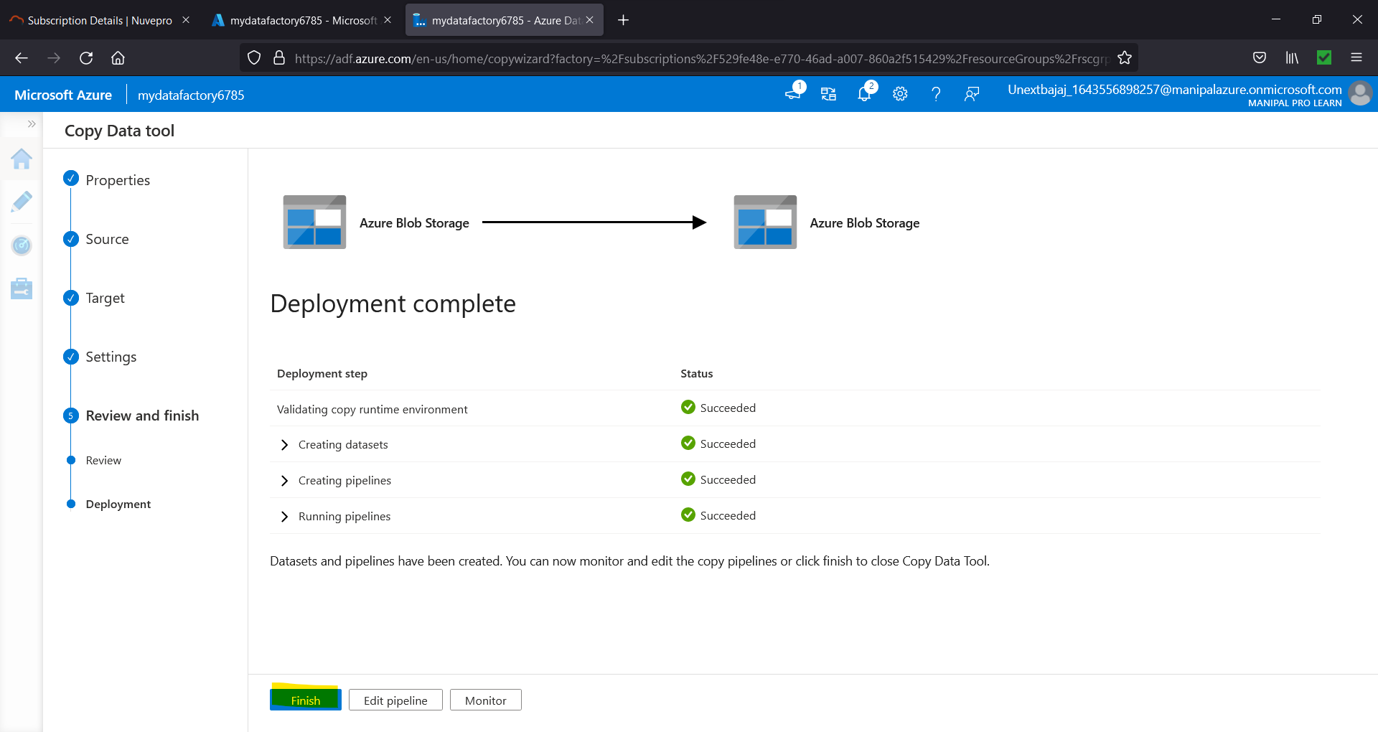

Figure 8.20. Click Next

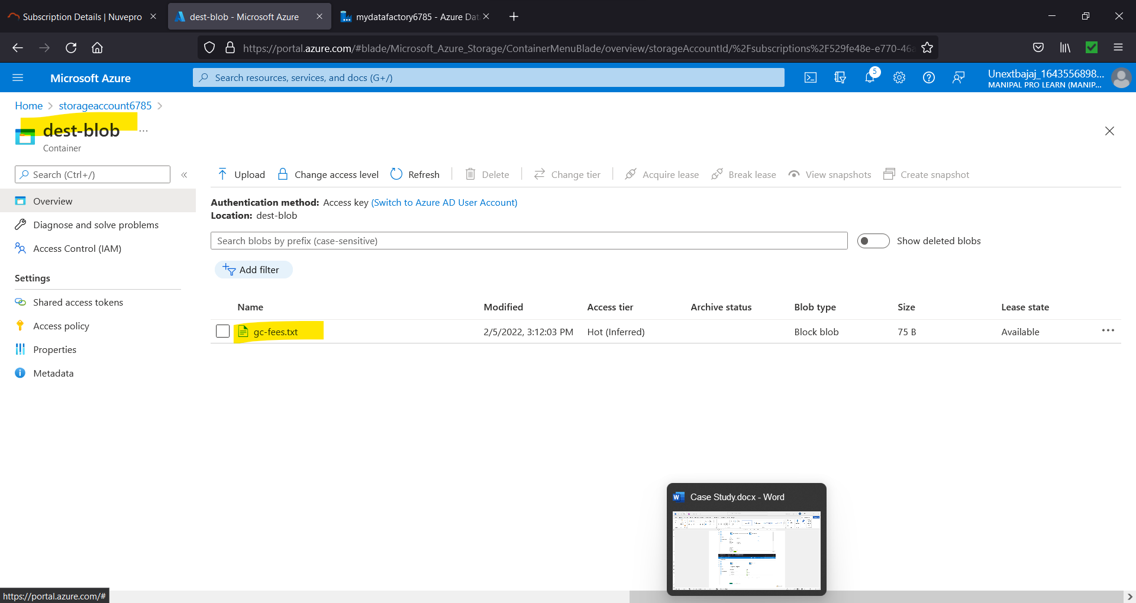

Figure 8.21. File copied from source to destination.

1. **Explain Azure Data factory pipeline process with the diagram.**

A data factory might have one or more pipelines. A pipeline is a logical grouping of activities that performs a unit of work. Together, the activities in a pipeline perform a task. For example, a pipeline can contain a group of activities that ingests data from an Azure blob, and then runs a Hive query on an HDInsight cluster to partition the data.

The benefit of this is that the pipeline allows you to manage the activities as a set instead of managing each one individually. The activities in a pipeline can be chained together to operate sequentially, or they can operate independently in parallel.

1. **In Azure, please create a Python app service & explain all the steps with screenshots?**

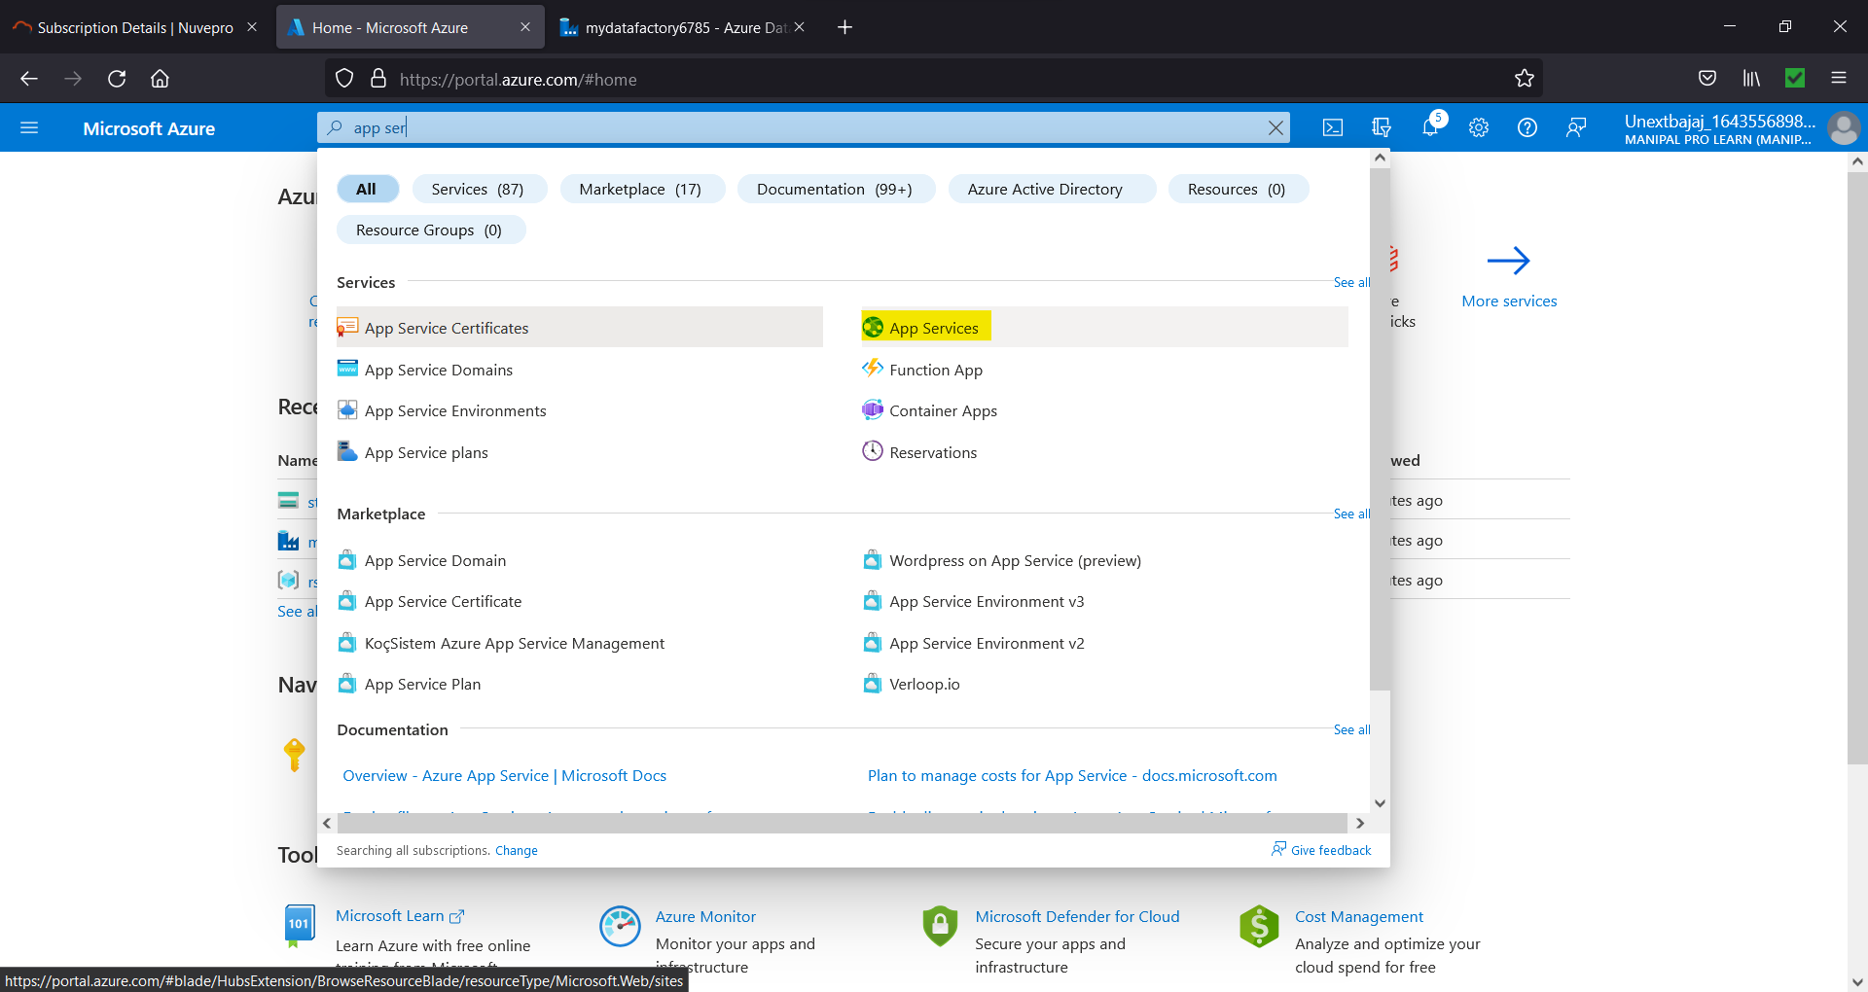

Figure 10.1. Search for App services.

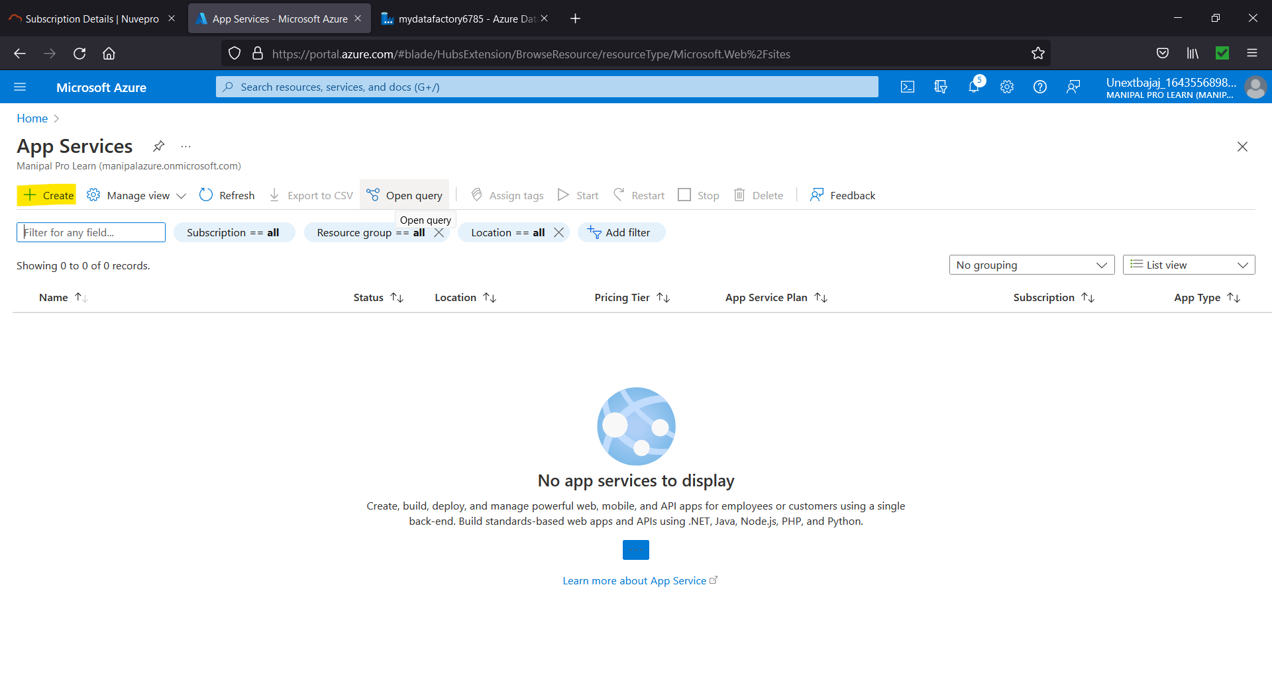

Figure 10.2. Select Create.

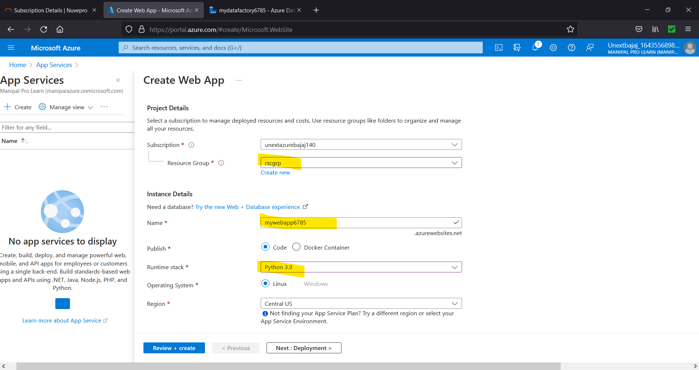

Figure 10.3. Choose Settings and then click Review + create

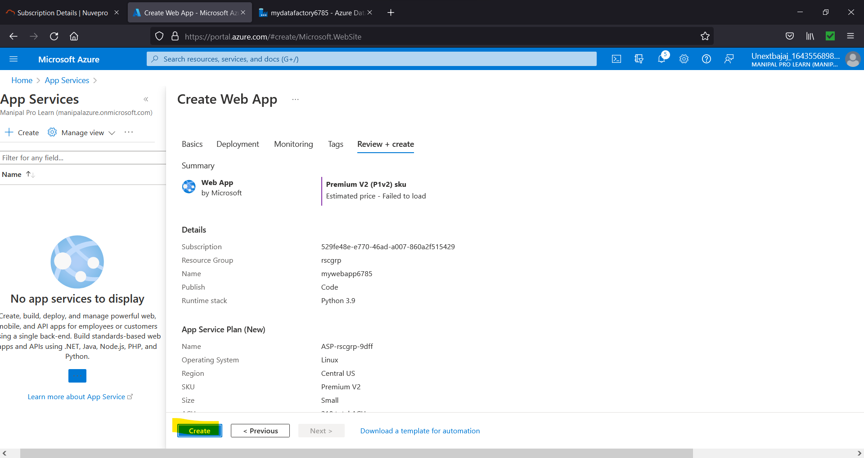

Figure 10.4. Select Create

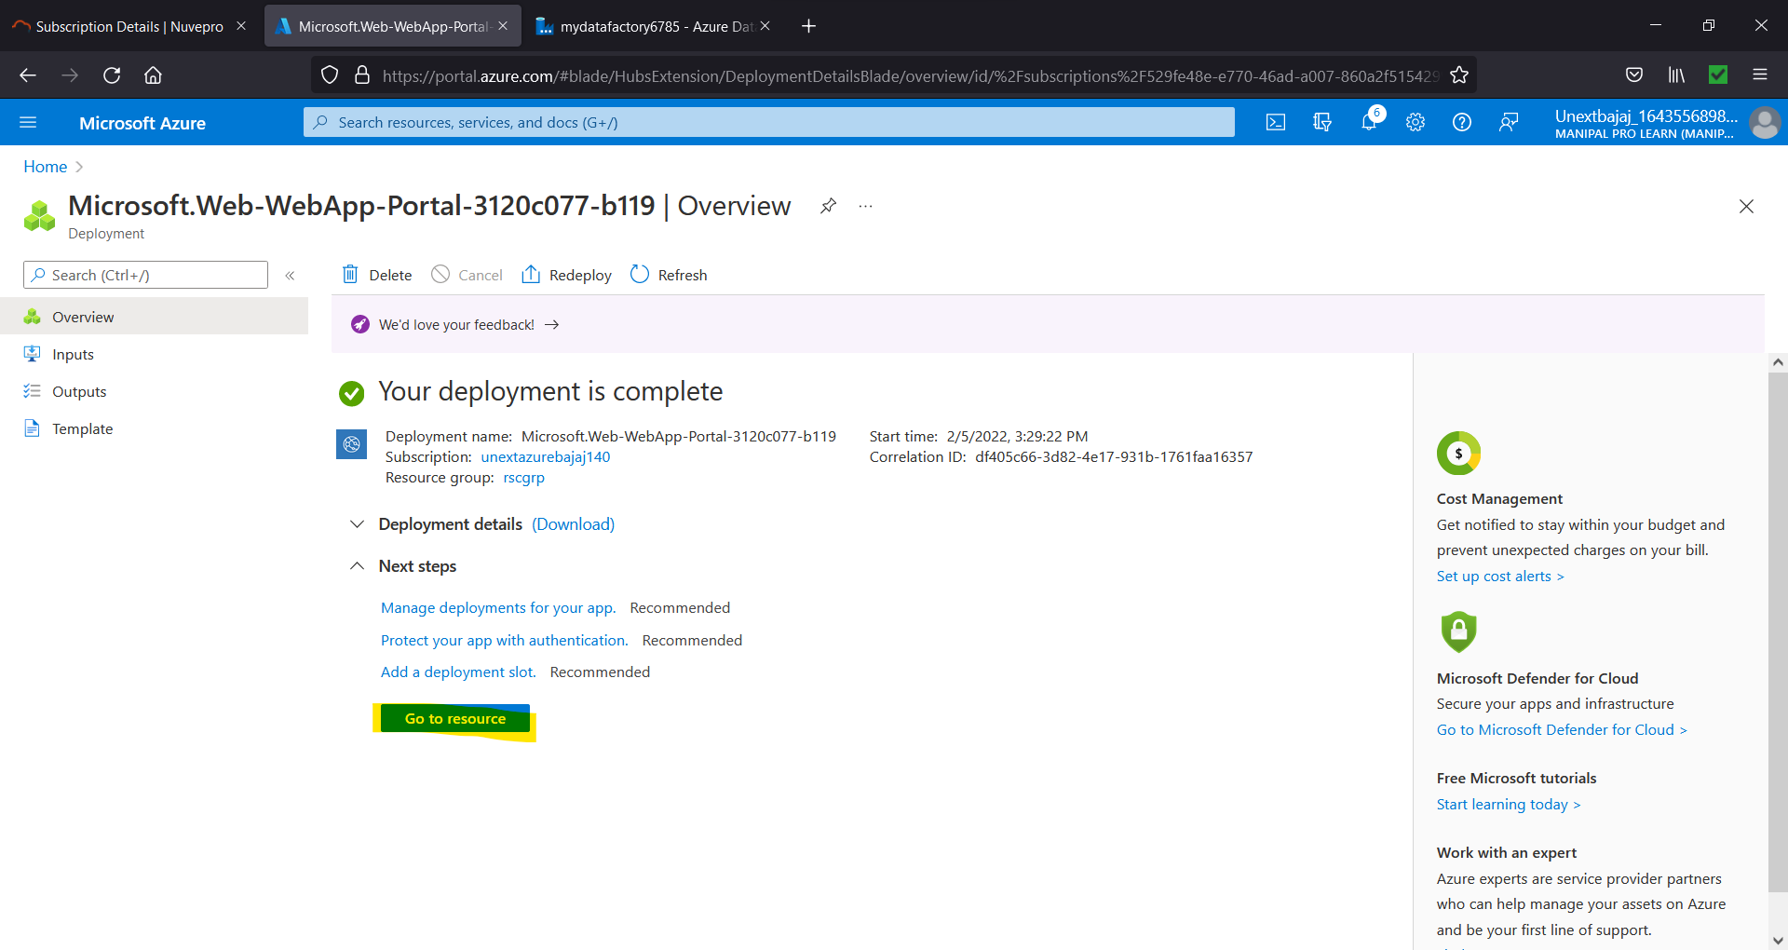

Figure 10.4. Go to resource

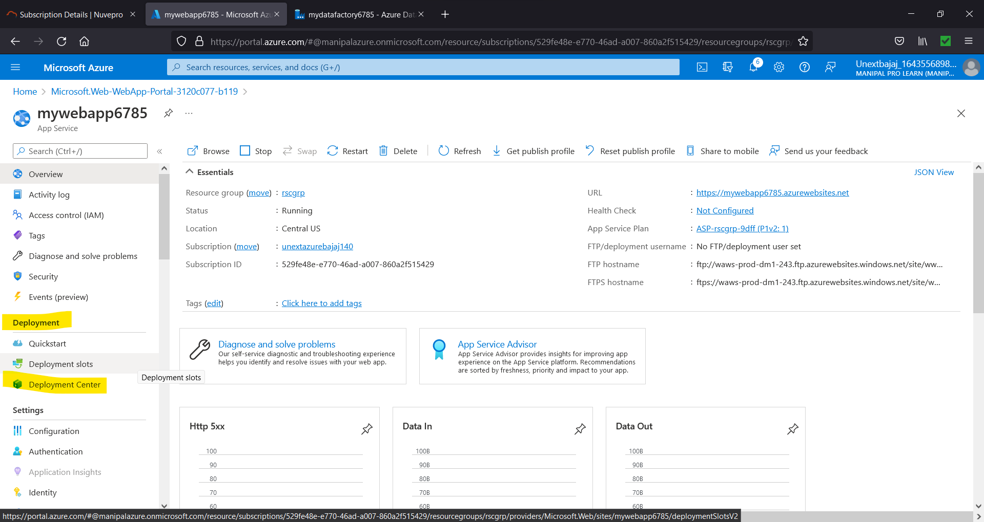

Figure 10.5. Under Deployment, select Deployment Centre

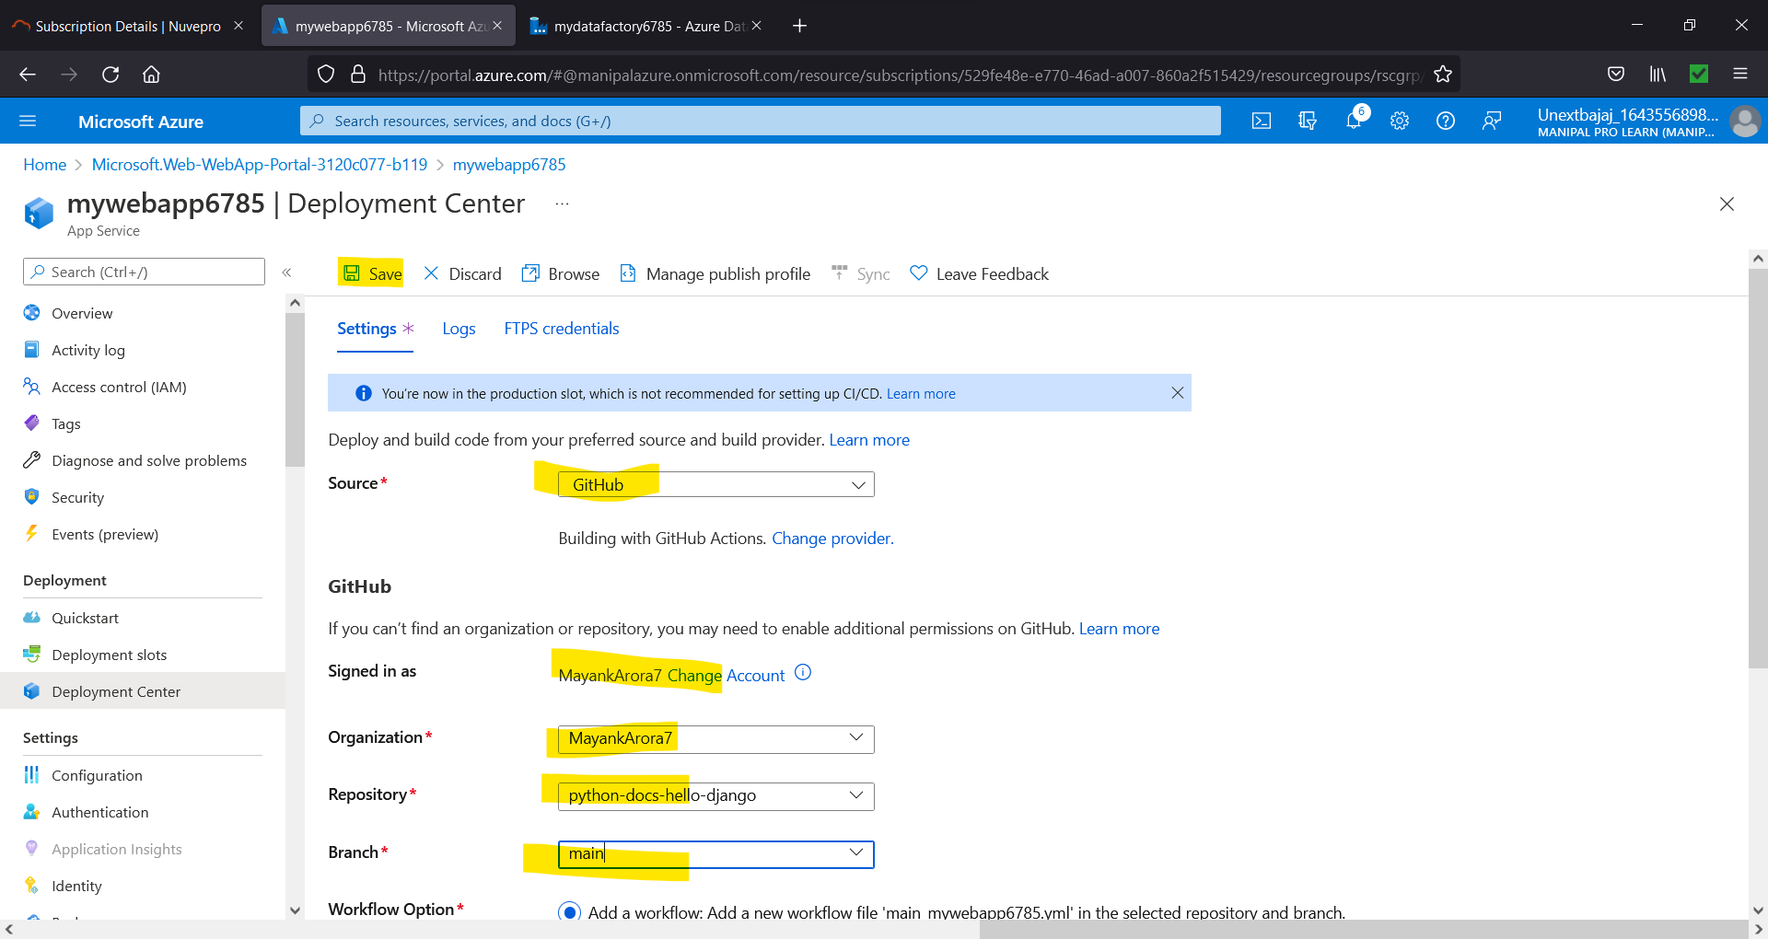

Figure 10.6. Select the settings and click save

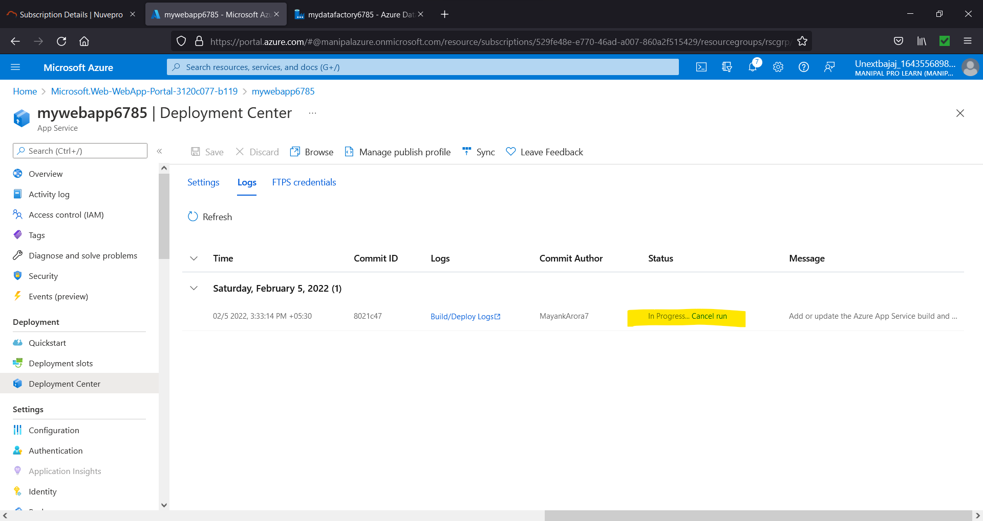

Figure 10.7. Wait for this to change to a success message

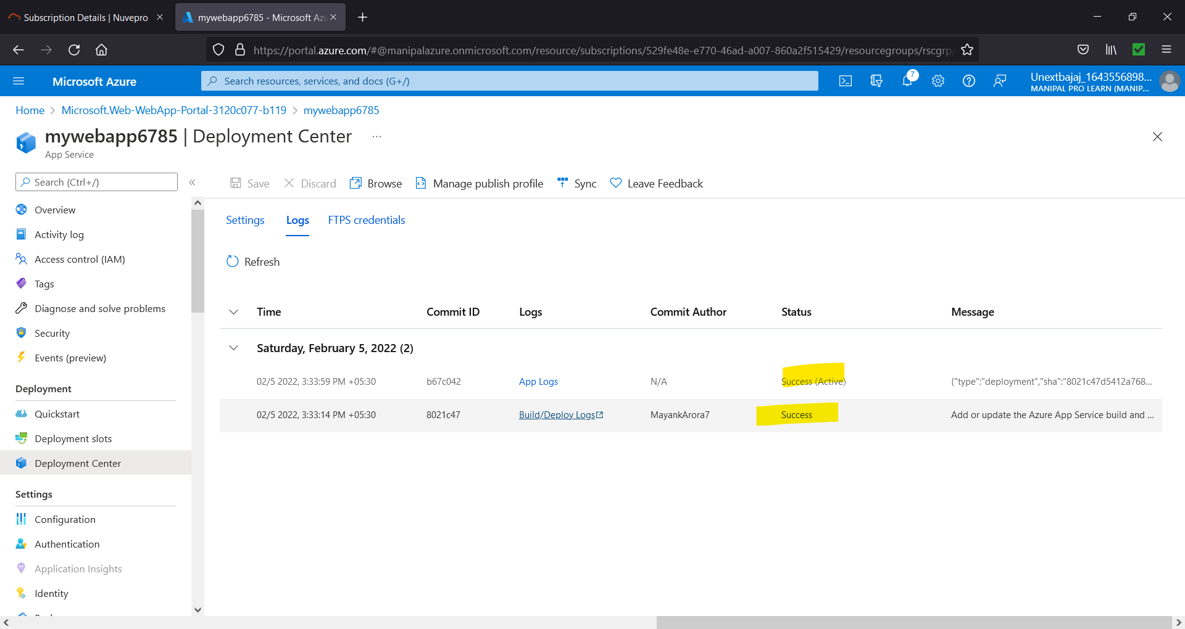

Figure 10.8. Success

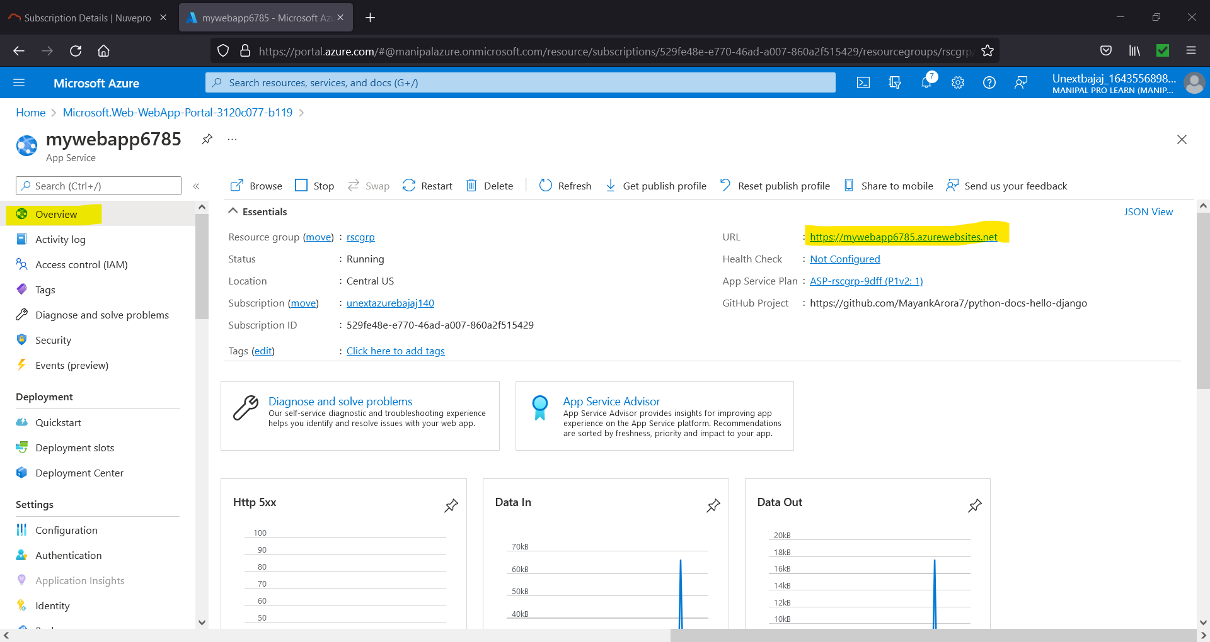

Figure 10.9. Go to overview, highlighted URL is the URL of the app,

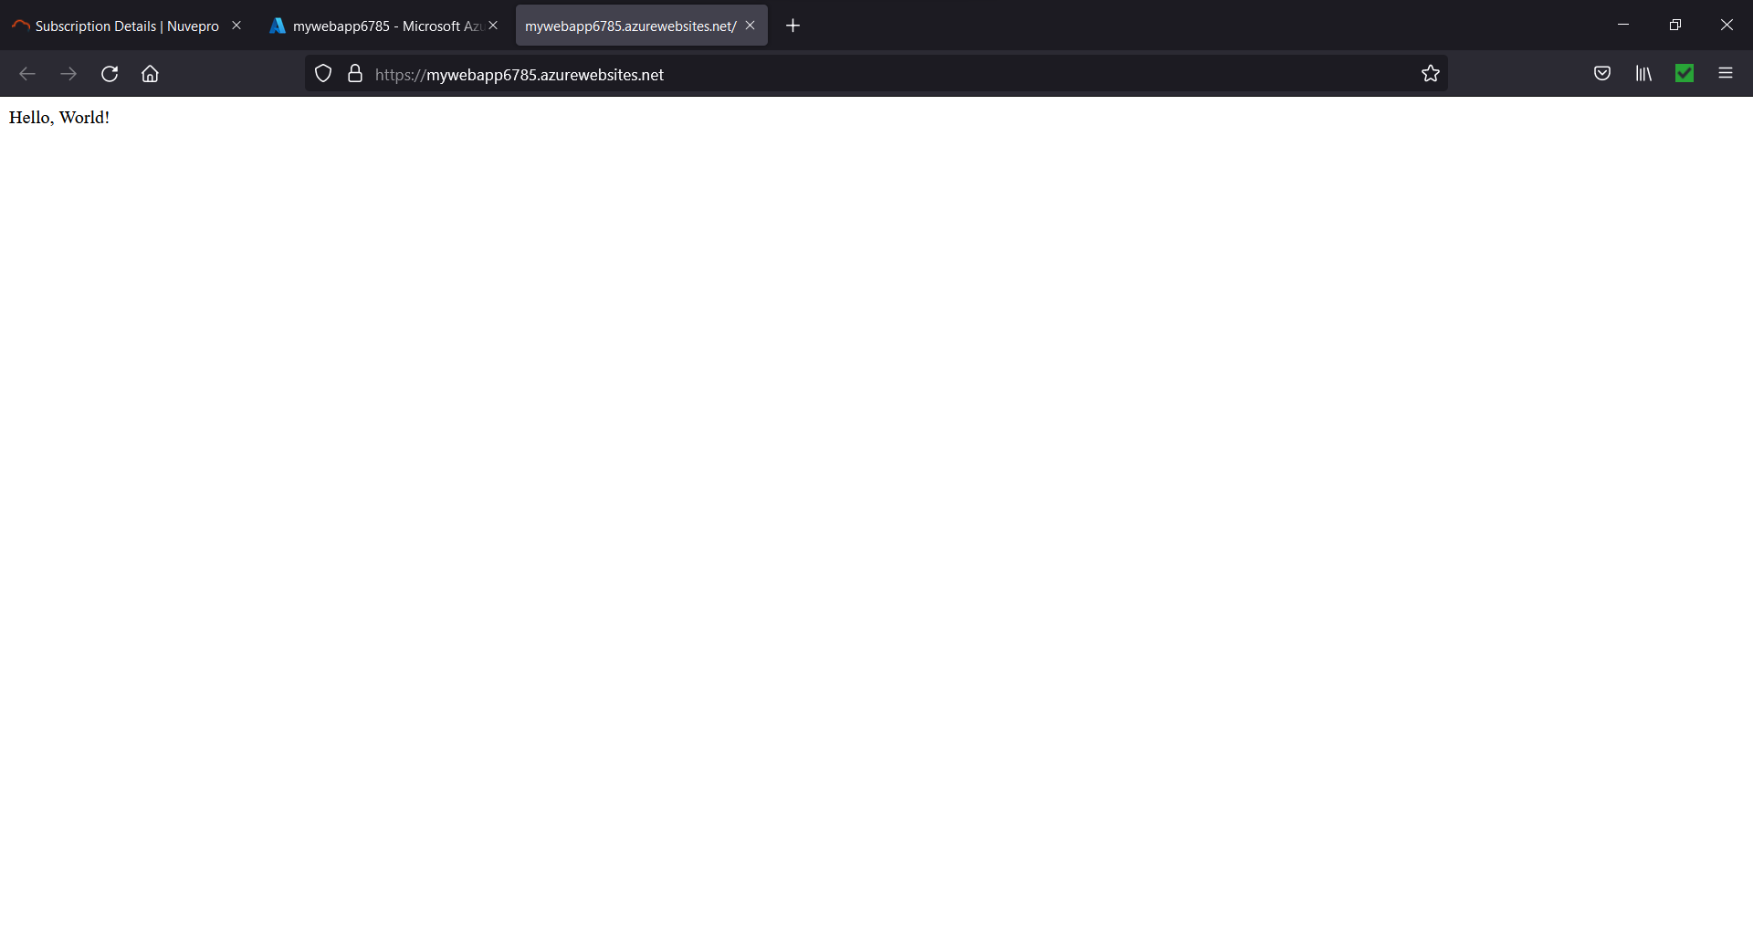

Figure 10.10. App is up and running.

1. **Please create Azure data bricks & explain with all steps & screenshots?**

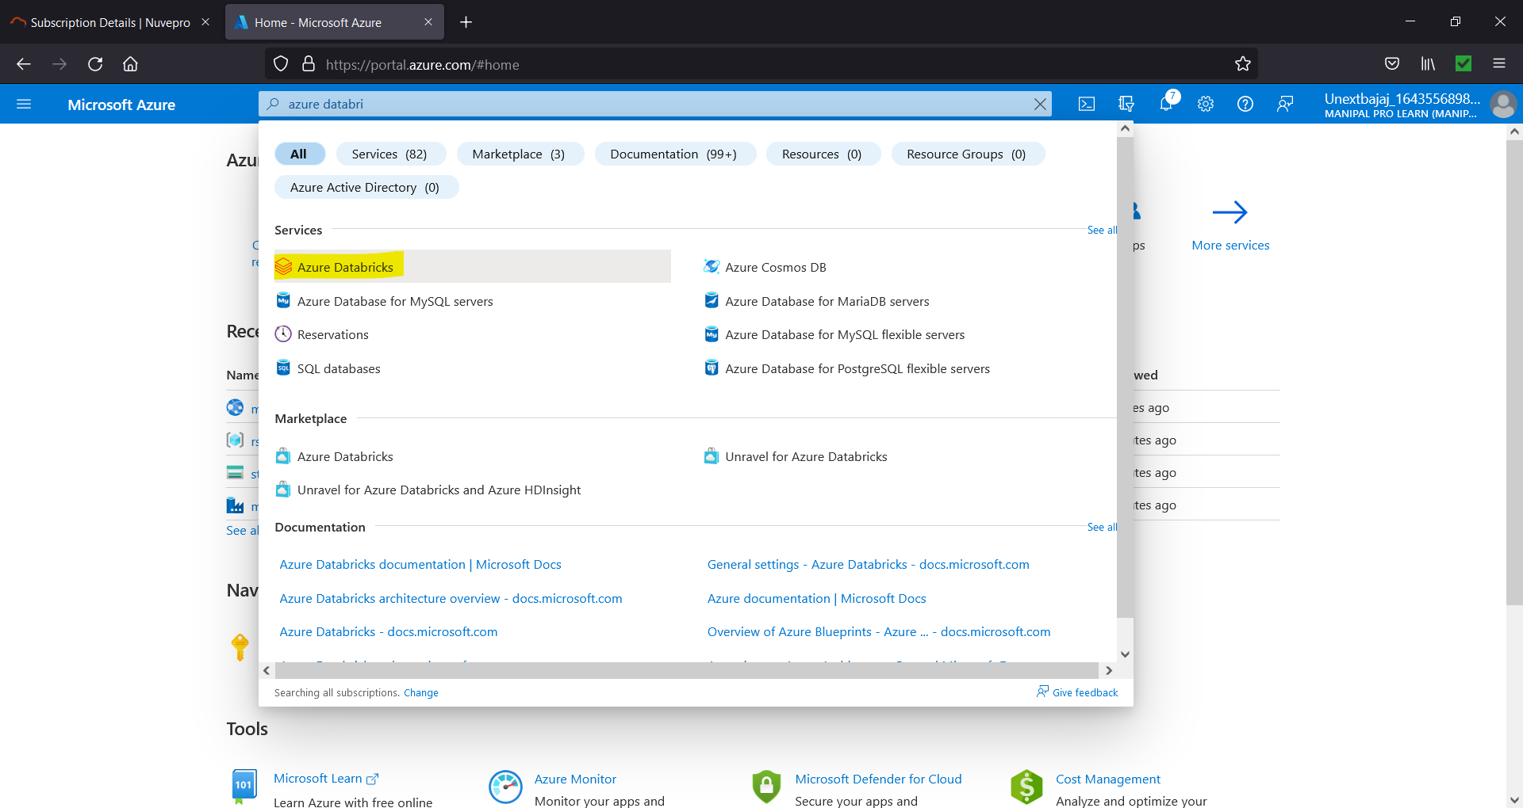

Figure 11.1 Select Azure Databricks

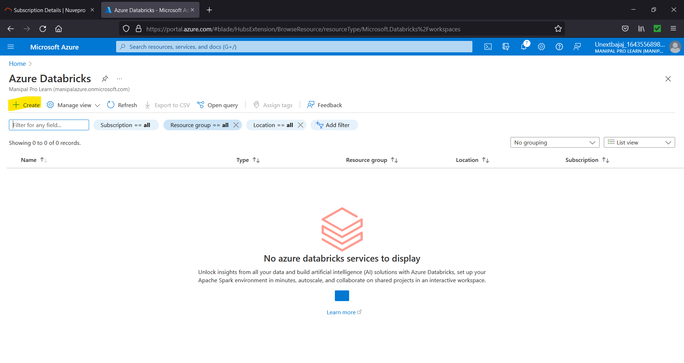

Figure 11.2. Select Create

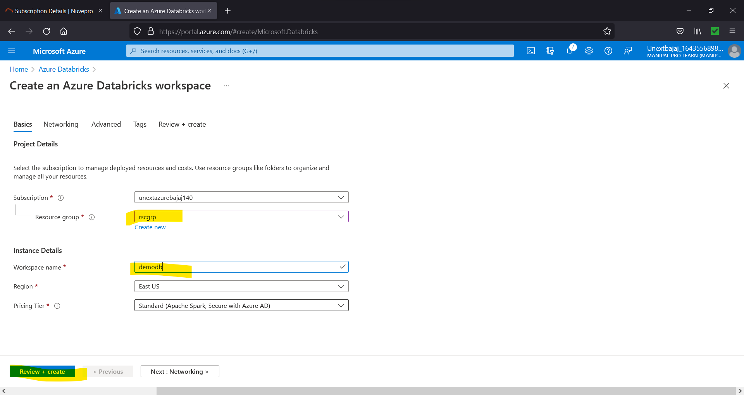

Figure 11.3. Choose Settings

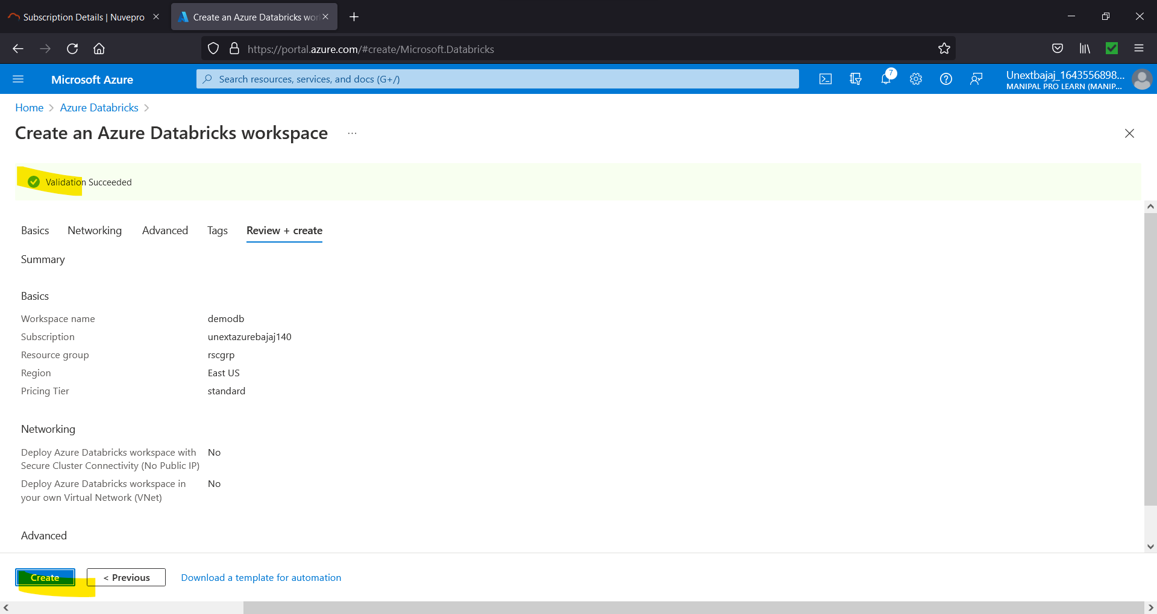

Figure 11.4. Create

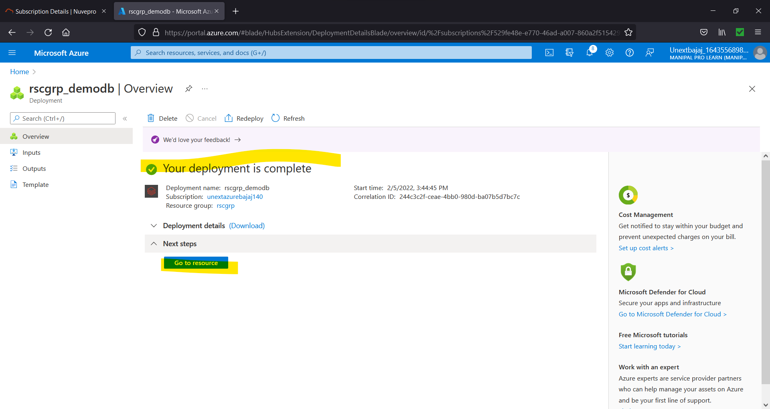

Figure 11.5. Go to resource

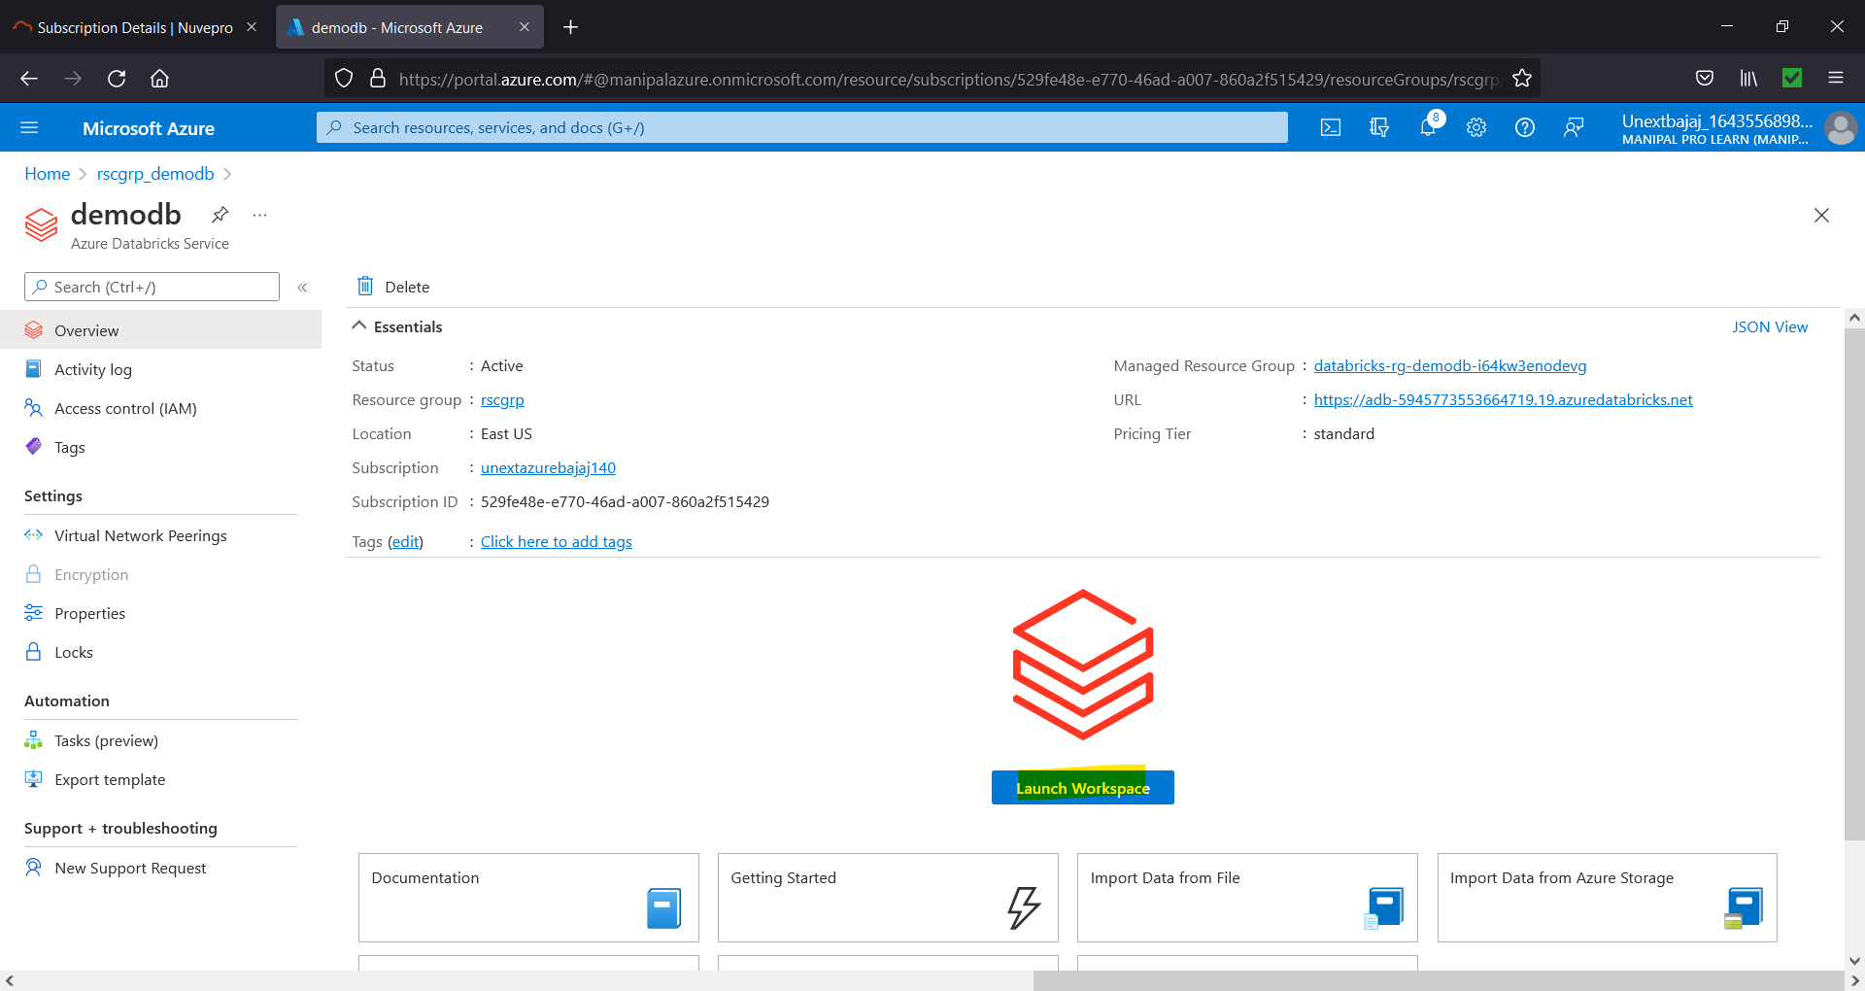

Figure 11.6. Launch Workspace

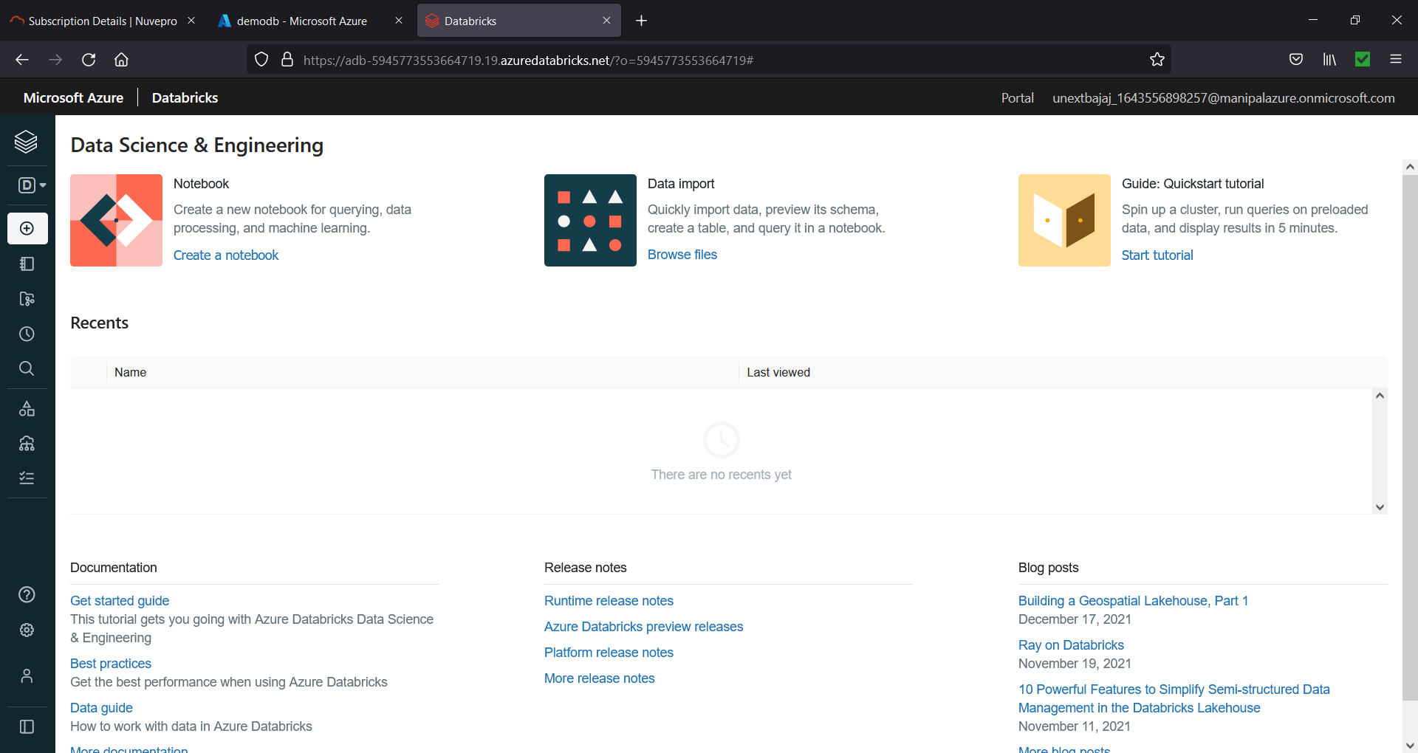

Figure 11.7. Databricks

1. **In Azure data bricks - please add data & create table**
   1. **Using UI option**
   2. **create a table using the notebook option & explain all the steps.**

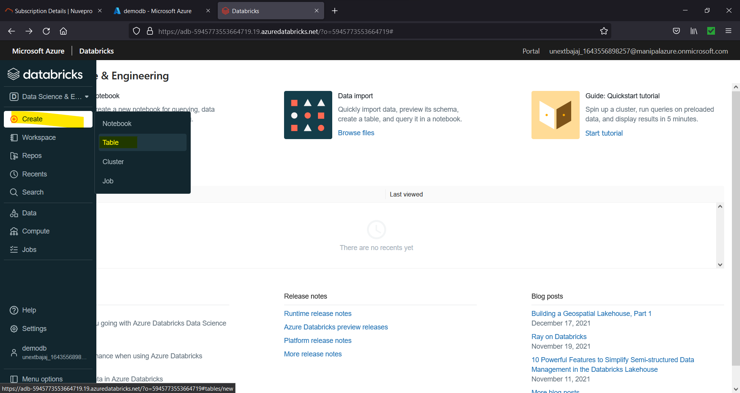

Figure 12.1. For creating tables, we first need a cluster, so after creating a cluster select create 🡪 table

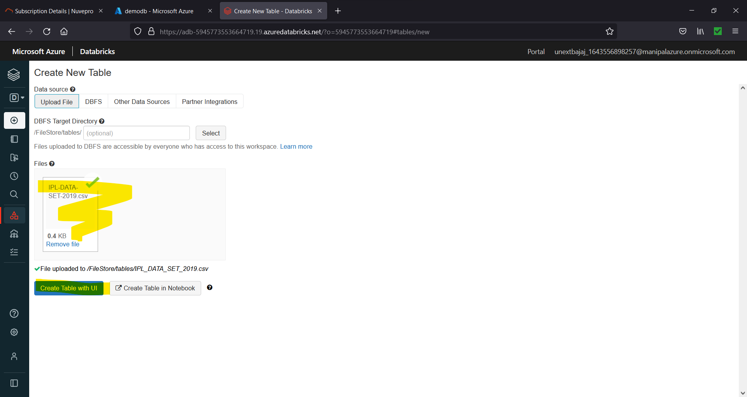

Figure 12.2. Upload a file and choose desired option

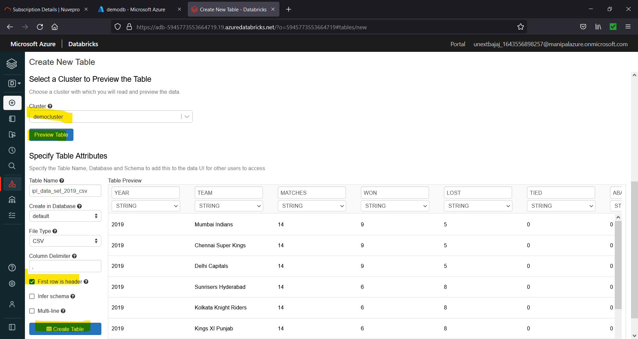

Figure 12.3. (Using UI) Choose Settings 🡪 Create a Table

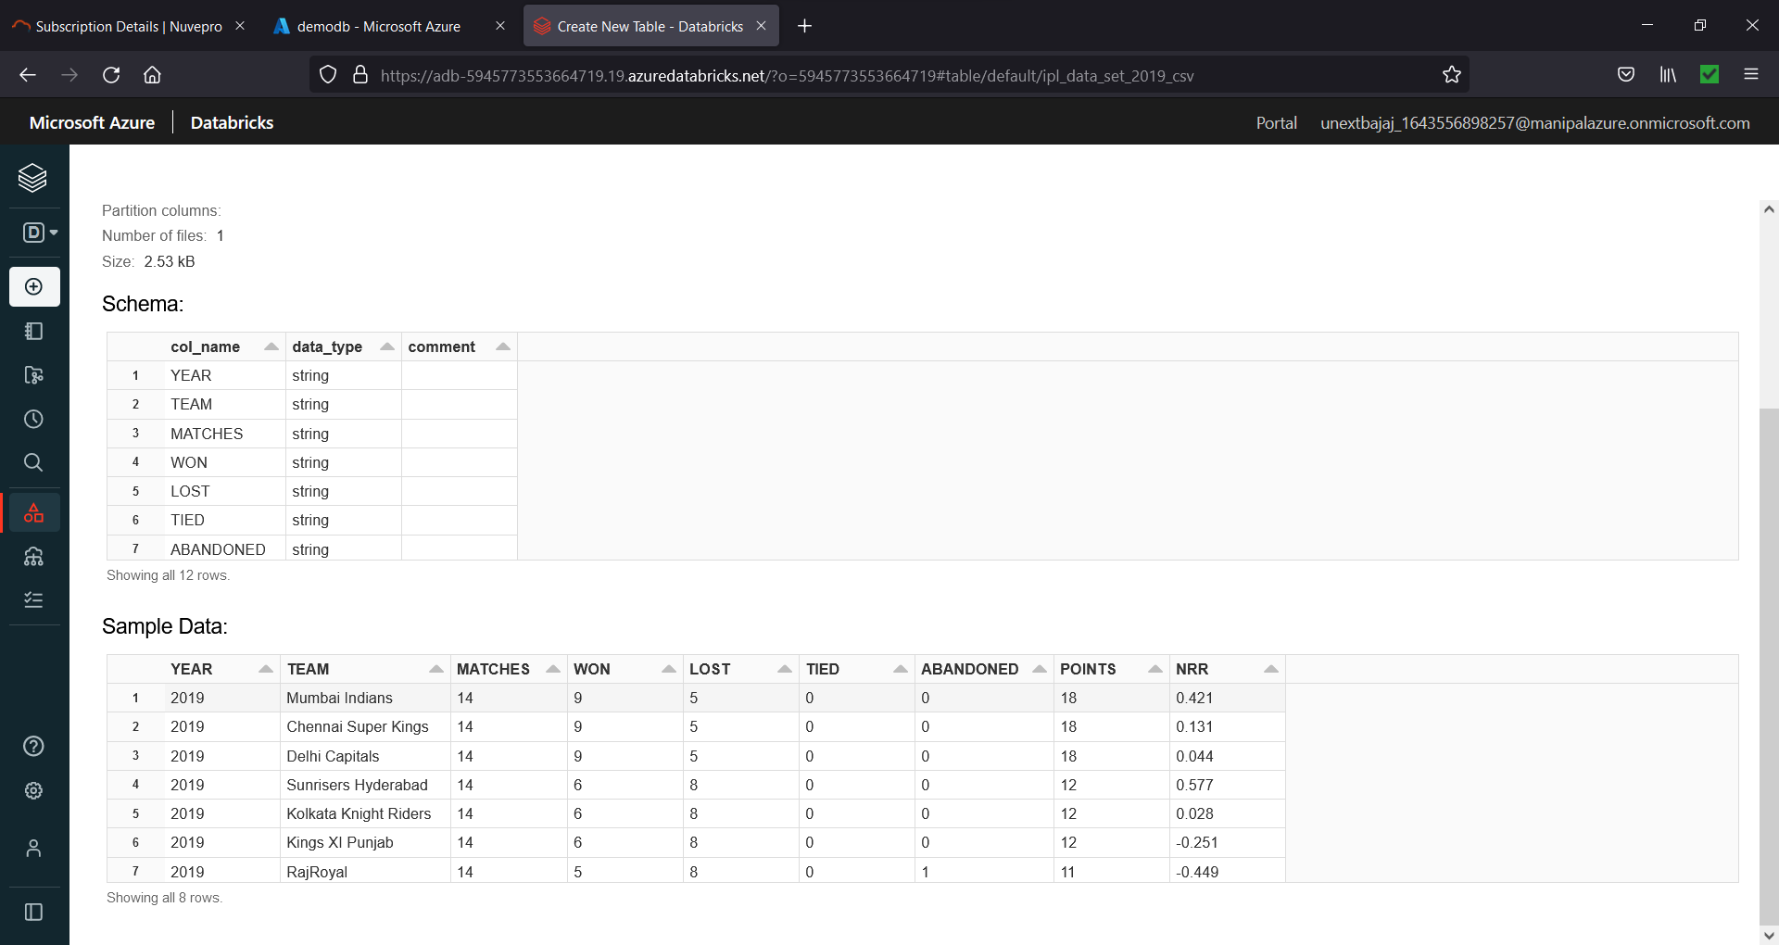

Figure 12.4. Using UI

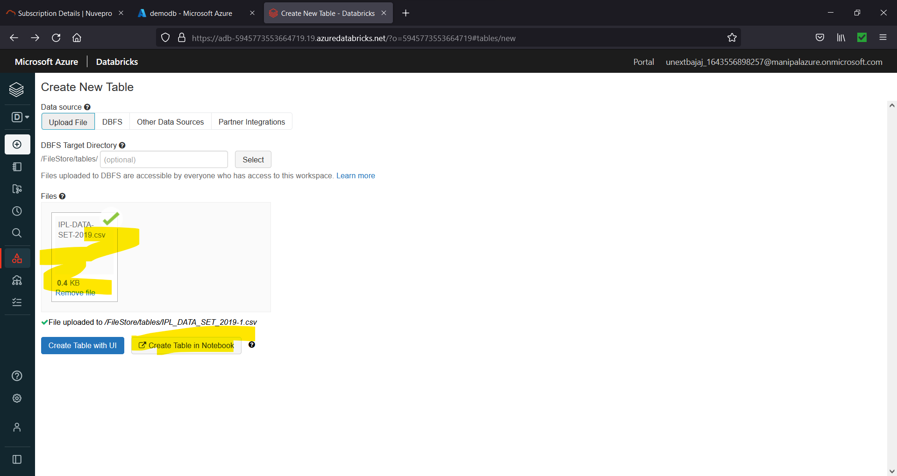

Figure 12.5. Using Notebook

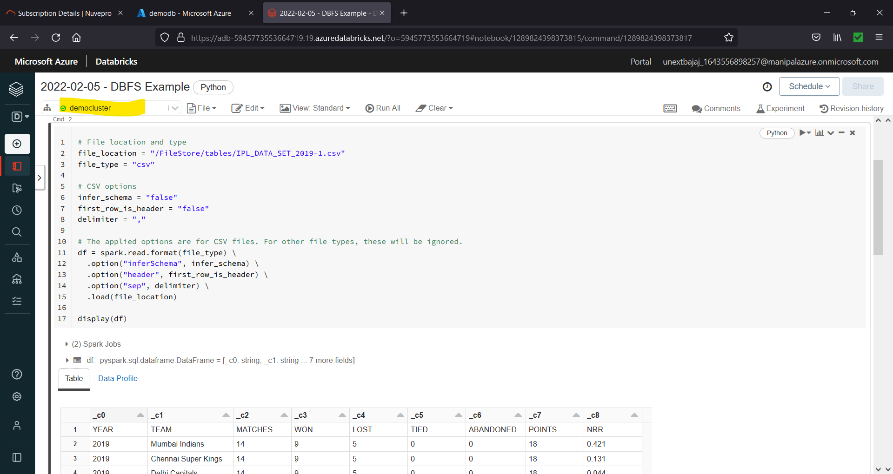

Figure 12.6. (Using Notebook) Remember to attach a cluster.

1. **In Azure data bricks - please create Cluster & explain with all steps with screenshots?**

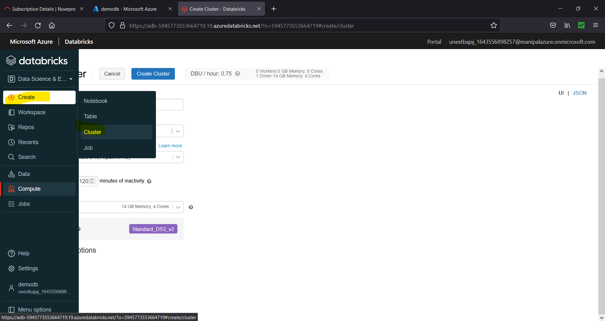

Figure 13.1. Select Create 🡪 Cluster

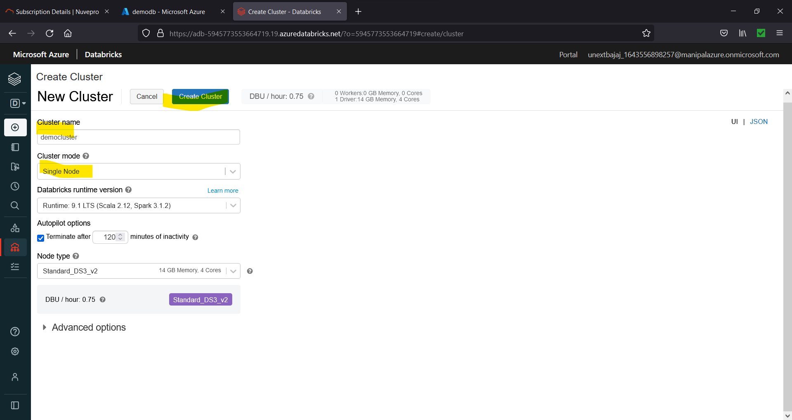

Figure 13.2. Choose Settings 🡪 Create Cluster

1. **In Azure data bricks - please create sample Notebook & jobs, further assign sample notebook to jobs & run it, explain with all steps with screenshots?**

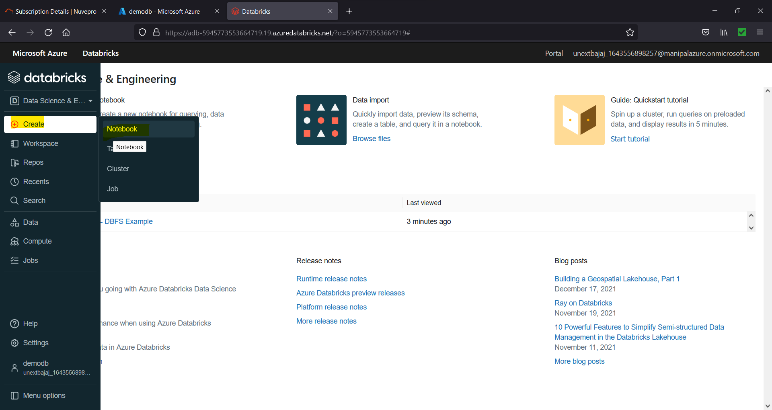

Figure 14.1. For creating notebook, we first need a cluster, so after creating a cluster select create 🡪 notebook

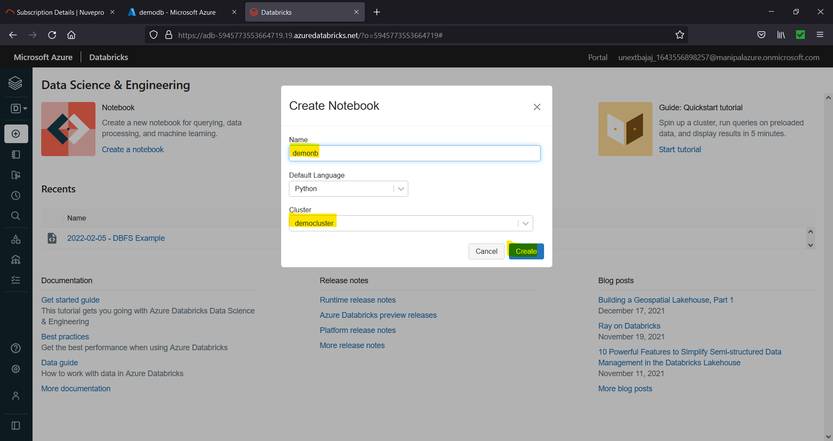

Figure 14.2. Choose Settings

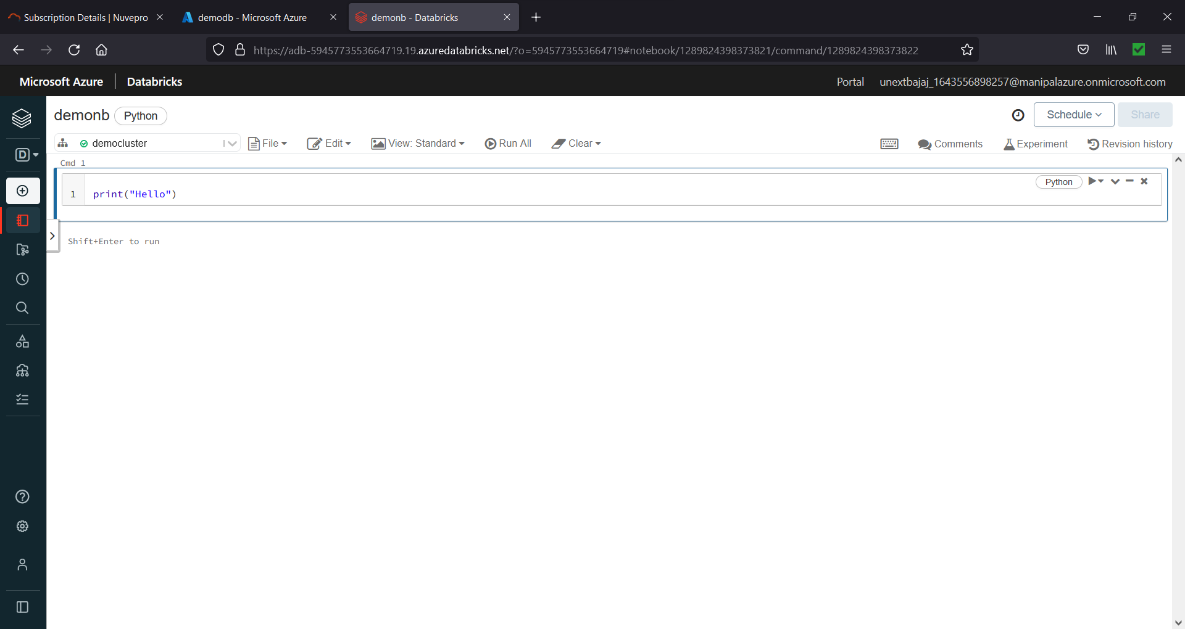

Figure 14.3. Write Anything in notebook

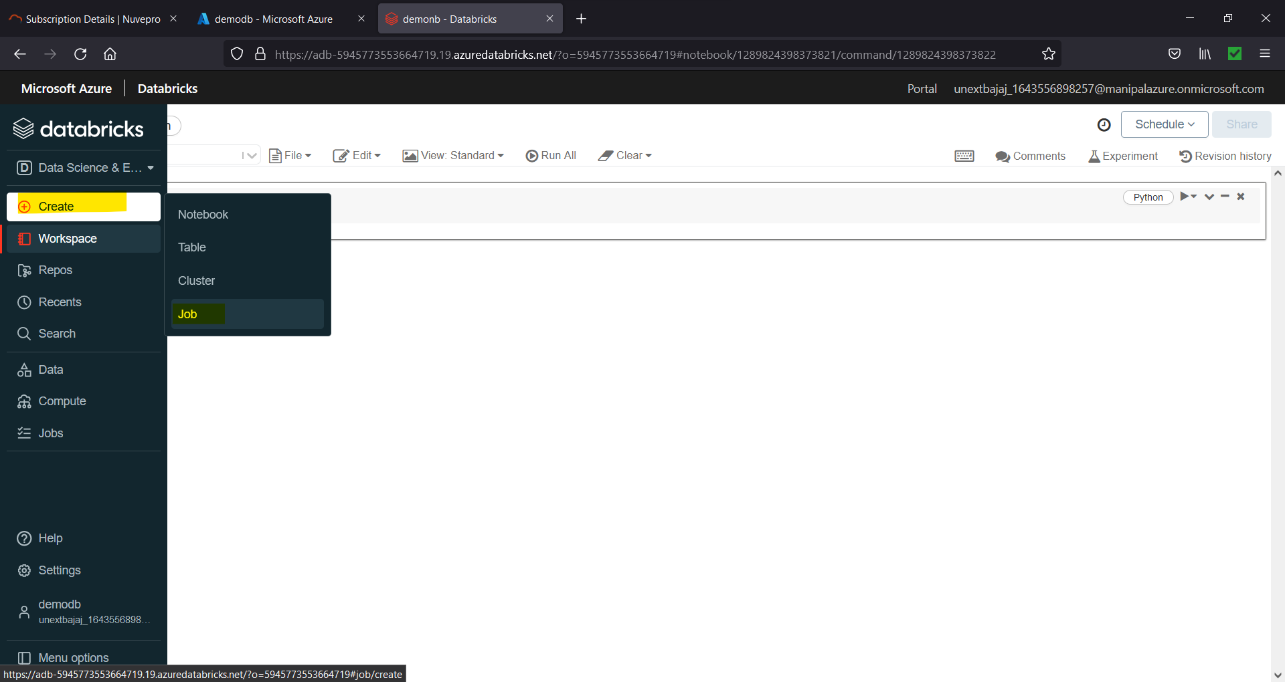

Figure 14.4. Create 🡪 Job

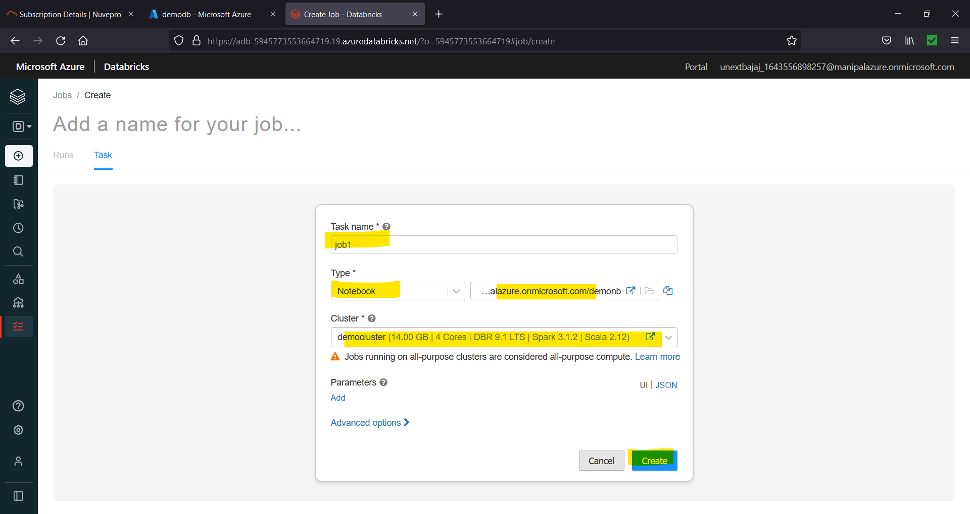

Figure 14.5. Choose Setting 🡪 Create

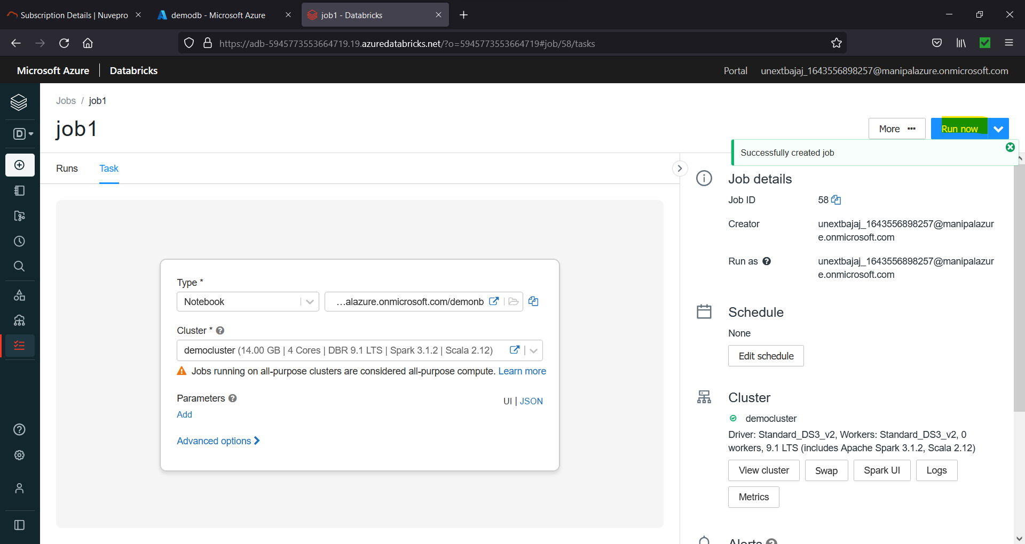

Figure 14.6. Run the Job

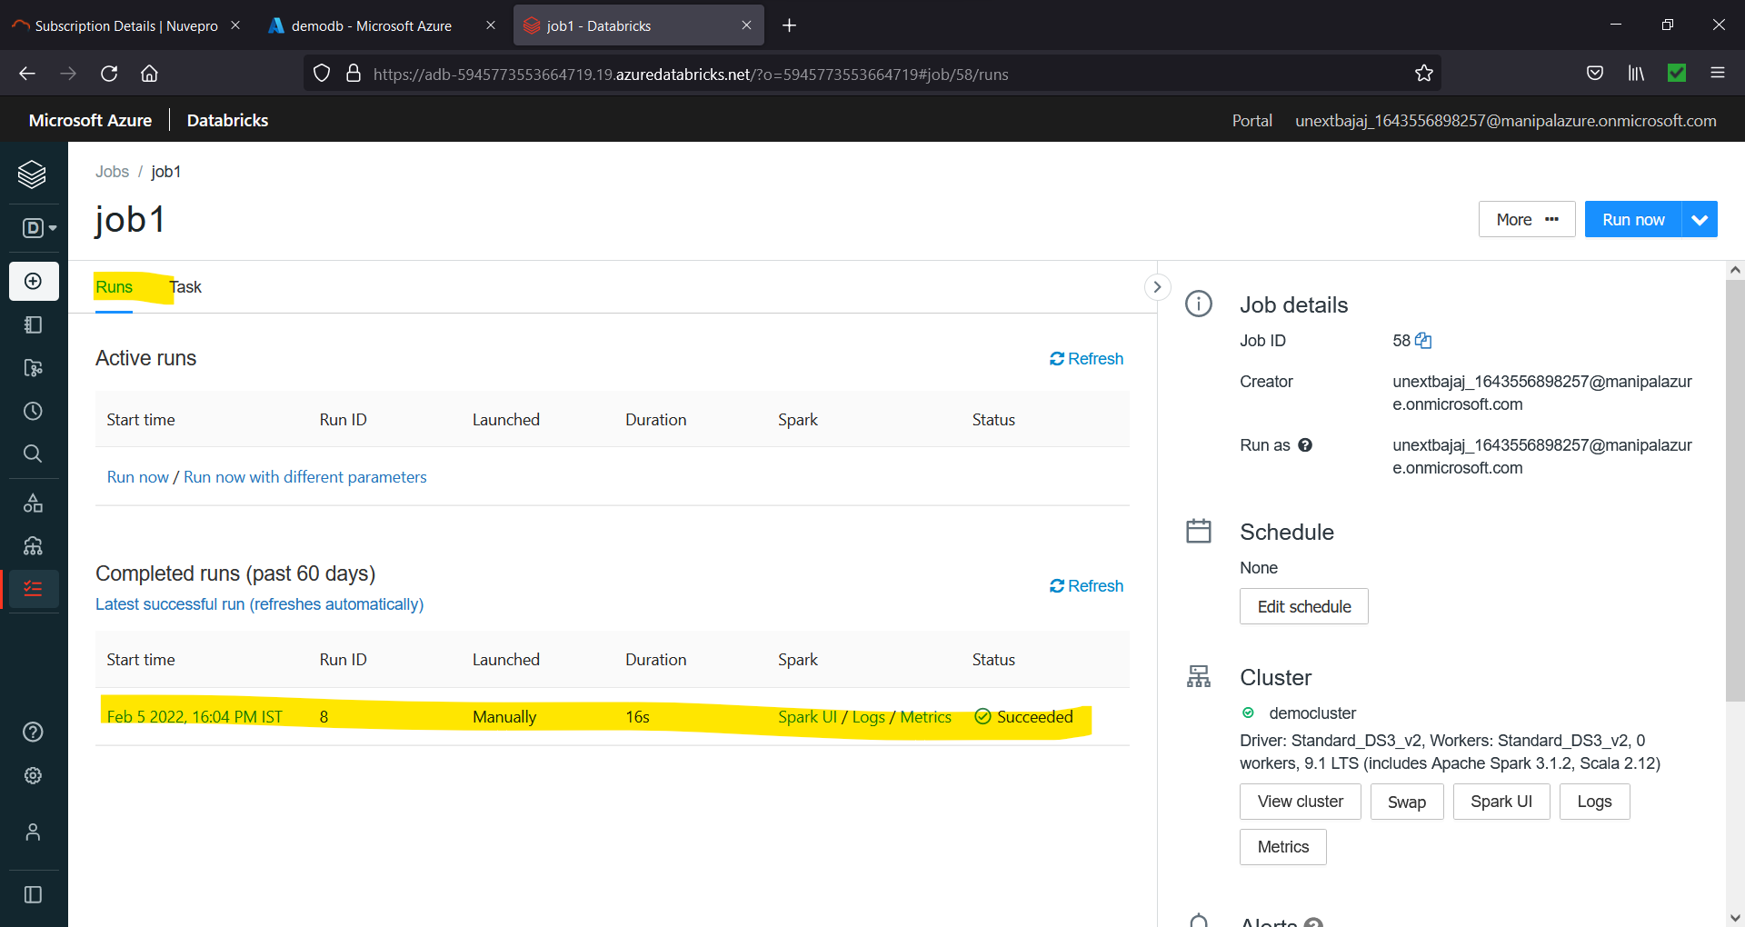

Figure 14.7. Job runs successful